Car Insurance Business Plan US

… Comprehensive, Affordable, Responsible

TABLE OF CONTENT

1.0 EXECUTIVE SUMMARY……………………………………………………………………….…………….….4
1.1 Vision
1.2 Mission
1.3 Core Values
1.4 Keys to Success
1.5 Objectives

2.0 Company Summary ………………………………………………………………………………………........8
2.1 Business Description
2.4 Milestones

3.0 Ownership and Management…………………………………………………………………………………12
3.1 Management Summary
3.2 Business Model Canvas
3.3 Management Background
3.4 Personnel Plan

4.0 Organizational Structure ……….........................................................................................16
4.1 Organizational Chart

5.0 Value Proposition and Competitive Comparison………………………………………………….18
5.1 Service/Product Offering
5.2 Competitive Advantage

6.0 Market Research and Analysis…………………………………………………………..………………20
6.1 Industry Overview
6.2 Target Market
6.3 Major Competition

7.0 Marketing and Sales Plan…………………………………………………………………………………25
7.1 Product
7.2 Pricing
7.3 Place
7.4 Promotions
7.5 Sales

8.0 Internet Plan ………………………………………………………………………………..………………….28
8.1 Website/Blog Plan
8.2 Social Media Plan

9.0 Strategy and Implementation Summary..........................................................................31
9.1 Marketing & Sales Plan
9.2 Marketing Strategy
9.3 Sales & Marketing Target
9.4 Promotion Pattern
9.5 Distribution Strategy

10.0 Sales Plan..........................................................................................................................36
10.1 Sales Strategy
10.2 Sales Forecast

11 Operational Strategy.............................................................................................................38
12 Human Resources................................................................................................................38
13 Quality Control.....................................................................................................................40
14 Processes...............................................................................................................................41
15 Financials.............................................................................................................................42
16 Exit Plan and Strategy..........................................................................................................47
17 Plan Improvement................................................................................................................48

1.0 EXECUTIVE SUMMARY

AC Insurance is a new company that will be run by ………..(Owner)……… as a sole owner. Established with the primary purpose of providing professional, ethical, and customer-focused car insurance services, AC Insurance will be a success from its inception because we understand that modern businesses necessitate multifaceted and advanced methods which we fully understand and intend to implement. We intend to promote our insurance company as one that provides a suite of car coverage options for its customers at affordable rates.

At AC Insurance, we always put the needs of our clients first and act in accordance with the highest standards of professional integrity in all that we do. We'll always keep our professionalism, honesty, creativity, and focus on our customers at the forefront. Further, we make sure to exclusively engage seasoned professionals to help steer the company.

Holding ourselves to the highest standards means providing for our customers' wants and needs in a way that is both accurate and comprehensive. For the benefit of our business associates, employees, and customers, we foster an atmosphere that nurtures a humane and environmentally responsible method of making a living and making one's way in the world.

At all times, AC Insurance is prepared to show its dedication to sustainability by community service and the use of environmentally friendly processes whenever possible.

Capital Needs
AC Insurance will run at an assumed sales profit of $129,228 in its next year of expansion, with a profit after tax $50,295 and a consistent progression for the future years. We seek an additional loan of $32,000 in capital contribution. The chart below explains our projections:

(All figures shown in the graphs are in $’000)

Our marketing strategy will include the use of both flank and guerrilla type of marketing attack to topple larger brands by offering unique service and experiences at competitive prices that is being ignored by larger brands. We will also include online marketing with great focus on social media and an active blog to position our brand as the industry leader with our regular contents.

Our Vision

Our vision is to create a highly effective car insurance service business that will become the number one choice for both individuals and corporate organizations in ___target location__ and the whole of the United States

1.2 Our Mission

AC Insurance is an insurance provider committed to offering competitive rates without sacrificing quality or coverage. In order to do this, we will form a mutually beneficial partnership with each of our customers.

Our success will be determined by the level of confidence our customers have in us to provide them with the best possible price, service, and knowledge.

1.3 Our Core Values
The following core values drive our operations, products and team.
- Quality
- Integrity
- Excellent Service and Product Delivery
- Efficiency
- Extra Value Driven Professionalism
- Innovation

1.4 Keys to Success
AC Insurance’s enviable keys to success will include the following:
- Efficacious Publicity: Our publicity strategy is to consciously position our brand as a maven within the industry by affiliating with complementary corporate and luxury brands. Our campaigns and publicity will include online visibility such as social media engagement and an interactive website supported with an active blog as well as prints and referral in reaching our potential clients.
- Referral System: A strong referral system will be implemented as an automated system to increase our outreach.
- Brand and Reputation: The brand model is aimed at delivering decisive advantage both to the individual mind and to the market place. Our brand feel and experience will go beyond the basic service that we offer but will include other value-added services such as convenience, excellent customer experience, and trust that creates loyalty to the brand. Our brand strategy will be geared towards an abstract feel of superior experience with AC Insurance.
- Convenience: Our products and services will be easily accessible, and reasonably priced.

1.5 Objectives:
In a more quantifiable outline, we hope to achieve the following:
- Predefine a series of brand promises we must keep. This will be more like a broadcasted accord of threshold we will never fall short off.
- To create a service-based company whose goal is to exceed customers expectation while creating hype moments (neuropsychologically exciting experiences) and moments worth returning to.
- To have a clientele retention and return rate of near 90% year on year.
- To increase the number of clients served by at least 200% per year through superior marketing performance and word-of-mouth referral schemes.

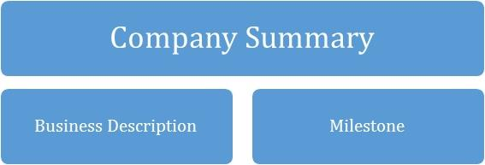

2.0 COMPANY SUMMARY

AC Insurance is a brand focused on providing professional car insurance services across a wide range of individuals. We’d lay prominence on the unavailability of professional, quality, and affordable car insurance services across the region, thereby giving our customers the desired results.

In addition, with the invaluable experience garnered over the years and with the support of a seasoned team, tools and technology, AC Insurance will promote positive responses towards what we do, that will convert consumers into customers then into loyalists and eventual evangelists.

What will set AC Insurance apart from the competition is our focus on service innovation through technology and commitment to providing professional, friendly, self-service, prompt, cost effective, and most importantly, personalised services.

2.1 Business Description
As a legal entity, is registered as Auto Car Insurance LLC. We will operate from an outlet in _______, equipped with a reception to receive customers, and interact with them.

We will provide services related to specialised car insurance on a monthly subscription basis and value-added services, such as consulting as part of our wide range of services.

2.2 Milestones till date
Type | Status | Timeline
Business Name Availability Check | Completed | September 2022
Business Incorporation | Completed | August 2022
Opening of Corporate Bank Accounts various banks in the ____Country Name___ | Completed | July 2022
Opening Online Payment Platforms | Completed | September 2022
Application and Obtaining Tax Payer’s ID | In Progress | November 2023
Application for business license and permit | Completed | June 2022
Purchase of All form of Insurance for the Business | In Progress | October 2023
Renting of Office Facility | In Progress | February 2023
Securing Point of Sales (POS) Machines | Completed | December 2022
Opening Mobile Money Accounts | Completed | January 2023
Opening Online Payment Platforms | Completed | January 2023
Conducting Feasibility Studies | Completed | January 2022
Start – up Capital Generation | In Progress | November 2023
Writing of Business Plan | Completed | January 2022
Drafting of Employee’s Handbook | Completed | January 2022
Design of The Company’s Logo | In Progress | February 2023
Graphic Designs and Printing of Packaging Marketing / Promotional Materials | In Progress | February 2023
Recruitment of employees | In Progress | July 2023
Purchase of the Needed furniture, office equipment, and electronic appliances | In Progress | May 2023
Creating Official Website for the Company | In Progress | October 2023
Creating Awareness for the business (Business PR) | In Progress | January 2023
Health Safety and Fire Safety Arrangement | Completed | November 2022
Establishing business relationship with key players in the industry | Completed | January 2022

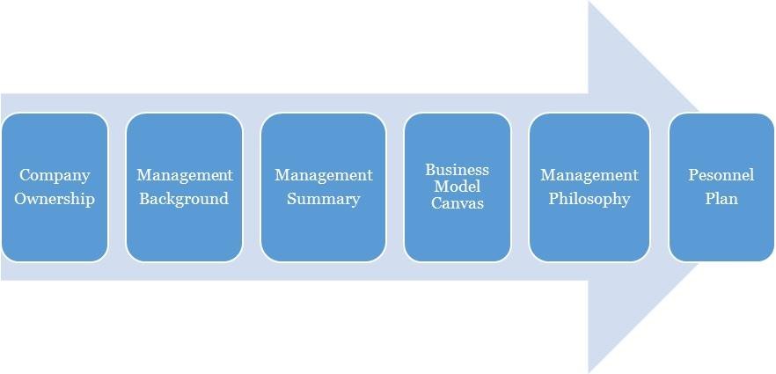

3.0 OWNERSHIP AND MANAGEMENT

AC Insurance is owned by _________. The management of AC Insurance is a simple one with the CEO acting as the MD to provide leadership and management for the organization.

Name | Title | No. Of Shares | % Of Ownership
Owner | CEO |  | 100%
TOTAL |  |  | 100

3.1 Management Background
Owner:
Mr DEF is a dynamic individual, adapted to working in fast-paced health environments where the focus and objectives are to deliver first class service; with an amazing track record of experience in Leadership across several auto establishments.

He is also the CEO of AC Insurance, which he started in ____ and has the capacity to lead it through an amazing performance in the coming years with the goal to expand. ___Owner’s Name___ is also a versatile and experienced customer service Advisor.

He holds a Bachelor’s Degree in __________, US, from _________, ________, US. His trainings and experience have also helped him develop leadership and coaching skills and a strategic view-point to every project or endeavour. He also possesses a natural ability to build and maintain valuable professional relationships with clients, vendors and colleagues.

3.2 Management Summary
The management philosophy at AC Insurance will be based on mutual respect for each of our fellow colleagues and for every customer.

Our success will greatly depend on how effective our relationship is with our customer; this is why we will focus on treating our employees’ right and encourage them to treat the customers likewise. Our employees are the face of the brand and will represent the brand when interacting with our client. Customer friendly employees will increase general client loyalty and repeat business.

The management team will consist of the owner/CEO and the general manager. We will hire only those who demonstrate the qualities necessary for working in a nurturing environment, and the willingness to move forward in study of energetic principals if not already so trained. We will be hiring the ultimate "people persons."

Employees will be encouraged to work within their creative, physical, and intellectual boundaries. All duties will be divided and delegated according to the strengths and weaknesses of our staff. At AC Insurance, we will expect a high degree of customer service skills and personality as this is essential to our success. The management team will assess the productivity and performance evaluations of all employees every two months. These bi-monthly evaluations are conducive to the continued growth of our business.

3.3 Business Model Canvas
Business Model Canvas for AC Insurance
Key Partnerships  Financial partners, Auto Repair shops, Auto part dealers | Value Propositions  - Excellence  - Relationship  - Customer Service  - Professionalism  - Credibility  - Affordable Services | Customer Segments  Business to Business  - Industries  - Corporate Organizations  Business to Client  - High-Income Individuals  - Middle-Class Individuals
Key Activities  Procurement, Onboarding, Distribution, IT Operations, Marketing, Vetting. | Key Resources  Skills, physical location, staff | Channels  Direct sales, website, referrals
 | Customer Relationship  Online, offline, community  Social media, customer support, discounts and promotional | Channels  Direct sales, website, referrals
Cost Structure  Operational costs: Marketing & ads, logistics, Internet subscription, airtime charges, fuel, maintenance  Utility: electric bills, rents, salaries (skilled labor) etc. |  | Revenue Streams  - Gold Car Insurance Package  - Silver Car Package  - Bronze Car Package  - General Insurance Consultation

3.4 Personal Plan
AC Insurance is a growing firm and as such staff will be hired according to recommendations, experience and education in their field. High standards will be kept through the orientation and inclusion period for new employees and the new employees will be given a mentor to shadow for the first two (2) weeks of arriving. In so doing, the employees can pick up the ethics of working and representing the AC Insurance brand.

Checklists will be drafted to monitor employee’s quality of service after three months. Staffing and training will be available for sales representatives and customer service candidates. Every personnel will be given specific assignments and valued on completion of the assignment. One on one meetings will be held to discuss and handle any arising issue regarding performance and service.

4.0 ORGANIZATIONAL STRUCTURE

To have a truly value driven team that would be productive, there is a need to map out what is most important to the organization and the team in order of prioritization. This is to ensure a chain of interrelated entities that will define our organization structure. For AC Insurance., the following is a further illustration.
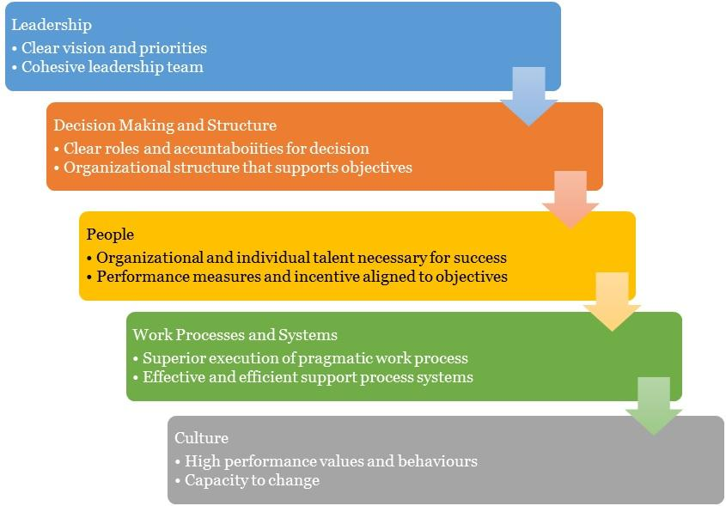

4.1 Organizational Chart

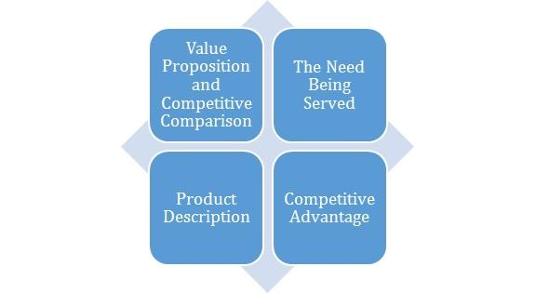

5.0 Value Proposition and Competitive Comparison

Value Proposition
At AC Insurance., we understand that the core of our businesses is centred on people, and this is the paradigm that inspires our entire processes and structures. We promise to make our clients experience more with our brand as we provide superior dog grooming care at a cost-effective rate.
In a more measurable outline, here’s our value proposition and market reach:
- Provide the best car insurance services within ____Target location___.
- Scale up the operations and expand the car insurance business into other locations and services.
- Ensure maximum profit for our shareholders using effective and efficient strategies in the markets that we operate in.

5.1 Service/Product Offering
Our area of concentration includes:
- Gold Car Insurance Packages (which covers a wide range of repairs, servicing et. al)
- Silver Insurance Packages (limited to a number of repairs and servicing)
- Bronze Insurance Packages (covers basic auto servicing)
- General Insurance Consultations

Service Description

In ………. District, US, AC Insurance offers professional and affordable car insurance. We take satisfaction in the fact that for more than ___ years, we have worked with our clients to identify the greatest coverage at a cost that meets their requirements. Our clients are aware that we are there to offer assistance and advice in the case of a claim in order to achieve a quick and efficient claim settlement.

We issue binders, new policies, endorsements, and handle renewals much like other independent brokers.

To ensure that the right coverage is in place, we have emphasized to our insureds the value of effective communication between the broker and customer. And as our clients gain more knowledge about insurance, we have seen a significant rise in the number of clients who want in-depth discussions about the polices of their auto coverage and how they may get the most out of their insurance.

5.2 Competitive Advantage
AC Insurance stands apart from the competition because of its position as a strategic ally to its clients. By establishing a foundation for success on the backs of loyal customers, we fortify our company against potential rivals. The longer we work with a client, the more we educate them on the value of our services.
Our second competitive edge comes from the breadth and depth of our offerings and our talented workforce. We're one of the only companies to keep our doors open six days a week. Our larger team means that we can continue to provide excellent service to our customers even when their assigned broker is out of the office on inspections or otherwise preoccupied.

Furthermore, our commercial insurance experts can provide excellent service to, and underwrite coverage for, local businesses. And we have some excellent commercial markets that our rivals can't access.

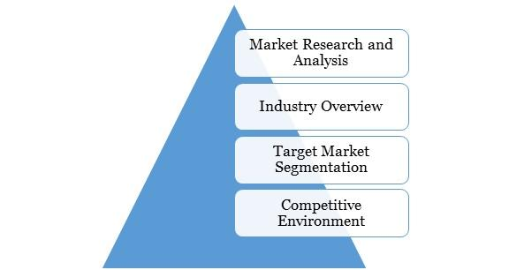

6.0 MARKET RESEARCH AND ANALYSIS

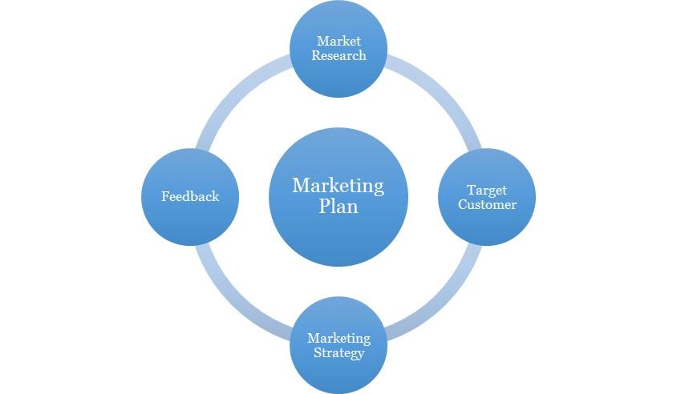

6.1 Market Overview

During the projected period, the US car insurance market is anticipated to expand at a CAGR of almost 3%.

According to sources, the net premiums collected by the US insurance industry in 2018 totaled USD 1.22 trillion, with 51% of those premiums coming from non-life insurers and 49% from life insurers. In 2018, USD 618 billion in net non-life premiums were written overall. The autonomous vehicle (AV) revolution is anticipated to bring about a fundamental transition from personal ownership to shared mobility, which will have a substantial impact on the car industry. This fundamental restructuring of the auto industry will undoubtedly have a significant impact on a number of other industries, including supply chain management, insurance, and infrastructure and urban planning. Non-life insurers have concentrated on innovation and disruption to manage the low-growth, low-profit market.

They have shown a keen interest in recent technological advancements like telematics, the Internet of Things (IoT), and blockchain.

Target Market
AC Insurance is based in ……., US which houses approximately 20 million residents, our focus is two distinct market segments:
- Adults: People between the ages of 27 and 39 who care about the general performance of their cars and how they look. This group can be further broken down into high- income and middle-income men and women who each make more than $45,000 a year.
- Seniors: This group thinks that going to the car repair workshops is a safe way to improve their car performance. Seniors usually use more than $50,000 a year from their savings to live on. Almost everyone in this group is retired, so most of their day is spent doing things for fun.
Other target groups include government establishments and financial institutions.
Our geographical focus at the moment is …………, US. In the next phase, our target groups would include …………., US. The ……… region houses a population of over two (2) million. AC Insurance only requires a minimum of 0.01 percent of this population to break even on a daily basis.

6.3 Competitive Environment
The industry, with respect to this service niche is relatively green. There are top and thriving car insurance companies in the US, with strategic locations in …………. Some of them are listed below;
- ……………..
- ……………..
- ……………..
- ……………...
- ………………
- ……………..

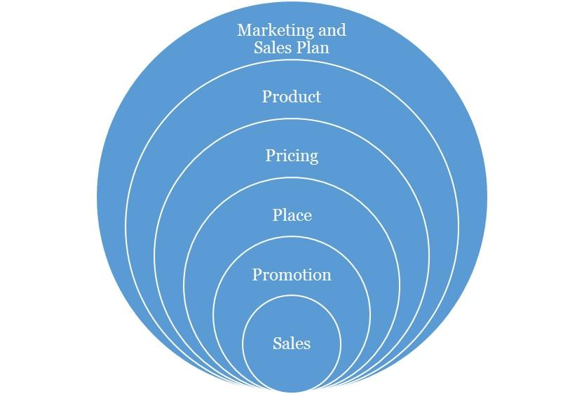

Marketing and Sales Plan

Concerning our marketing, we will execute a comprehensive strategy that is centred on the 4P’s of marketing (this refers to Product, Pricing, Place and Promotions) which are fundamental to any campaign. Each aspect is discussed as follows:

7.1 Product
We have developed relevant products that are tailored for the customer segments that have been identified. These will cut across the core aspects of our service offering.

7.2 Pricing
The pricing strategy to be adopted will be a combination of the cost-plus pricing and competition-based pricing. This entails fixing prices for the services that ensures that production costs are covered and a fair profit margin is realised from sales. However, in selecting this price points, consideration will be given to the prices offered by competitors in the industry. We are high end as shown in the services we provide, but more affordable than the average ones. This will ensure that we do not price ourselves out of the market. And as we progress, our brand growth and imagery will become a factor to our pricing.

7.3 Place
We seek locations that puts us in a comfortable uncontested niche that will help ensure we can capture the clients in the vicinity and retain them. Our physical location and place aim to strike a balance between brand exposures, awareness, achieving maximum accessibility to clients, while keeping costs low.

As the business grows and expands, subsequently, we will explore the possibility of establishing AC Insurance in other large cities across the US where potential clients are identified to be situated.

7.4 Promotions
In terms of promotion, we will implement an awareness process engineering aimed at market activation, customer acquisition and retention strategy. Our promotions will be hinged on creating awareness and deals from the quality of our service offering, the experience, cost and time effectiveness etc. We will employ innovative product and service promotion techniques to acquire customers.

Types of Promotion and Explanation
Advertising | As an SME, AC Insurance will minimize its exposure to Above The Line advertising with exceptions to major events, but will engage in Below The Line and Through The Line Advertising.  The Above The Line (ATL) advertising includes the following; mass media, large format printing, electronic broadcasts and it’s for building brand awareness and goodwill.  The Below The Line (BTL) includes the following; industry magazine, newsletters, social media and google AdWords.  AC Insurance will invest resources and promote using BTL with a focus on social media and an active blog in targeting specific clients and to build an awareness. Social media unlike traditional media provides insights and analytics to measure pubic interaction and a quicker ROI.
Public Relations | Consistency, good clients’ relationship and excellent service will grow the brand’s recognition and increase its market share and sustain growth. We will also continually share our core values and brand promises with the public, with the aim of making AC Insurance synonymous with high-end car insurance service.  We will also maintain close relationship with our clients for feedback, as well as with our vendors in clusters, alliances and complementary organizations.  The art of a good public relations is not only to obtain favourable publicity within the community, but to raise and keep the awareness within the vicinity. It also involves being able to handle attention, support and feedback.
Sales Promotion | We will create strategies targeted to our client segments and make available promotions and referral bonus to increase sales. We trust we will keep these clients with our excellent service and through our value-added service creating loyalty.
Internet Marketing | We will promote and sell our service over the internet such as our interactive website, active blog, social media handles, affiliate marketing and sponsoring across popular blogs and social media influencers.

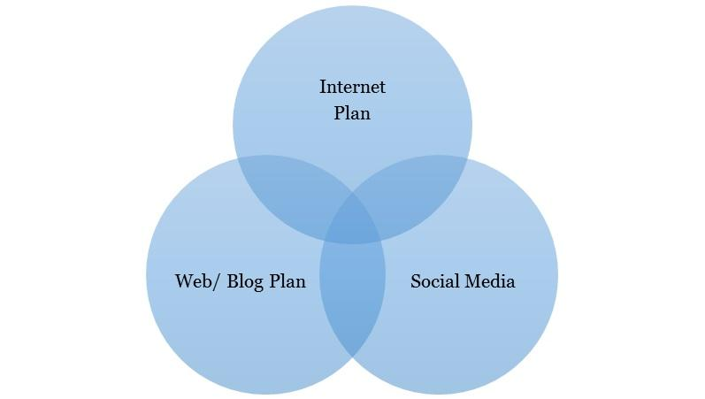

8.0 Internet Plan

The internet is here to stay and any business not positioned towards this trend will most likely be disrupted from within the industry. Internet plan is not limited to a website alone as this is one of the many platforms that should be maximized for business purposes.

8.1 Web/Blog Plan
Our website will serve as a source of information for online visitors and our strategy is to optimize the use of search engine optimization and search engine marketing (SEO/SEM), and the development of editorial content. This simple strategy will easily position the brand as a maven within this segment of the industry. AC Insurance will evaluate and also include on-demand capabilities into its business model.

The site will be developed so that users can see everything they need "above the fold." We will also give tips and insights to effective car maintenance on the blog section as an added advantage for visiting our website.

The overall strategy of the website will be to provide a clear and simple architecture that allows the user obtain all the information they need, simply and easily.

Website Marketing Strategy
The website will be integral in AC Insurance’s marketing effort as the site is a key sales tool for both local and distant customers. The URL address will always be used in promotional material, encouraging people to check out the company and product offering. In addition to the inclusion in traditional marketing campaigns, AC Insurance will submit its website to a variety of search engines, significantly increasing the number of inquiries from people searching our services.

Development Requirement
A computer programmer/designer will be employed with the tasks to manage the design, implementation, and maintenance of the website. The majority of the tasks will be completed by him/her; a few tasks that are outside of his/her skill set will be subcontracted to associates

8.2 Social Media Plan
Objectives:
- To increase the AC Insurance brand awareness
- To build close rapport with potential and existing market
- Position the AC Insurance brand as the maven within the industry
- Increase two-way communication with current and prospective clients.

Understanding the Different Social Media Platform
Platforms | Unique Features
Facebook | A social networking site that allows you have conversations with customers, post photos and videos, promote special offers, and more.  - Over 2 billion users.  - The face book audience is general and wide ranged.
Instagram | An online visual sharing platform for you to share moments, products and services with customers.  - It has over 700 million users.  - Instagram accommodates posts in form of audio visuals and pictures.
Twitter | A 'micro-blogging' service that allows you send and receive short messages from customers and potential customers.  - Often used to promote cause and beliefs using hashtags  - The twitter audience is a mixture of socialites and intellectuals with a knack for sarcasm  - It has about 330 million users globally
Blog | Designed to accommodate well laid out thoughts in form of articles. An ideal blog post can contain up to 500 words and must be well written to ensure flow and readability. The use of images are encouraged too.  The aim of the blog post is to create content that:  - Share and promote the company core values with the public.  - Create content that is targeted towards selling of the company’s product/service.

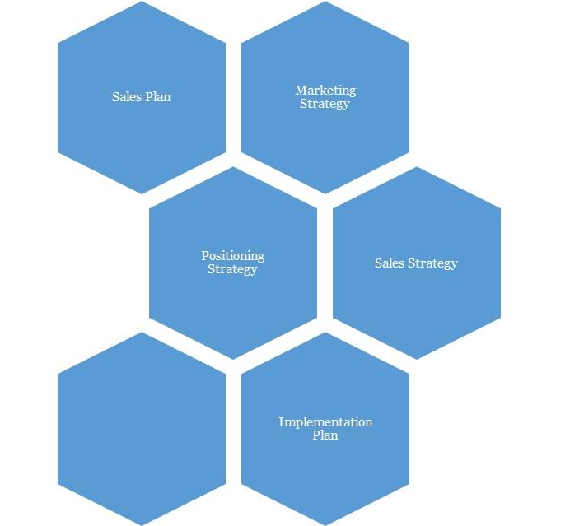

9.0 Strategy and Implementation Summary

We at AC Insurance recognize the importance of marketing and promoting our service as a factor to business growth and success. And to that end, we plan to promote our retail business with an ambitious, targeted marketing campaign. Our goal is to keep our marketing budget to no more than 5% of our gross annual sales.

9.1 Marketing and Sales Plan
AC Insurance will activate the following market plans to boost brand visibility and acceptance as well as grow engagement:
- Define our central ideology is essential.
- Create prominence on social media. This is just beyond posts and likes, but engagement techniques too. This may require a social media content plan.
- Define AC Insurance’s set of brand promises clearly

AC Insurance will also activate the following plans:
- Create a Partnership for Insurance: The client does not want to look for a new broker yearly. Focus on creating long-lasting relationships with our clients and teach both the client and our team the benefits of doing so.
- Focus on target markets: Instead of letting potential customers choose us, which can lead to our brokerage drawing problematic consumers from other brokers, we must concentrate on personal and business clients whom we find and choose to insure.

9.2 Marketing Strategy:
AC Insurance will rely on the following strategies to grow its client base. The first is through effective brand activation, powerful, striking and consistent PR practice. Aggressive marketing with emphasis on its quality service experience and superior customer service as well as non-stereotypical public relations through its spin off projects. Customers will be blown away with the level of service and value that they receive.

AC Insurance will also be leveraging on the wide range of options it could offer apart from its core services.

And lastly, AC Insurance will use a lot of bait for referral, freebies (gift packs and packages that help advertise its brand), happy hours where the costs are cheaper and incentives especially in the early stages, in order to build a large and loyal client base.

9.3 Promotion Pattern
At AC Insurance, our promotional strategy will be based on maximizing technology and new media through the internet and our cluster group alliances. But most importantly, an exponential referral scheme.

Advertising:
- We will utilize the social magazines, cinemas, and top executive conferences and seminars with our exclusive services.
- We will have a comprehensive website with full interactivity. We will also make use of the social networks to promote and drive traffic to what we do.

Also, we will love to work with PR/Advertising Stakeholders. These refer to the sales influencers. They include:
Blogs: Blogging has become very popular now in US and is one of the most popular means of brand/product promotion. The question we hope to constantly ask and answer the question, “How Can AC Insurance maximize the platform of blogging to create awareness in a less typical way”?

9.4 Distribution Strategy
One of our distribution channels will be focused on the use of alliances;
- We will place our brochure within the offices of our corporate referral clients. We will also be giving commissions to clients who refer us to others.
- We will work on building a database of all the top executives of banks, IT firms and other offices around a 50metre radius and to try to create an alliance with them.
- In addition, we will forge alliances with businesses that will be strategically beneficial for generating new clients.

9.5 Positioning Strategy
In terms of positioning, we would be applying a marketing warfare concept where we choose to apply four different methodologies depending on the market dynamics. These methodologies are listed below as:
- Defensive: Defensive strategy would be applied when we are sure to be the market leaders.
- Offensive: Offensive strategy would be applied when we are sure to be the strong challenger.
- Flanking: Flank strategy would be applied when we are sure to be the weaker challenger.
- Guerrilla: Guerrilla strategy would only be applied when we are sure to be struggling for survival and want to avoid being crushed by the bigger competitors.

We believe that marketing is all about positioning, and we being able to identify our position and applying the right strategy. At this point it is interesting to note that our marketing program is not just about customers, but about gaining, for ourselves, a noticeable proportion of the total available market share or its segment being occupied.

9.6 Pricing Strategy
As we progressively penetrate the market, our fees will come with discounts yet it would retain a competitive positioning as much as possible. But as we gain larger brand equity, we will add more value-added services that will justify an increase in our prices when we ever see the need to do so. However, it is important to note that while competition enables a healthy business atmosphere, we aim to build an iconic brand that makes the competition feel irrelevant by continuously perfecting and offering more value-added service to all of our clients. We will not charge over, nor substantially under, rather will we be charging standard prices in line with quality for our services just as our contemporaries in do.

10.0 SALES PLAN

10.1 Sales Strategy
The sales function will be driven by our in-house sales unit. The unit will be responsible for lead generation and management. This will be required to meet sales targets that will be set on a weekly basis. The sales unit will be headed by the manager and the CEO will be kept abreast. Both of them will be responsible for coordinating all sales activities and delivering on sales.

10.2 Sales Programs
- Our comprehensive brochure will explain the nature of our services, and how this benefits our clients. It will be able to paint a vivid picture of who we are, what we offer and where we are going.
- Our website and social media will be comprehensively informative, updated weekly of our services, latest car maintenance techniques as well as tips. Additionally, we will have pages on social networks to always create traffic to AC Insurance.

Sales Projections
N.B: Check the Sales breakdown sheets on the financial model for more information

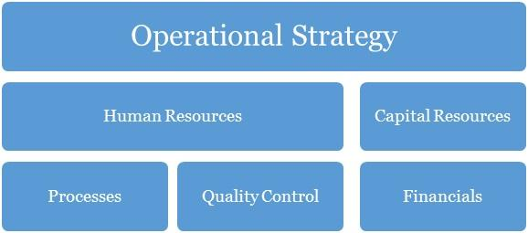

11.0 Operational Strategy

Operation strategy in any business organization is essentially about how the organization seeks to subsist and flourish within the environment over the long-term. The decisions and actions taken within its operations have a direct impact on the basis for which the organization is able to operate. The way in which AC Insurance secures, deploys and utilizes resources will determine the extent to which we can successfully pursue our specific performance objectives. Our operations are built on our core values of professionalism, empathy, resourcefulness, continuous improvement.

Further ahead in this growth process, in whatever we do, we will consider the concept of collaboration too as a major step necessary for effective business management. It is the role of management to know what is of topmost priority to their organization and to their business. And then concentrate more on that core. Our business will as much as it can encourage new and upcoming small medium businesses which provide a service within our need base to step up to the challenge of being the best through their affiliations with AC Insurance.

12.0 Human Resources

There has to be a well-defined corporate culture with an immersion process for all of its human resources. This starts off as an on boarding process for new entrants, and then a constant reminder as they stay in the organization (trainings, review, test and appraisals, KSS (knowledge Sharing Sessions) with each of this, having an injection of the DNA of the brand’s core values reminded into them.

This section of AC Insurance’s processes is one that identifies the current and future human resource needs for our organization to achieve its projected goals as listed in our mission and vision statements. It would serve as the link between our management and the overall strategic plan of our organization.

Human resources management and development is a core issue and is hinged on professionalism and productivity. A high premium is placed on our most valued assets, the men and women who would make the AC Insurance service household brand in the US and most especially beyond. Our human capital base is made up of people from diverse professional, ethnic, tribal and cultural backgrounds, who exhibit high level of business ethics, are performance driven, result-oriented, ambitious, team players and conform to the company’s standards and core values.

Our employee policies will include:
- Weekly management meetings
- Monthly employee meetings
- On-going training
- Performance reviews every six months
- Performance incentives
- Encouragement of creativity
- Financial Plan

At AC Insurance, we understand and partner with employees individually and collectively to support them in meeting their unique aspirations and needs by training, developing, motivating, providing professionally challenging jobs to help them attain self-discovery, fulfilment and contribute to the achievement of our corporate objectives.

The goal at AC Insurance is to have a team of committed associates who empower each other so that the customer's expectations can be exceeded. Our goal is to offer career opportunities, advancement opportunities and a level of income and benefits that is competitive within the region and job classification. It is our long-term goal to be the preferred employer within our niche market.

13.0 Quality Control

Quality control here refers to the standards and mode of operation and delivery of value within the organization. This should be defined in the structure so much that all products delivered should be exact with the intended work with no variations at all. To achieve this, there has to be checks, balances and predefined structures to ensure minimal variation from scope, deliverables and quality. This should be in the designation and job description of a Quality Control Officer. This is perhaps the most important work role in the organization.

Quality Control Plan
Our company’s quality control team will monitor and audit every stage of value creation and delivery. The manager will be in charge of analysing quality work done and even the materials supplied by vendors; he is expected to identify any inadequacies that would affect the brand. Indeed, these personnel will be fully authorized to enforce whatever corrective measures may be necessary (including shutting down service or recalling garments) so as to maintain the company’s reputation for excellence.

14.0 Processes

Operational processes are vital to solving problems and tasks while managing the day-to-day issues associated with the engagement, development, management and interaction of people, techniques, businesses and systems. Without a stable foundation of corporate operational processes, organizations devote their management efforts to managing problems in this area, thereby generally failing to achieve the efficiency and effectiveness as well as the confidence, trust and support of staff i.e. the cornerstone to being able to win and grow.

With a thorough understanding of our business operations, we can categorize our entire business processes into the following main aspects including:
  - Management processes
  - Core Business processes
  - Supporting Processes
  - Collaboration
  - Automation

15.0 Financials

The basis for our financial planning has been looking forward with conservative estimates for revenue and expenses. We are committed to consistently growing our cash balances through the prudent management of our expenses. Our focus will be on remaining profitable year after year, while also building adequate cash reserves.

Capital Requirements
In order to expand our business as desired, we require about 54,691 Dollars to support the already tangible investments made into the business. The capital requested would be used to incur the following expenses.
Capital Requirements
 | Amount
Capital Expenditure | 33, 423
Operating Expenses (6 months) | 20,268
Other Required Items | 1,000
 | 54, 691

Financial Viability
The main criterium for establishing the company is that it achieves financial viability both in the short and long term. Shareholders must be rewarded for the risks that they are assuming by investing in the company through the payment of regular dividends within specified parameters of prudent business requirements.
The company must satisfy customers but at the same time take cognizance of the fact that it may cost more to satisfy some needs than any customers are willing to pay. Or it may be much more costly to try to attract new customers than it is to build a strong relationship with-and repeat purchases from- existing customers. So, profit – the difference between the firm’s revenue and its total costs – is the bottom-line measure of our success and ability to survive. The management team will ensure that there is a balancing point that helps it to determine the needs it will try to satisfy.
Aggressive financial targets have been set for AC Insurance to achieve on an annual basis. These targets are the key focus of the company, without compromising quality of service delivery, and includes a return on stakeholders’ funds.

Break-Even Analysis
Gross Margin % of Sales
Gross Margin | $ 117,480.00
Total Sales | $ 228,600.00
Gross Margin/Total Sales | 51.4%
Total Fixed Expenses
Payroll | $ 22,703.76
Operating Expenses | $ 40,545.71
Operating + Payroll | $ 63,249.47
Breakeven Sales in Dollars(Annual)
Gross Margin % of Sales | 51.4%
Total Fixed Expenses | $ 63,249.47
Yearly Breakeven Amount | $ 123,074.81
Monthly Breakeven Amount | $ 10,256.23

PLEASE SEE EXCEL SHEET ATTACHED IN A SEPERATE DOCUMENT

IMPORTANT ASSUMPTIONS
The financial plan depends on important assumptions, most of which are shown in the following table. The key underlying assumptions are:
- We assume a slow-growth economy, without major recession in the following years.
- We assume that there are no unforeseen changes in federal grant funding availability.
- We assume a continued need for our products in the market.
General Assumptions
Inflation Rate | -
Cost Escalator | 10%
Tax Rate | 32%
Dividend Pay-out Ratio | 0%

16.0 EXIT PLAN AND STRATEGY

No one attempts a business with the anticipation of failure. However sometimes ventures do not fulfil their promise. We at AC Insurance are committed to our concept and its viability. In the event that our venture cannot achieve profitability and retire the encumbrances the promoter or investors in the business have several exits scenario options subject to the prevailing conditions and circumstances at the time. These could include any of the following:

SCENARIO I (Promote Staff):
Promotion of its staffs to partnership based on performance, dedication, skills and years of service – this should be considered in the long run.

SCENARIO II (Sell/divest stock):
A promoter or investor looking to exit the business can sell equity to other interested investors. The sellers can choose to sell all or part of their equity.

SCENARIO III (Initial Public Offering):
The company can also break up some of its products into separate entities as it grows large enough. But it is most likely, that sometimes soon; it may go public and will aim to be quoted in the Stock Exchange.

SCENARIO IV (Default):
If we are unable to sell the operation for sufficient proceeds, we will be forced to default whereby the loans acquired will be in senior standing. Any further outstanding balances will be borne by the equity share owners of the business on a weighted percentage based on the total amounts due in bankruptcy proceedings.

17.0 Plan Improvement
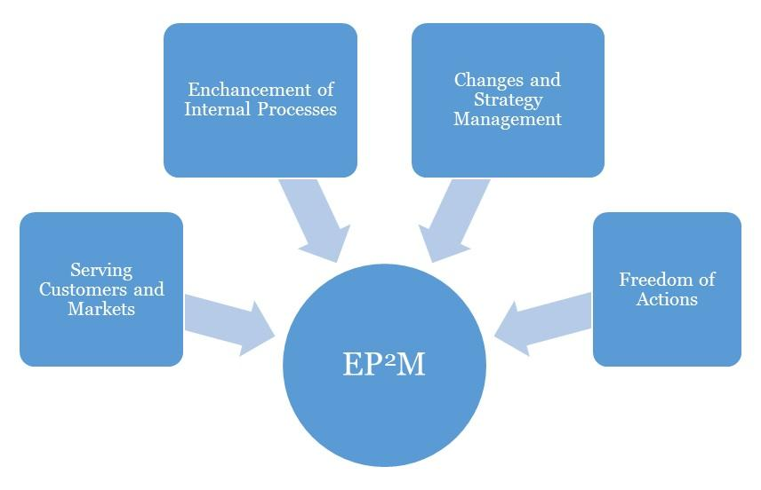
Effective Progress and Performance Measurement

Performance Measurement
This business plan's performance should be assessed against its effectiveness in achieving its high priority goals and performance targets. Occasionally, three (3) months interval should be advised for AC Insurance business.
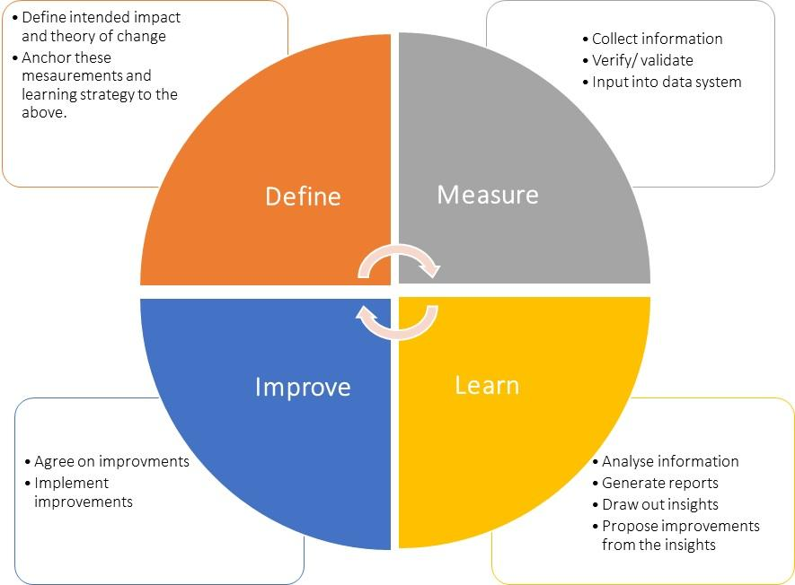

Plan Review and Up Date
To ensure your business plan continues to provide a sharp focus and remain responsive to change, it should be formally reviewed and updated every six months, at the achievement of a strategic goal and at any other time deemed necessary. Implementation of this plan is to be a fixed agenda item at meetings of AC Insurance’s Board of Directors.

