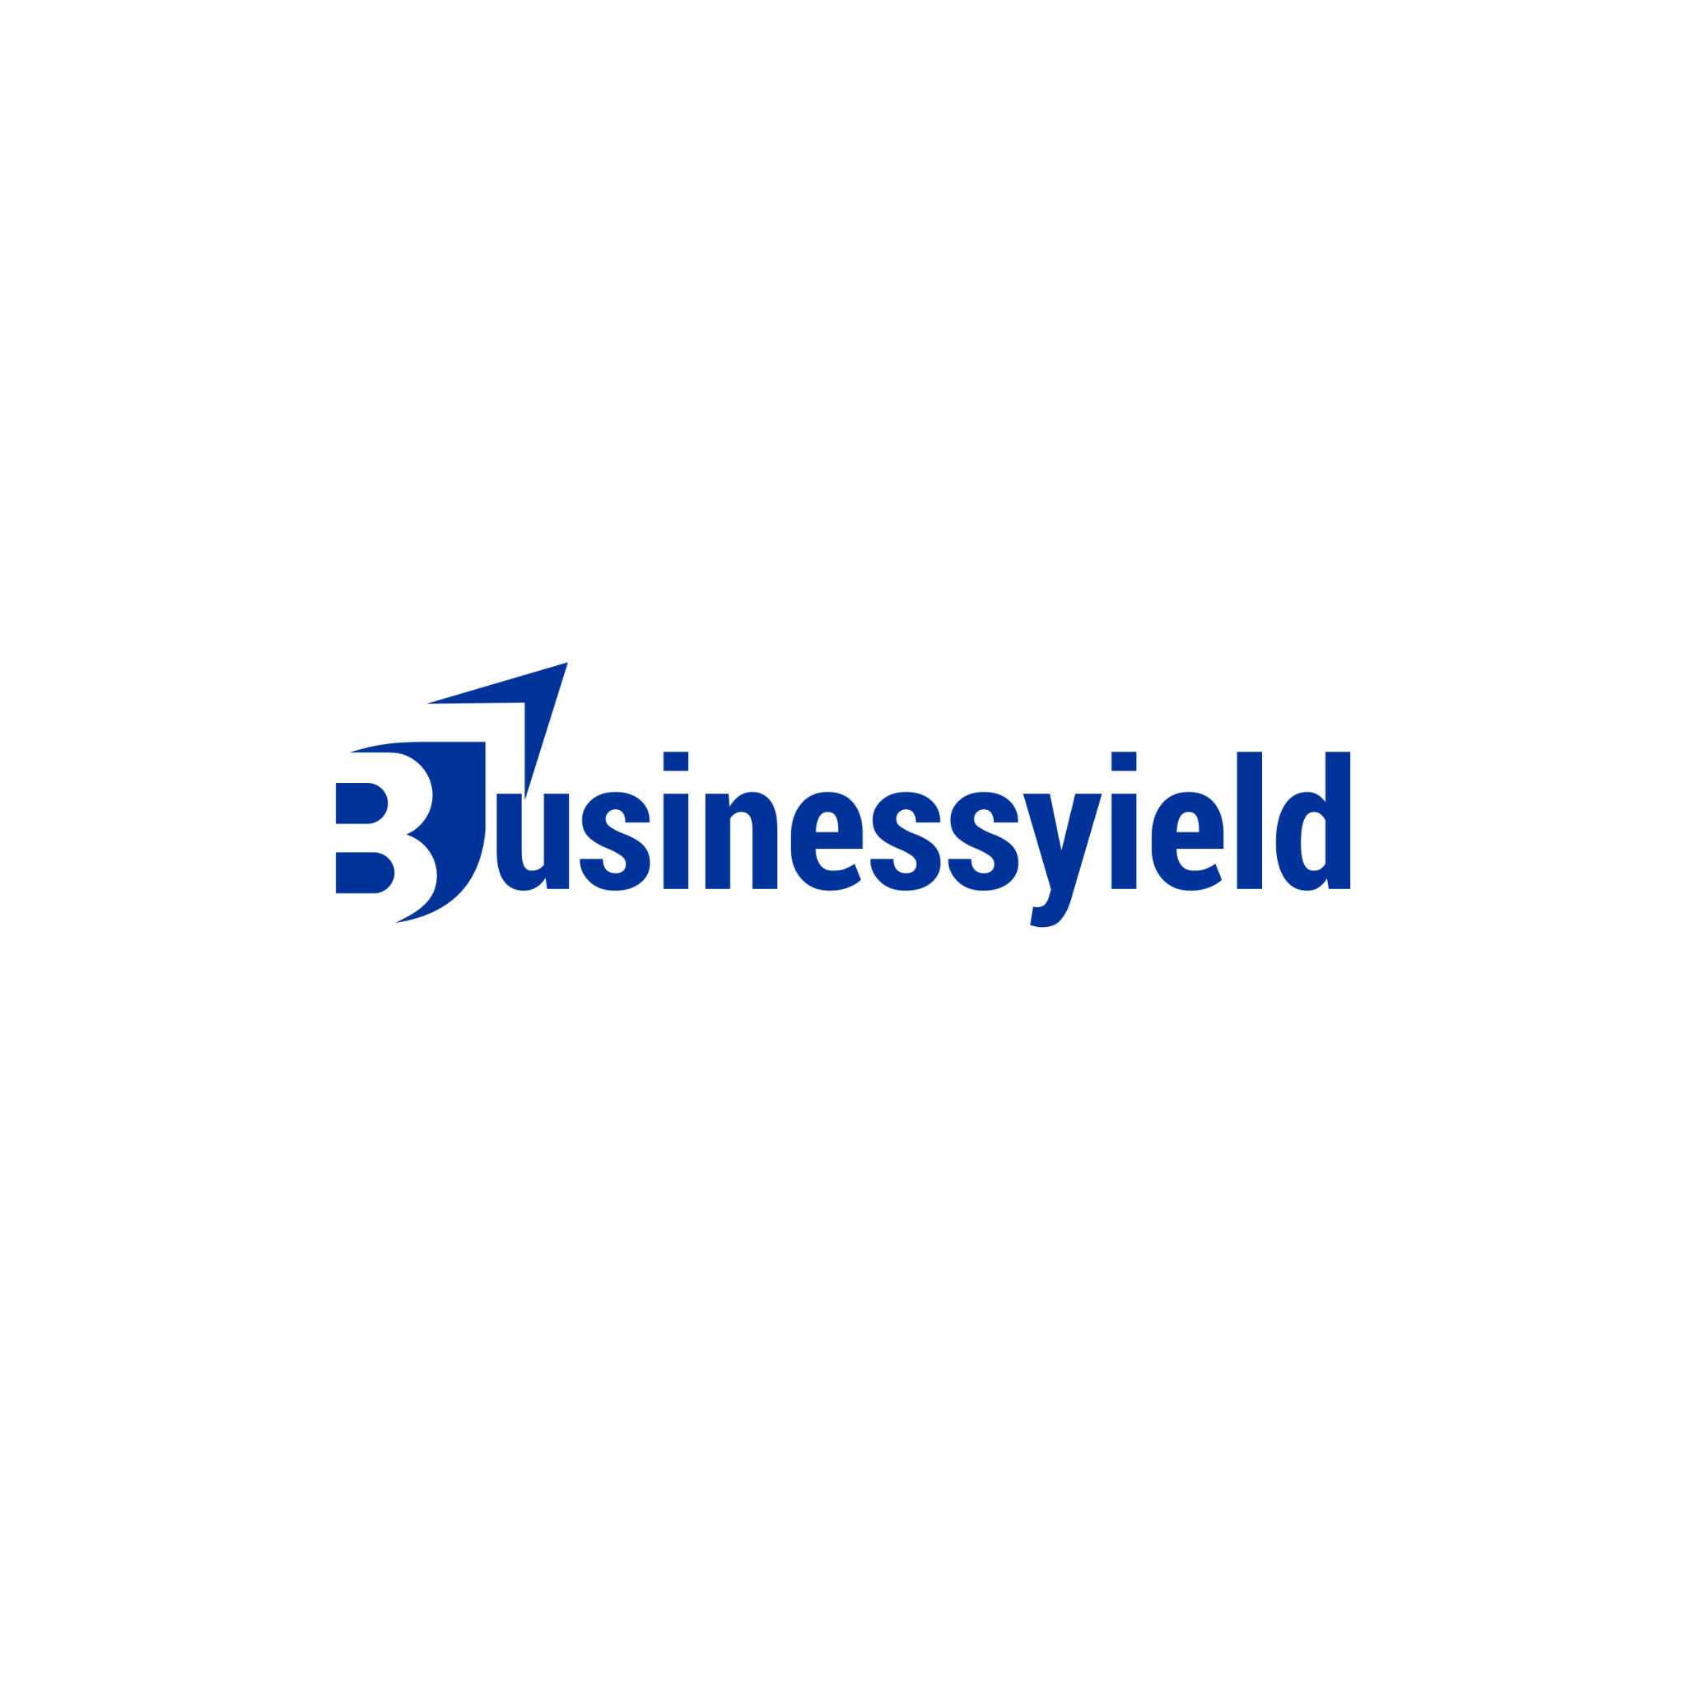
Here's a checklist outlining how native advertising has gained recognition in the business world and how it can benefit business owners:

- Increased Popularity: Native advertising has gained recognition due to its effectiveness in blending seamlessly with the surrounding content, making it less disruptive to the user experience compared to traditional ads.
- Content Integration: Native ads are integrated into the platform's content, matching the form and function of the surrounding media. This integration enhances engagement and encourages interaction.
- Enhanced Engagement: By aligning with the platform's style and tone, native ads tend to generate higher engagement rates compared to traditional banner ads. Users are more likely to interact with content that feels native to the platform they are using.
- Improved Credibility: Native ads often appear alongside trusted content, which can enhance credibility and trustworthiness for the advertiser. This association with reputable content can positively influence consumer perception.
- Targeted Reach: Native advertising platforms often offer advanced targeting options, allowing advertisers to reach specific demographics, interests, and behaviors. This precision targeting increases the likelihood of reaching the right audience with relevant content.
- Seamless User Experience: Unlike traditional ads that can interrupt the user experience, native ads seamlessly blend into the content flow, providing a non-disruptive advertising experience. This approach reduces ad fatigue and improves overall user satisfaction.
- Mobile Optimization: With the growing use of mobile devices, native advertising offers a responsive and mobile-friendly advertising solution. Ad formats are optimized for various screen sizes and devices, ensuring a consistent user experience across platforms.
- Measurable Results: Native advertising platforms often provide detailed analytics and performance metrics, allowing advertisers to track the effectiveness of their campaigns in real time. This data-driven approach enables businesses to optimize their strategies for better results.
- Brand Awareness and Loyalty: Native ads can help businesses build brand awareness and loyalty by delivering valuable and relevant content to target audiences. By providing informative or entertaining content, businesses can establish themselves as industry leaders and foster stronger connections with consumers.
- Cost-Effective: While native advertising may require an initial investment, its effectiveness in reaching and engaging target audiences can result in a higher return on investment (ROI) compared to traditional advertising methods.

By leveraging the power of native advertising, business owners can enhance their marketing efforts, reach more qualified leads, and ultimately drive business growth.

