BusinessYield Consult
SPA Business Plan US

Table of Contents
1.0 EXECUTIVE SUMMARY 3
Capital Needs 4
1.1 Our Vision 5
1.2 Our Mission 5
1.3 Our Core Values 5
1.4 Keys to Success 5
1.5 Objectives: 6
2.0 COMPANY SUMMARY 7
2.1 Business Description 7
2.2 Milestones to date 8
3.0 OWNERSHIP AND MANAGEMENT 11
3.1 Management Background 11
3.2 Management Summary 12
3.3 Business Model Canvas 13
3.4 Personal Plan 14
4.0 ORGANIZATIONAL STRUCTURE 15
4.1 Organizational Chart 15
5.0 Value Proposition and Competitive Comparison 16
Value Proposition 16
5.1 Service/Product Offering 16
5.2 Competitive Advantage 17
6.0 MARKET RESEARCH AND ANALYSIS 19
6.1 Market Overview 19
Economic, Social and Technological Factors 20
6.2 Target Market 20
6.3 Competitive Environment 22
7.0 Marketing and Sales Plan 23
7.1 Product 23
7.2 Pricing 23
7.3 Place 24
7.4 Promotions 24
8.0 Internet Plan 26
8.1 Web/Blog Plan 26
8.2 Social Media Plan 27
9.0 Strategy and Implementation Summary 29
9.1 Marketing and Sales Plan 29
9.2 Marketing Strategy: 30
9.3 Promotion Pattern 31
9.4 Distribution Strategy 31
9.5 Positioning Strategy 32
9.6 Pricing Strategy 32
10.0 SALES PLAN 33
10.1 Sales Strategy 33
Sales Projections 33
11.0 Operational Strategy 34
12.0 Human Resources 35
13.0 Quality Control 37
Quality Control Plan 37
14.0 Processes 38
15.0 Financials 39
Capital Requirements 39
Financial Viability 39
Break-Even Analysis 40
16.0 EXIT PLAN AND STRATEGY 42
17.0 Plan Improvement 43
Performance Measurement 43
Plan Review and Up to Date 44

1.0 EXECUTIVE SUMMARY
[Company Name] is a new upscale business in [Enter Business Location], just outside of [Business Region]. It promises a complete day spa experience. Our massage styles are unparalleled, as we only provide the best. A few examples include: traditional Swedish Massage, Hot Stone Massage, Deep Tissue work, Pregnancy, Sports, and Reflexology.

We also offer excellent facial and body treatments. We have the most recent anti-aging products and techniques to effectively meet the needs of our clients. In fact, we are strategically located near a hair and nail salon in order to attract clients who are also in need of spa services.

We have a posh and classy environment that can entice anyone to come and experience what it is like to run an ultra-chic spa. Furthermore, we have gifts for every customer who visits us. Our Spa will be open from 8 a.m. to 10 p.m. Monday through Thursday, and will be open 24 hours a day Friday through Sunday.

We chose this format because our market research and feasibility studies revealed that customers have the most flexible time schedules on weekends. It is important to note that we have the best DJs in the house every day of the week, who have been trained to serenade customers while they are being serviced.

[Company Name] has well-trained employees who know how to give clients the best service possible. It's no surprise that our mantra at our [Company Name] is "customers first." Because our products are mostly organic, customers can be confident that they will not experience any adverse effects on their skin.

One of the things that most clients look for in a spa is the level of coziness; as a result, we have done adequate research in that area, which is why we have spent quite a bit of money in making our Spa really beautiful and conducive. Our state-of-the-art facility in [Enter Business Name] is so appealing that people in need of our services can't help but walk in because we use cutting-edge technology.

Our excellent customer service is second to none, and we have thoroughly trained our employees to understand that the customer is king in this business.

Capital Needs
[Company Name] Ltd will run at an assumed sales profit of $276,864 in its next year of expansion, with a profit after tax of $94,539 and a consistent progression for the future years. The chart below explains our projections:

(All figures shown in the graphs are in $’000)

Our marketing strategy will demand we often patronize our competitors in other to make our service delivery most excellent and the best in our market sphere. We would also include the use of both flank and guerrilla type of marketing attack to topple larger brands by offering unique service and experiences at competitive prices that are being ignored by larger brands. We will also include online marketing with a great focus on social media and an active blog to position our brand as the industry leader with our regular contents.

1.1 Our Vision
Our vision at [Company Name] is to become the market leader at providing excellent Spa service care through innovation and at a cost-effective rate in the country by the year 2025.

1.2 Our Mission
Our mission at [Company Name] is to always deliver excellent Spa care services at the most effective and efficient means possible through the use of technology and exceptional customer service.

1.3 Our Core Values
The following core values drive our operations, products and team.
A. Quality
B. Integrity
C. Excellent Service Delivery
D. Efficiency
E. Extra Value-Driven Professionalism
F. Innovation

1.4 Keys to Success
[Company Name]’s enviable success is achieved through offering convenience, personalization and efficiency respectively.
Convenience: With bigger Spa brands, anyone can be lost as just a number. At [Company Name], we hope to provide a more up close, personalized and customized delivery. This will be aided through the use of technology, perhaps an online portal where our services can conveniently be accessed from anywhere and at any time. We are surely poised to delivering this.
Efficacious Publicity: Our publicity strategy is to consciously position our brand as a maven within the industry by affiliating with complementary corporate and luxury brands. Our campaigns and publicity will include online visibility such as social media engagement and an interactive website supported with an active blog as well as prints and referral in reaching our potential clients.
Referral System: Also, a strong referral system is essential as we will reward refer
Brand and Reputation: The business and brand model is aimed at delivering decisive advantage both to the individual mind and to the market place. Our brand feel and experience will go beyond the basic service that we offer but will include other value-added services such as convenience, excellent customer experience, and trust that creates loyalty to the brand. Our brand strategy will be geared towards an abstract feel of superior experience with [Company Name].

1.5 Objectives:
In a more quantifiable outline, we hope to achieve the following:
1. Predefine a series of brand promises we must keep. This will be more like a broadcasted accord of threshold we will never fall short off.
2. To create a service-based company whose goal is to exceed customers expectation while creating hype moments (neuropsychologically exciting experiences) and moments worth returning to.
3. To have clientele retention and return rate of near 90% year on year.
4. To increase the number of clients served by at least 200% per year through superior marketing performance and word-of-mouth referral schemes.

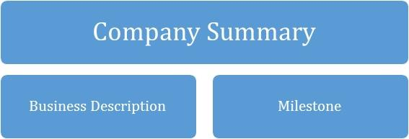

2.0 COMPANY SUMMARY
[Company Name] is a health and client-centric brand focused on providing professional, healthy, medical and beauty Spa services for a wide range of individuals including; busy corporate executives, housewives, business owners, travellers, students etc. We’d lay prominence on the high demand for top-quality and cost-effective Spa services thereby giving our customers the desired results.

In addition, with the invaluable experience garnered over the years and with the support of a seasoned team, tools and technology, [Company Name] will promote positive responses towards what we do, that will convert consumers into customers then into loyalists and eventual evangelists.

What will set [Company Name] apart from the competition is our focus on SPA service innovation through technology and commitment to providing professional, friendly, self-service, prompt, cost-effective, time-effective and most importantly, personalised services.

2.1 Business Description
As a legal entity, the company is registered as [Company Name] limited. We operate from an outlet in [enter location], and we look forward to opening a second outlet at [enter location where you would want to expand to] equipped with a reception to receive customers and interact with them.

We offer seven ultra-chic, ultra-comfortable treatment rooms with the finest spa linens and equipment. We offer massage in a variety of styles – traditional Swedish Massage, Deep Tissue work, Hot Stone Massage, Reflexology, Sports, Pregnancy and others. We also offer facial and body treatments, like a Vitamin C Antioxidant Facial and Pevonia’s Anti-Free Radical Treatment.
Eventually, our services will include a top-notch beauty salon service that caters for a wide range of beauty needs.

2.2 Milestones to date
Type | Status | Timeline
Business Name Availability Check | Completed | [Enter deadline]
Business Incorporation | Completed | [Enter deadline]
Opening of Corporate Bank Accounts various banks in the ____Country Name___ | Completed | [Enter deadline]
Opening Online Payment Platforms | Completed | [Enter deadline]
Application and Obtaining Tax Payer’s ID | In Progress | [Enter deadline]
Application for business license and permit | Completed | [Enter deadline]
Purchase of All form of Insurance for the Business | In Progress | [Enter deadline]
Renting of Office Facility | In Progress | [Enter deadline]
Securing Point of Sales (POS) Machines | Completed | [Enter deadline]
Opening Mobile Money Accounts | Completed | [Enter deadline]
Opening Online Payment Platforms | Completed | [Enter deadline]
Conducting Feasibility Studies | Completed | [Enter deadline]
Start – up Capital Generation | In Progress | [Enter deadline]
Writing of Business Plan | Completed | [Enter deadline]
Drafting of Employee’s Handbook | Completed | [Enter deadline]
Design of The Company’s Logo | In Progress | [Enter deadline]
Graphic Designs and Printing of Packaging Marketing / Promotional Materials | In Progress | [Enter deadline]
Recruitment of employees | In Progress | [Enter deadline]
Purchase of the Needed furniture, office equipment, and electronic appliances | In Progress | [Enter deadline]
Creating Official Website for the Company | In Progress | [Enter deadline]
Creating Awareness for the business (Business PR) | In Progress | [Enter deadline]
Health Safety and Fire Safety Arrangement | Completed | [Enter deadline]
Establishing business relationship with key players in the industry | Completed | [Enter deadline]

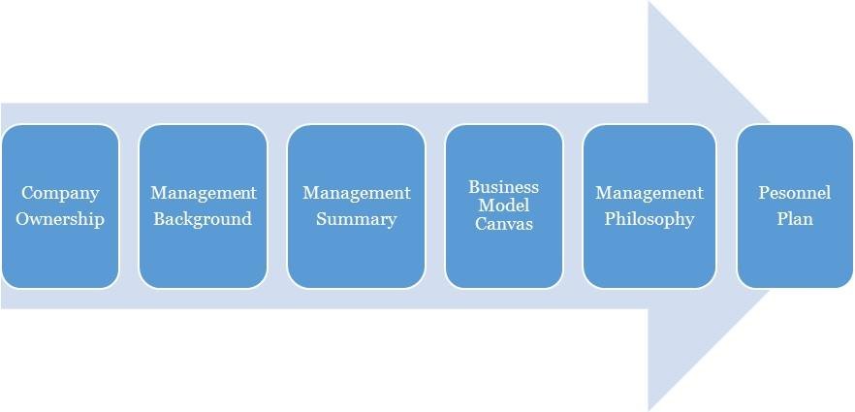

3.0 OWNERSHIP AND MANAGEMENT

[Company Name] is owned by John Doe. The management of [Company Name] is a simple one with the CEO acting as the MD to provide leadership for the organization as well manage operations.

As of [enter date]
Name | Title | No. Of Shares | % Of Ownership
John Doe | CEO |  | 100%
TOTAL |  |  | 100

3.1 Management Background
JOHN DOE:
Mr John Doe is a dynamic and hardworking individual, accustomed to working in fast-paced environments where the focus and objectives are to deliver first-class services; with an amazing track record of experience in Leadership.

He is also the Chief Executive Officer of [Company Name] Dry cleaners LTD, which He started in [Date of Inception] and has been able to lead it through an amazing performance over the course of the last …………. with the goal to expand. Mr John Doe is also a versatile and experienced customer service Advisor and Relationship Management expert.

He holds a Master’s Degree in International Marketing Management from AAA University, Aberdeen, Scotland, and member of Chartered Institute Marketing (CIM), United States and a Bachelor of Science Degree in Accounting from [University Name] US. His training and experiences have also helped him develop his leadership and coaching skills and a strategic viewpoint to every project or endeavour. He also possesses a natural ability to build and maintain valuable professional relationships with clients, vendors and colleagues.

3.2 Management Summary
The management philosophy at [Company Name] will be based on mutual respect for each of our fellow colleagues and for every customer.

Our success will greatly depend on how effective our relationship is with our customer; this is why we will focus on treating our employees’ right and encourage them to treat the customers likewise. Our employees are the face of the brand and will represent the brand when interacting with our client. Customer-friendly employees will increase general client loyalty and repeat business.

The management team will consist of the owner/CEO and the general manager. We will hire only those who demonstrate the qualities necessary for working in a nurturing environment, and the willingness to move forward in the study of energetic principals if not already so trained. We will be hiring the ultimate "people persons."

Employees will be encouraged to work within their creative, physical, and intellectual boundaries. All duties will be divided and delegated according to the strengths and weaknesses of our staff. At [Company Name], we will expect a high degree of customer service skills and personality as this is essential to our success. The management team will assess the productivity and performance evaluations of all employees every two months. These bi-monthly evaluations are conducive to the continued growth of our business.

3.3 Business Model Canvas
Business Model Canvas For [Company Name]
Key Partnerships  - Financial Partners  - Suppliers for Organic Products | Value Propositions  1. Excellence  2. Brand  3. Relationship  4. Customer Service  5. Professionalism | Customer Segments  Business to Business  - Corporate Organizations  - Beauty Salon Businesses  Business to Client  - Busy Corporate Executives  - Housewives  - Business Owners  - Households  - Students
Key Activities  Procurements, a wide range of body treatments, anti-aging treatments, massage services | Key Resources  Equipment, skills, physical location, vehicles, staff | Channels  Direct sales, website, social media, Referrals
 | Customer Relationship  Online, offline, community  Social media, customer support, discounts and promotional | Channels  Direct sales, website, social media, Referrals
Cost Structure  Operational costs: Marketing & ads, logistics, Internet subscription, airtime charges, fuel, maintenance  Utility: electric bills, rents, salaries (skilled labour) etc. |  | Revenue Streams  - Therapeutic Massage Services  - Body Treatments  - Facials  - Anti-aging Treatments

3.4 Personal Plan
[Company Name] is a growing firm and as such staff will be hired according to recommendations, experience and education in their field. High standards will be kept through the orientation and inclusion period for new employees and the new employees will be given a mentor to shadow for the first two (2) weeks of arriving. In so doing, the employees can pick up the ethics of working and representing the [Company Name] brand.

Checklists will be drafted to monitor an employee’s quality of service after three months. Staffing and training will be available for sales representatives and customer service candidates. Every personnel will be given specific assignments and valued on completion of the assignment. One on one meetings will be held to discuss and handle any arising issue regarding performance and service.

4.0 ORGANIZATIONAL STRUCTURE
To have a true value-driven team that would be productive, there is a need to map out what is most important to the organization and the team in order of prioritization. This is to ensure a chain of interrelated entities that will define our organization structure. For [Company Name], the following is a further illustration.
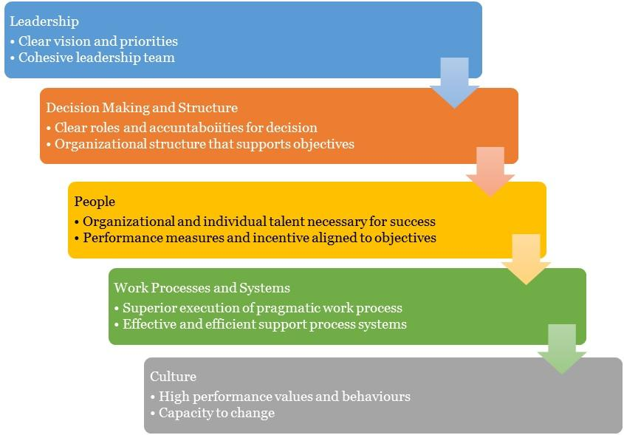

4.1 Organizational Chart

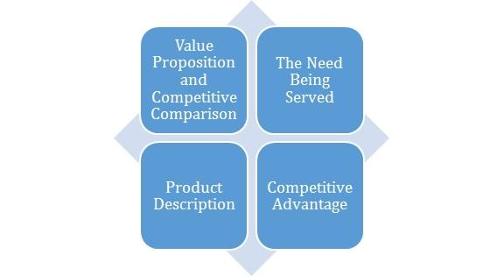

5.0 Value Proposition and Competitive Comparison

Value Proposition
At [Company Name], we understand that the core of our businesses is centred on people, and this is the paradigm that inspires our entire processes and structures. We promise to make our clients experience more with our brand as we provide superior spa care at a cost-effective rate.

In a more measurable outline, here’s our value proposition and market reach:
1. Provide the best of spa service within [Enter Business Location].
2. Scale up the operations and expand the spa business.
3. Ensure maximum profit for our shareholders using effective and efficient strategies in the markets that we operate in.

5.1 Service/Product Offering
Our short-term area of concentration includes:
- Therapeutic Massage Services
- Body Treatments
- Facials
- Anti-aging Treatments

5.2 Competitive Advantage
The spa industry is one of the most competitive sectors in the service industry, with an ever-increasing number of spas offering similar treatments and services. To succeed in this highly competitive market, it is essential for us to develop a unique competitive advantage that sets us apart from our competitors. We have set the following in place to help us dominate the markets effectively:

Unique Services
This will include exclusive treatments that use rare or exotic ingredients or specialized therapies that cater to specific health conditions. By offering something that no other spa offers, including home services when necessary, we will attract customers who are looking for a unique and exclusive experience.

Exceptional Customer Service
Exceptional customer service is essential for any business, but it is particularly important in the spa industry. Customers come to a spa to relax and unwind, and it is our responsibility to ensure that they have a positive experience. By providing personalized attention to each customer and ensuring that they leave feeling relaxed and satisfied with their experience, we will create a loyal customer base that will keep coming back for more.
So, creating a welcoming and comfortable atmosphere, hiring friendly and knowledgeable staff, and offering personalized services are just a few ways that we will provide exceptional customer service.

Location
The location of a spa will also be a significant competitive advantage for us. By choosing a prime location with high visibility, accessibility, and foot traffic, we will attract customers who are looking for a convenient and relaxing experience.
Investing in a spa facility that offers a beautiful and tranquil environment, complete with all the necessary amenities such as private changing rooms, showers, and relaxation areas, will also help us create a unique and memorable spa experience for customers.

Price Point
Finally, offering competitive pricing will be an effective way to create a competitive advantage in the spa industry. By offering lower prices than competitors without sacrificing quality or services, we will attract budget-conscious customers who might not have otherwise considered a spa experience.
Creating package deals or loyalty programs for customers will also help us create a sense of value and encourage repeat business.

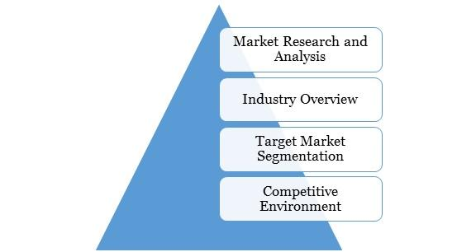

6.0 MARKET RESEARCH AND ANALYSIS

6.1 Market Overview
Working is always required in order to meet the essential requirements of life in the United States. This is because of the high cost of living. There are some people who are required to work nonstop, leaving them with little or no time to focus on their own health and well-being. Because there isn't enough time to take a closer look at how they currently appear, there are some people who do not mind how they currently look at all.

Others, however, wouldn't mind making a little bit of time for themselves to indulge in some self-care activities. These are the types of individuals who do not mind going to a spa or having a spa attendant come to their house to give them a massage. They do not mind paying a premium at all in order to have access to all of these services and even more.

Over the course of these many years, we have witnessed firsthand how the spa industry has continued to expand in tandem with the ever-increasing demand for its services. The ability to hire a spa attendant for a private service is one of the many wonderful perks that come along with working in this industry.

In the past, this used to be a problem due to the fact that some attendees had doubts about it. On the other hand, things are completely different now because the spa industry has evolved into a type of service provisioning business that does not adhere to any standards. It should come as no surprise that very businesspeople who are climbing the corporate ladder can be sure that they will receive the highest quality spa services.

The spa industry in the US, for example, has been experiencing steady growth in recent years, as more people seek out wellness and self-care services. With a market worth of $1.1 billion in 2020 and an annual growth rate of 4.3% between 2015 and 2020, the spa industry in the US is a significant contributor to the service industry.

However, the process of opening a spa requires meticulous planning and preparation, just like opening any other kind of business. This is due to the importance of getting off to a good start from the very beginning. When starting a spa business, some of the challenges that must be overcome include renting or purchasing a facility to use, acquiring the various pieces of equipment that are required, finding the appropriate employees, and acquiring the necessary skills. Additionally, there are steps that must be taken to find the right employees. Despite this, there are a few additional steps that require a high level of technical expertise that need to be eliminated.

In order to successfully operate a spa business, it is essential to provide a selection of payment methods that are convenient for clients to use. It is essential to point out that modern spa businesses also offer a variety of additional services in addition to the traditional spa treatments. Some businesses even provide customers with a place to relax with refreshments and light fare while they wait for service or even after they have received it.

For the owners of the spa, these are also additional avenues through which they are able to generate additional funds for increasing their spa's profitability and for successfully growing the business overall. When opening a spa, it is essential to choose a location that is in close proximity to other beauty-related businesses such as boutiques, hair salons, and nail salons. This is done in order to ensure that there will be plenty of opportunities to attract the kind of people who are interested in receiving spa services.

Economic, Social and Technological Factors
The economic factors that drive the spa business in the US include disposable income and consumer confidence. The spa industry is a luxury service, and therefore, it is highly dependent on consumers' discretionary income. When the economy is growing and consumers have more disposable income, they are more likely to spend money on luxury services such as spa treatments. Additionally, a strong economy generally leads to higher consumer confidence, which can result in increased spending on luxury services.
On the other hand, increasing awareness and importance of wellness and self-care are major drivers of the spa market across the country. In recent years, there has been a growing interest in wellness and self-care, with consumers seeking ways to manage stress and improve their physical and mental health. The spa industry plays a significant role in meeting these needs by offering a range of services, such as massages, facials, and meditation classes, which can help to promote relaxation, reduce stress, and improve overall well-being.
But the most important factor are the technological factors. Technological drivers include the use of technology to enhance customer experience and improve efficiency. Many spa businesses are investing in technology to offer online booking systems, digital check-ins, and mobile apps that allow customers to access services and make bookings conveniently. Additionally, technological advancements in equipment and treatment techniques have led to the development of innovative treatments and services, such as cryotherapy and infrared sauna treatments, which can attract tech-savvy customers.

6.2 Target Market
Before deciding on a location that would be appropriate for our [Company Name], we carried out market research and feasibility studies. As a result, we were able to determine the types of customers who will derive the greatest value from the services we provide.

As a result of this, we came to the conclusion that [Enter Business location] was our best option, given that we are certain to attract people from working class backgrounds as well as people from backgrounds beyond working class, such as high-income individuals. Because of this, these individuals will be the target demographic of our marketing efforts for the spa business;
- Busy Corporate Executives
- House Wives
- Business Owners
- Athletes
- Travelers
- Students
As individual as our clients are, they seem to fall into one of three general categories Self-Pampering/Relaxation, Alternative Care Users, and Athletes. Besides the obvious differences in the style of massage or treatments each of these prefer, they also represent separate groups for marketing and retention purposes. In addition, the booming anti-aging market is an additional momentum builder.
- Our repeat customers are those who can afford massage and body treatments for self-pampering or relaxation. These clients come weekly to monthly for years and refer family and friends. An ad in the local alternative news weekly (especially with a $5 off coupon) or a donation to a charity auction may bring in a one-time or long-term client. Gift Certificates from friends for birthdays and other occasions are another source of one-time visitors. Our desired location has a great demographic for this client.

- Customers in the Alternative Care trust chiropractors, naturopaths, herbalists, and acupuncturists over allopathic medicine. A local alternative care networking group, posters on other practitioners' offices, and ads in the local alternative newspaper are great ways to get referrals this segment.

- Amateur athletes are the business's final pillar. Local runners, cyclists, and out-of-towners who return for annual events book massages. They are loyal and will recommend massage, especially if they feel it improved their performance. After healing, the Injury group will become long-term clients. Chronic injuries or pain, especially as they age, can make them repeat clients.

Our geographical focus at the moment is [enter business location]. In the next phase, our target groups would include [Enter Business Location. The [enter business location] houses a population of over two (2) million. [Company Name] only requires a minimum of 0.01 per cent of this population to break even on a daily basis.

6.3 Competitive Environment
The industry, with respect to this service niche, is relatively green. There are top and thriving spa companies in [Enter Business Location]. Some of them are listed below;
- …………….
- …………….
- …………….
- …………….
- ……………

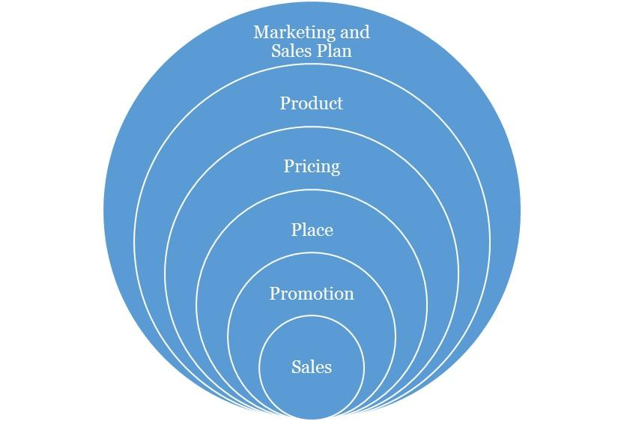

7.0 Marketing and Sales Plan
Concerning our marketing, we will execute a comprehensive strategy that is centred on the 4P’s of marketing (this refers to Product, Pricing, Place and Promotions) which are fundamental to any campaign. Each aspect is discussed as follows:

7.1 Product
We have developed relevant products that are tailored for the customer segments that have been identified. These will cut across the core aspects of our service offering.

7.2 Pricing
The pricing strategy to be adopted will be a combination of the cost-plus pricing and competition-based pricing. This entails fixing prices for the services that ensure that production costs are covered and a fair profit margin is realized from sales. However, in selecting this price points, consideration will be given to the prices offered by competitors in the industry. We are high end as shown in the services we provide, but more affordable than the average ones. This will ensure that we do not price ourselves out of the market. And as we progress, our brand growth and imagery will become a factor to our pricing.

7.3 Place
We seek locations that put us in a comfortable uncontested niche that will help ensure we can capture the clients in the vicinity and retain them. Our physical location and place aim to strike a balance between brand exposures, awareness, achieving maximum accessibility to clients while keeping costs low.

As the business grows and expands, subsequently, we will explore the possibility of establishing [Company Name] in other major places in [Enter Business Location] and other large cities in the US where potential clients are identified to be situated.

7.4 Promotions
In terms of promotion, we will implement an awareness process engineering aimed at market activation, customer acquisition and retention strategy. Our promotions will be hinged on creating awareness and deals from the quality of our service offering, the experience, cost and time effectiveness etc. We will employ innovative product and service promotion techniques to acquire customers.

Types of Promotion and Explanation
Advertising | As an SME, [Company Name] will minimize its exposure to Above The Line advertising with exceptions to major events, but will engage in Below The Line and Through The Line Advertising.  The Above the Line (ATL) advertising includes the following; mass media, large format printing, electronic broadcasts and it’s for building brand awareness and goodwill.  The Below the Line (BTL) includes the following; industry magazine, newsletters, social media and Google AdWords.  [Company Name] will invest resources and promote using BTL with a focus on social media and an active blog in targeting specific clients and to build awareness. Social media, unlike traditional media provides insights and analytics to measure pubic interaction and a quicker ROI.
Public Relations | Consistency, good clients’ relationship and excellent service will grow the brand’s recognition and increase its market share and sustain growth. We will also continually share our core values and brand promises with the public, with the aim of making [Company Name] synonymous with high-end spa service.  We will also maintain a close relationship with our clients for feedback, as well as with our alliances and complementary organizations.  The art of good public relations is not only to obtain favourable publicity within the community but to raise and keep the awareness within the vicinity. It also involves being able to handle attention, support and feedback.
Sales Promotion | We will create strategies targeted to our client segments and make available promotions and referral bonus to increase sales. We trust we will keep this client with our excellent service and through our value-added service creating loyalty.
Internet Marketing | We will promote and sell our service over the internet such as our interactive website, an active blog, social media handles, affiliate marketing and sponsoring across popular blogs and social media influencers.

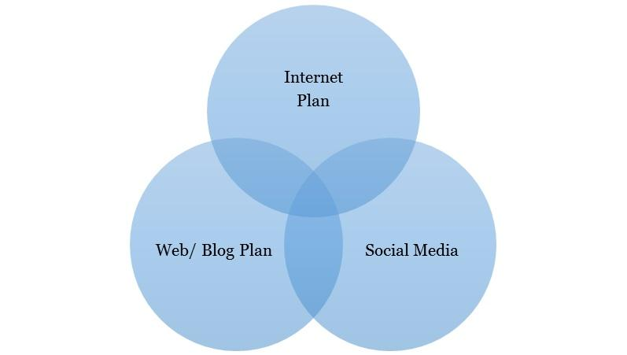

8.0 Internet Plan

The internet is here to stay and any business not positioned towards this trend will most likely be disrupted from within the industry. Internet plan is not limited to a website alone as this is one of the many platforms that should be maximized for business purposes.

8.1 Web/Blog Plan
Our website will serve as a source of information for online visitors and our strategy is to optimize the use of search engine optimization and search engine marketing (SEO/SEM), and the development of editorial content. This simple strategy will easily position the brand as a maven within this segment of the industry. [Company Name] will evaluate and also include on-demand capabilities into its business model.

The site will be developed so that users can see everything they need "above the fold." The website will feature key items along with the unique services of spa care. Editorial content will entail ideas of workout and cuisine options that are appropriate before work and during a wide range of other scenarios. We will also give tips and insights to the best healthy living practices on the blog section as an added advantage for visiting our website.

The overall strategy of the website will be to provide a clear and simple architecture that allows the user obtain all the information they need, simply and easily.

Website Marketing Strategy
The website will be integral in [Company Name]’s marketing effort as the site is a key sales tool for both local and distant customers. The URL address will always be used in promotional material, encouraging people to check out the company and product offering. In addition to the inclusion in traditional marketing campaigns, [Company Name] will submit its website to a variety of search engines, significantly increasing the number of inquiries from people searching for our services.

Development Requirement
A computer programmer/designer will be employed with the tasks to manage the design, implementation, and maintenance of the website. The majority of the tasks will be completed by him/her; a few tasks that are outside of his/her skill set will be subcontracted to associates

8.2 Social Media Plan
Objectives:
- To increase the [Company Name] brand awareness
- To build a close rapport with potential and existing market
- Position the [Company Name] brand as the maven within the industry
- Increase two-way communication with current and prospective clients.

Understanding the Different Social Media Platform
Platforms | Unique Features
Facebook | A social networking site that allows you to have conversations with customers, post photos and videos, promote special offers, and more.  - Over 2 billion users.  - The Facebook audience is general and wide ranged.
Instagram | An online visual sharing platform for you to share moments, products and services with customers.  - It has over 700 million users.  - Instagram accommodates posts in form of audio-visuals and pictures.
Twitter | A 'micro-blogging' service that allows you to send and receive short messages from customers and potential customers.  - Often used to promote cause and beliefs using hashtags  - The Twitter audience is a mixture of socialites and intellectuals with a knack for sarcasm  - It has about 330 million users globally
Blog | Designed to accommodate well laid out thoughts in form of articles. An ideal blog post can contain up to 500 words and must be well written to ensure flow and readability. The use of images is encouraged too.  The aim of the blog post is to create content that:  - Share and promote the company core values with the public.  - Create content that is targeted towards the selling of the company’s product/service.

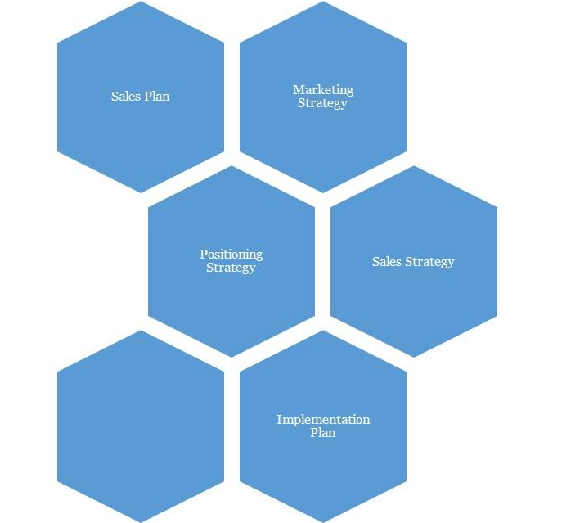

9.0 Strategy and Implementation Summary
We at [Company Name] recognize the importance of marketing and promoting our service as a factor to business growth and success. And to that end, we plan to promote our retail business with an ambitious, targeted marketing campaign. Our goal is to keep our marketing budget to no more than 5% of our gross annual sales.

9.1 Marketing and Sales Plan
[Company Name] will activate the following market plans to boost brand visibility and acceptance as well as grow engagement:
1. Defining our central ideology is essential.
2. Creating prominence on social media. This is just beyond posts and likes, but engagement techniques too. This may require a social media content plan.
3. Define [Company Name]’s set of brand promises clearly

[Company Name] will also activate the following plans:
- Open [Company Name] with a loud party. We shall also offer free trial for all our visitors for the first three days of launching the business.
- Advertise our Spa business on national dailies, local TV stations and local radio station
- Promote [Company Name] online via our official website and all available social media platforms
- Continuously improving the performance of our brands
- Hire the services of experts to make our brands the first choice for in [Business Location]
- Delivering consistent customer experiences to all our guest; making our first impression count positively
- Make use of attractive hand bills to create awareness and also to give direction to our state-of-the-art facility.
- Adopt direct mailing coupon marketing approach
- Position our signage/flexi banners at strategic places
- Create a loyalty plan that will enable us reward our regular customers
- Engage on road shows within our neighbourhood to create awareness for our business.

9.2 Marketing Strategy:
[Company Name] will rely on three separate strategies to grow its client base. The first is through effective brand activation, powerful, striking and consistent PR practice. Aggressive marketing with an emphasis on its quality self-service experience and superior customer service as well as non-stereotypical public relations through its spin-off projects will help us remain in the mind of prospects and clients respectively. Customers will be blown away with the level of service and value that they receive.
[Company Name] will also be leveraging on the wide range of options it could offer apart from its core services. They would include membership for networking, a customised service delivery (including home services) and unique exclusivity in its professional services to its clients.

And lastly, [Company Name] will use a lot of bait for referral, freebies (gift packs and packages that help advertise its brand), happy hours where the costs are cheaper and incentives, especially in the early stages, in order to build a large and loyal client base.

9.3 Promotion Pattern
At [Company Name], our promotional strategy will be based on maximizing technology and new media through the internet and our cluster group alliances. But most importantly, an exponential referral scheme.
Advertising:
- Encourage our loyal customers to help us use Word of Mouth mode of advertisement (referrals)
- Advertise our Laundromat business in relevant magazines- beauty and non-beauty magazines, local newspaper, local TV stations and local radio station.
- Promote our Spa business online via our official website
- List our Spa business on local directories (yellow pages)
- Sponsor relevant community programs
- Leverage on the internet and social media platforms like; Instagram, Facebook , twitter, et al to promote our brand
- Install our Bill Boards on strategic locations
- Direct coupon mailing approach
- Engage in road show from time to time
- Distribute our fliers and handbills in target areas all around [Business Location].
Also, we will love to work with PR/ Advertising Stakeholders. These refer to the sales influencers. They include:
Blogs: Blogging has become very popular now in the US and is one of the most popular means of brand/product promotion. The question we hope to constantly ask and answer the question, “How Can [Company Name] maximize the platform of blogging to create awareness in a less typical way”?

9.4 Distribution Strategy
One of our distribution channels will be focused on the use of alliances:
1. We will place our brochure within the offices of our corporate referral clients. We will also be giving commissions to clients who refer us to others.
2. We will work on building a database of all the top executives of banks, cinemas, IT firms and other offices around a 50-metre radius and to try to create an alliance with them.
3. In addition, we will forge alliances with our referral clients, financial institutions, corporate firms, media, and businesses that will be strategically beneficial for generating new clients.

9.5 Positioning Strategy
In terms of positioning, we would be applying a marketing warfare concept where we choose to apply four different methodologies depending on the market dynamics. These methodologies are listed below as:
1. Defensive: Defensive strategy would be applied when we are sure to be the market leaders.
2. Offensive: Offensive strategy would be applied when we are sure to be the strong challenger.
3. Flanking: Flank strategy would be applied when we are sure to be the weaker challenger.
4. Guerrilla: Guerrilla strategy would only be applied when we are sure to be struggling for survival and want to avoid being crushed by the bigger competitors.

We believe that marketing is all about positioning, and we being able to identify our position and applying the right strategy. At this point, it is interesting to note that our marketing program is not just about customers, but about gaining, for ourselves, a noticeable proportion of the total available market share or its segment being occupied.

9.6 Pricing Strategy
As we progressively penetrate the market, our fees will come with discounts yet it would retain a competitive positioning as much as possible. But as we gain larger brand equity, we will add more value-added services that will justify an increase in our prices when we ever see the need to do so. However, it is important to note that while competition enables a healthy business atmosphere, we aim to build an iconic brand that makes the competition feel irrelevant by continuously perfecting and offering more value-added service to all of our clients. We will not charge over, nor substantially under, rather we will be charging standard prices in line with quality for our services just as our contemporaries do.

10.0 SALES PLAN

10.1 Sales Strategy
The sales function will be driven by our in-house sales unit. The unit will be responsible for lead generation and management. This will be required to meet sales targets that will be set on a weekly basis. The sales unit will be headed by the manager and the CEO will be kept abreast. Both of them will be responsible for coordinating all sales activities and delivering on sales.

Sales Projections

(All figures shown in the graphs are in $’million)
N.B: Check the Sales Forecast sheets on the financial model for more information

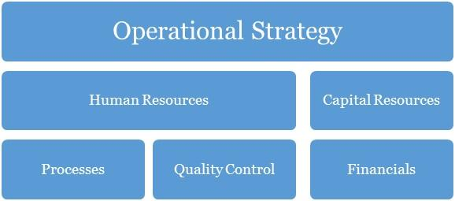

11.0 Operational Strategy
Operation strategy in any business organization is essentially about how the organization seeks to subsist and flourish within the environment over the long-term. The decisions and actions taken within its operations have a direct impact on the basis for which the organization is able to operate. The way in which [Company Name] secures, deploys and utilizes resources will determine the extent to which we can successfully pursue our specific performance objectives. Our operations are built on our core values of professionalism, empathy, resourcefulness, continuous improvement.

Further ahead in this growth process, in whatever we do, we will consider the concept of collaboration too as a major step necessary for effective business management. It is the role of management to know what is of topmost priority to their organization and to their business. And then concentrate more on that core. Our business will as much as it can encourage new and upcoming small-medium businesses which provide a service within our need base to step up to the challenge of being the best through their affiliations with [Company Name].

12.0 Human Resources

There has to be a well-defined corporate culture with an immersion process for all of its human resources. This starts off as an onboarding process for new entrants, and then a constant reminder as they stay in the organization (training, review, test and appraisals, KSS (knowledge Sharing Sessions) with each of this, having an injection of the DNA of the brand’s core values reminded into them.

This section of [Company Name]’s processes is one that identifies the current and future human resource needs for our organization to achieve its projected goals as listed in our mission and vision statements. It would serve as the link between our management and the overall strategic plan of our organization.

Human resources management and development is a core issue and is hinged on professionalism and productivity. A high premium is placed on our most valued assets, the men and women who would make the [Company Name] household brand in the US and most especially beyond. Our human capital base is made up of people from diverse professional, ethnic, tribal and cultural backgrounds, who exhibit a high level of business ethics, are performance-driven, result-oriented, ambitious, team players and conform to the company’s standards and core values.

Our employee policies will include:
- Weekly management meetings
- Monthly employee meetings
- On-going training
- Performance reviews every six months
- Performance incentives
- Encouragement of creativity
- Financial Plan

At [Company Name], we understand and partner with employees individually and collectively to support them in meeting their unique aspirations and needs by training, developing, motivating, providing professionally challenging jobs to help them attain self-discovery, fulfilment and contribute to the achievement of our corporate objectives.

The goal at [Company Name] is to have a team of committed associates who empower each other so that the customer's expectations can be exceeded. Our goal is to offer career opportunities, advancement opportunities and a level of income and benefits that is competitive within the region and job classification. It is our long-term goal to be the preferred employer within our niche market.

13.0 Quality Control

Quality control here refers to the standards and mode of operation and delivery of value within the organization. This should be defined in the structure so much that all products delivered should be exact with the intended work with no variations at all. To achieve this, there has to be checks, balances and predefined structures to ensure minimal variation from scope, deliverables and quality. This should be in the designation and job description of a Quality Control Officer. This is perhaps the most important work role in the organization.

Quality Control Plan
Our company’s quality control team will monitor and audit every stage of value creation and delivery. The manager will be in charge of analysing quality work done and even the materials supplied by vendors; he is expected to identify any inadequacies that would affect the brand. Indeed, these personnel will be fully authorized to enforce whatever corrective measures may be necessary (including shutting down service) so as to maintain the company’s reputation for excellence.

14.0 Processes

Operational processes are vital to solving problems and tasks while managing the day-to-day issues associated with the engagement, development, management and interaction of people, techniques, businesses and systems. Without a stable foundation of corporate operational processes, organizations devote their management efforts to managing problems in this area, thereby generally failing to achieve efficiency and effectiveness as well as the confidence, trust and support of staff i.e. the cornerstone to being able to win and grow.

With a thorough understanding of our business operations, we can categorize our entire business processes into the following main aspects including:
  - Management processes
  - Core Business processes
  - Supporting Processes
  - Collaboration
  - Automation

15.0 Financials

The basis for our financial planning has been looking forward with conservative estimates for revenue and expenses. We are committed to consistently growing our cash balances through the prudent management of our expenses. Our focus will be on remaining profitable year after year, while also building adequate cash reserves.

Capital Requirements
In order to expand our business as desired, we require about $126,0222 to support the already tangible investments made into the business. The capital requested would be used to incur the following expenses.
Capital Requirements
 | Amount
Capital Expenditure | 90,658
Operating Expenses (6 months) | 35,364
TOTAL | 126,022

Financial Viability
The main criteria for establishing the company are that it achieves financial viability both in the short and long term. Shareholders must be rewarded for the risks that they are assuming by investing in the company through the payment of regular dividends within specified parameters of prudent business requirements.
The company must satisfy customers but at the same time take cognizance of the fact that it may cost more to satisfy some needs than any customers are willing to pay. Or it may be much more costly to try to attract new customers than it is to build a strong relationship with-and repeat purchases from- existing customers. So, profit – the difference between the firm’s revenue and its total costs – is the bottom-line measure of our success and ability to survive. The management team will ensure that there is a balancing point that helps it to determine the needs it will try to satisfy.
Aggressive financial targets have been set for [Company Name] to achieve on an annual basis. These targets are the key focus of the company, without compromising the quality-of-service delivery, and includes a return on stakeholders’ funds.

Break-Even Analysis

Gross Margin % of Sales
Gross Margin | $ 247,200.00
Total Sales | $ 313,200.00
Gross Margin/Total Sales | 78.9%
Total Fixed Expenses
Payroll | $ 69,958.15
Operating Expenses | $ 70,728.57
Operating + Payroll | $ 140,686.72
Breakeven Sales in Dollars (Annual)
Gross Margin % of Sales | 78.9%
Total Fixed Expenses | $ 140,686.72
Yearly Breakeven Amount | $ 178,248.71
Monthly Breakeven Amount | $ 14,854.06

For a more rigorously detailed financial plan:
PLEASE SEE EXCEL SHEET ATTACHED IN A SEPERATE DOCUMENT

IMPORTANT ASSUMPTIONS
The financial plan depends on important assumptions, most of which are shown in the following table. The key underlying assumptions are:
- We assume a slow-growth economy, without a major recession in the following years.
- We assume that there are no unforeseen changes in federal grant funding availability.
- We assume a continued need for our products in the market.

General Assumptions
Inflation Rate | -
Cost Escalator | 10%
Tax Rate | 30%
Dividend Payout Ratio | 0%

16.0 EXIT PLAN AND STRATEGY

No one attempts a business with the anticipation of failure. However, sometimes ventures do not fulfil their promise. We at [Company Name] are committed to our concept and its viability. In the event that our venture cannot achieve profitability and retire the encumbrances the promoter or investors in the business have several exits scenario options subject to the prevailing conditions and circumstances at the time. These could include any of the following:

SCENARIO I (Promote Staff):
Promotion of its staffs to a partnership based on performance, dedication, skills and years of service – this should be considered in the long run.

SCENARIO II (Sell/divest stock):
A promoter or investor looking to exit the business can sell equity to other interested investors. The sellers can choose to sell all or part of their equity.

SCENARIO III (Initial Public Offering):
The company can also break up some of its products into separate entities as it grows large enough. But it is most likely, that sometimes soon; it may go public and will aim to be quoted in the Stock Exchange.

SCENARIO IV (Default):
If we are unable to sell the operation for sufficient proceeds, we will be forced to default whereby the loans acquired will be in senior standing. Any further outstanding balances will be borne by the equity shareowners of the business on a weighted percentage based on the total amounts due in bankruptcy proceedings.

17.0 Plan Improvement
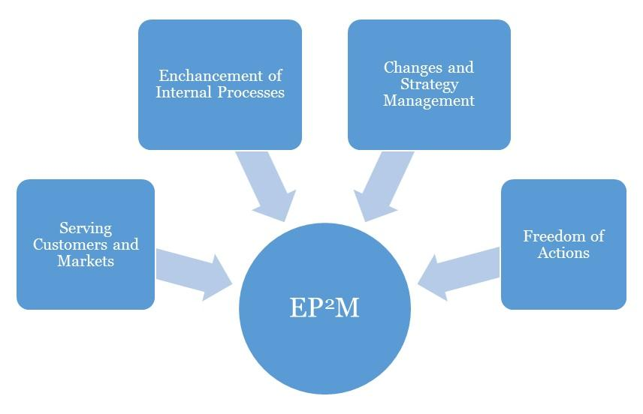
Effective Progress and Performance Measurement

Performance Measurement
This business plan's performance should be assessed against its effectiveness in achieving its high priority goals and performance targets. Occasionally, three (3) months interval should be advised for [Company Name] business.
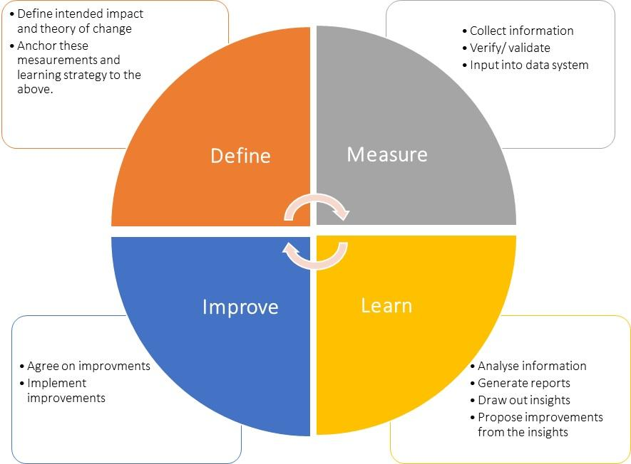

Plan Review and Up to Date
To ensure your business plan continues to provide a sharp focus and remain responsive to change, it should be formally reviewed and updated every six months, at the achievement of a strategic goal and at any other time deemed necessary. Implementation of this plan is to be a fixed agenda item at meetings of [Company Name]’s Board of Directors.

