Retail Store Business Plan
… More Than Shopping …
This business plan is intended solely for informational purposes to assist in determining if you with a due-diligence investigation of this project. The information contained herein is believed to be reliable, but the management team makes no representations or warranties with respect to this information. The financial projections that are part of this plan represent estimates based on extensive research and on assumptions considered reasonable, but they are of course not guaranteed. The contents of this plan are confidential and are not to be reproduced without express written consent.

TABLE OF CONTENT

1.0 EXECUTIVE SUMMARY……………………………………………………………………….…………….….4
1.1 Vision
1.2 Mission
1.3 Core Values
1.4 Keys to Success
1.5 Objectives

2.0 Company Summary ………………………………………………………………………………………........8
2.1 Business Description
2.4 Milestones

3.0 Ownership and Management…………………………………………………………………………………12
3.1 Management Summary
3.2 Business Model Canvas
3.3 Management Background
3.4 Personnel Plan

4.0 Organizational Structure ……….........................................................................................16
4.1 Organizational Chart

5.0 Value Proposition and Competitive Comparison………………………………………………….18
5.1 Service/Product Offering
5.2 Competitive Advantage

6.0 Market Research and Analysis…………………………………………………………..………………20
6.1 Industry Overview
6.2 Target Market
6.3 Major Competition

7.0 Marketing and Sales Plan…………………………………………………………………………………25
7.1 Product
7.2 Pricing
7.3 Place
7.4 Promotions
7.5 Sales

8.0 Internet Plan ………………………………………………………………………………..………………….28
8.1 Website/Blog Plan
8.2 Social Media Plan

9.0 Strategy and Implementation Summary..........................................................................31
9.1 Marketing & Sales Plan
9.2 Marketing Strategy
9.3 Sales & Marketing Target
9.4 Promotion Pattern
9.5 Distribution Strategy

10.0 Sales Plan..........................................................................................................................36
10.1 Sales Strategy
10.2 Sales Forecast

11 Operational Strategy.............................................................................................................38
12 Human Resources................................................................................................................38
13 Quality Control.....................................................................................................................40
14 Processes...............................................................................................................................41
15 Financials.............................................................................................................................42
16 Exit Plan and Strategy..........................................................................................................47
17 Plan Improvement................................................................................................................48

EXECUTIVE SUMMARY

[Company Name] Retail Shop is a store that will be located on one of [location], [State]'s busiest streets. We have been able to lease a space that is large enough to accommodate the design of the retail store we intend to open, and it is situated directly across from the largest residential estate in [location], [State].

Our retail store will carry an extensive selection of affordable durable and non-durable goods from various brands. We sell groceries, clothing, sports equipment, cosmetics, jewellery, baby items, children's toys, home furnishings, and home appliances, among other products. We are aware that there are numerous large and small retail establishments in [location], which is why we devoted time and resources to conducting our feasibility studies and market research so that we could offer significantly more than our competitors. We offer a variety of sell services to our customers, and our retail location is secure with multiple payment options.

In [location], [State], our customer service surpasses our ability to sell the goods and products of the leading brands in the manufacturing industry. We recognize that our customers are the reason we are in business, which is why we will go above and beyond to ensure their satisfaction when they visit our retail store and to encourage them to become our loyal customers and brand advocates.

[Company Name] Retail Shop will provide all customers with first-rate service whenever they visit our store. We have CRM software that will allow us to maintain a one-on-one relationship with all of our customers, regardless of their number. We will involve our customers in the selection of brands that will be stocked on our shelves as well as in business decisions. We are aware of the trend in the retail industry, and we will not only operate a system where customers must come to our store to make purchases or do whatever else they desire, but we will also operate an online store where customers can order goods and have them delivered to their homes or any other location within [State].

[Owner] and his family are the proprietors of the family business that is [Company Name] Retail Shop. Although the business is launching with only one location in [location], [State], there are plans to open additional locations throughout the state.

Capital Needs
[Company Name] Retail Shop run at an assumed sales profit of approximately $150,696 in its next year of expansion, with a profit after tax of $21,605 and a consistent progression for the future years. We seek an additional loan of $66,414 in capital contribution. The chart below explains our projections:

(All figures shown in the graphs are in $’000)

Our marketing strategy will include the use of both flank and guerrilla type of marketing attack to topple larger brands by offering unique service and experiences at competitive prices that is being ignored by larger brands. We will also include online marketing with great focus on social media and an active blog to position our brand as the industry leader with our regular contents.

1.1 Our Vision
Our vision is to open a one-stop retail shop in [Location], [State], and other [State] cities.

1.2 Our Mission
Our mission is to establish a retail business that will provide a diverse range of goods and products from top manufacturing brands at competitive prices to residents of [Location], [State] and other [State] cities.

1.3 Our Core Values
The following core values drive our operations, products and team.
- Integrity
- Excellent Service Delivery
- Efficiency
- Client Relationship
- Innovation

1.4 Keys to Success
[Company Name] Retail Shop ’s enviable success is achieved through offering convenience, personalization and efficiency respectively.

- Efficacious Publicity: Our publicity strategy is to consciously position our brand as a maven within the industry by affiliating with complementary corporate and luxury brands. Our campaigns and publicity will include online visibility such as social media engagement and an interactive website supported with an active blog as well as prints and referral in reaching our potential clients.
- Brand and Reputation: The business and brand model is aimed at delivering decisive advantage both to the individual mind and to the market place. Our brand feel and experience will go beyond the basic service that we offer but will include other value-added services such as convenience, excellent customer experience, and trust that creates loyalty to the brand. Our brand strategy will be geared towards an abstract feel of superior experience with [Company Name] Retail Shop
- Monitor Online Reviews/ Customer Satisfaction & Feedback: We understand that reviews can make or ruin any business and that the most powerful form of marketing is by word of mouth. As a result, we will ask for feedback from customers to know how they rate us and to find out areas to improve in our services. We will do our best to keep track of our reviews on a frequent basis. Respond to all customer reviews, whether positive or negative, if at all feasible, so that prospective clients that search for our store online will understand that we appreciate our customers and are constantly striving to improve. We will give customers an incentive (like a discount) to review our retail store and build trust online.
- Convenience: At [Company Name], we hope to provide a more up close, personalized and customized services. Our services will be aided through the use of technology, perhaps Geometric Information Services, automated SMS, and even an online portal where our services can conveniently be accessed from anywhere and at any time.
- Referral System: Also, maintaining a strong referral system is essential.
- Excellent Customer Care Service/ Discount Pricing: Our workers are available to address any questions or issues that our clients may have before to, during, or after using our services. We shall determine our pricing after considering not just the costs of production but also the prices offered by our primary competitors.

1.5 Objectives:
In a more quantifiable outline, we hope to achieve the following:
- Predefine a series of brand promises we must keep. This will be more like a broadcasted accord of threshold we will never fall short off.
- To create a service-based company whose goal is to exceed customers expectation while creating hype moments (neuropsychologically exciting experiences) and moments worth returning to.
- To have a clientele retention and return rate of near 90% year on year.
- To increase the number of clients served by at least 200% per year through superior marketing performance and word-of-mouth referral schemes.
- Profitably provide world-class retail store services that would enhance our clients' satisfaction & convenience level in general.
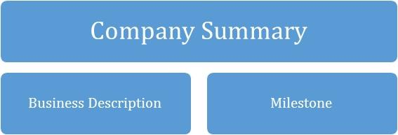

2.0 COMPANY SUMMARY

[Company Name] Retail Shop is a customer-centric brand that will be focused on providing affordable, durable and non-durable goods from various brands to its customers at competitive prices. We sell groceries, clothing, sports equipment, cosmetics, jewellery, baby items, children's toys, home furnishings, and home appliances, among other products.
We’d lay prominence on the overwhelming demand for a good retail shop around the globe and the convivence that comes with getting goods and packages to customers or loved ones without having to lift a muscle; thereby giving our customers the desired results.

In addition, with the invaluable experience garnered over the years and with the support of a seasoned team, tools and technology, [Company Name] Retail Shop will promote positive responses towards what we do, that will convert consumers into customers then into loyalists and eventual evangelists.

However, what will set [Company Name] Retail Shop apart from the competition is our focus on retail store service innovation through technology and commitment to providing professional, friendly, self-service, prompt, cost effective, time effective, a brand networking hub, and most importantly, personalised services.

2.1 Business Description
As a legal entity, the company is registered under the [Your Country’s Corporate Affairs Commission] as [Company Name] Retail Shop. We operate from a store in [Location], and we look forward to open a second store at [New location after expansion], equipped with a reception to receive customers, interact with them and direct them round the stores.

2.2 Milestones till date
Type | Status | Timeline
Business Name Availability Check | Completed | September 2022
Business Incorporation | Completed | August 2022
Opening of Corporate Bank Accounts | Completed | July 2022
Application and Obtaining Tax Payer’s ID | In Progress | November 2023
Application for business license and permit | Completed | June 2022
Purchase of Insurance for the Business | Completed | October 2023
Leasing of facility and remodeling the store | Completed | February 2023
Securing Point of Sales (POS) Machines | Completed | December 2022
Opening Mobile Money Accounts | Completed | January 2023
Opening Online Payment Platforms | Completed | January 2023
Conducting Feasibility Studies | Completed | January 2022
Generating capital from family members | Completed | November 2022
Applications for Loan from the bank | In Progress | June 2023
Writing of Business Plan | Completed | January 2022
Drafting of Employee’s Handbook | Completed | January 2023
Drafting of Contract Documents and other relevant Legal Documents | Completed | December 2022
Design of The Company’s Logo | In Progress | February 2023
Graphic Designs and Printing of Packaging Marketing / Promotional Materials | In Progress | February 2023
Recruitment of employees | In Progress | July 2023
Purchase of the Needed furniture, racks, shelves, computers, electronic appliances, office appliances and CCTV | In Progress | May 2023
Creating Official Website for the Company | In Progress | October 2023
Creating Awareness for the business both online and around the community | In Progress | January 2023
Health Safety and Fire Safety Arrangement | Completed | November 2022
Opening party / launching party planning
Compilation of our list of products that will be available in our store | Completed | February 2023
Establishing business relationship with vendors – suppliers of all our needed raw materials | In Progress | August 2023

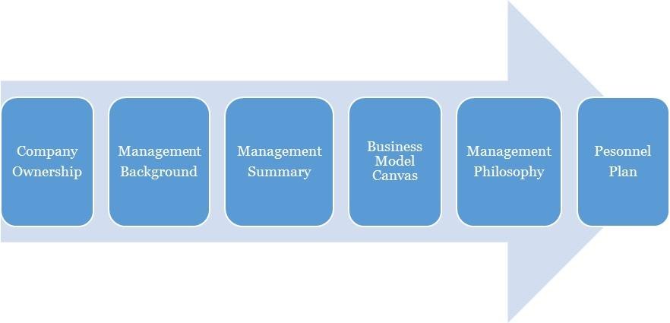

3.0 OWNERSHIP AND MANAGEMENT

[Company Name] Retail Shop is owned by [Owner]. The management of [Company Name] Retail Shop is a simple one with the CEO as the manager. Operations are managed by him.

As of November 2023,
Name | Title | No. Of Shares | % Of Ownership
Owner | CEO/MANAGER |  | 100%
TOTAL |  |  | 100%

3.1 Management Background
Owner:
[Owner] is a self-motivated and reliable individual, familiarized to working in fast-paced environments where the goal is to deliver top-notch service; with a remarkable track record of experience in Leadership, holding top positions in retail-related establishments.

He holds a Master’s Degree in _____, United Kingdom and a Bachelor of Science Degree in Accounting from ________, United States. His trainings and experience have also helped him develop his leadership and coaching skills and a strategic view-point to every project or endeavour.
[Owner] hails from ______ in ____; he is an innovative, vivacious individual with the passion to achieve greatness. He is also goal setter and achiever who ensures all the pre-requisites for achieving the set objectives are met. As a leader he recognizes the value of team work, team play and time management.

3.2 Management Summary
The management philosophy at [Company Name] Retail Shop will be based on mutual respect for each of our fellow colleagues and for every customer.

Our success will greatly depend on how effective our relationship is with our customer, this is why we will focus on treating our employees’ right and encourage them to treat the customers likewise. Our employees are the face of the brand and will represent the brand when interacting with our client. Customer friendly employees will increase general client loyalty and repeat business.
The management team will consist of the owner/CEO and the general manager. We will hire only those who demonstrate the qualities necessary for working in a nurturing environment, and the willingness to move forward in study of energetic principals if not already so trained. We will be hiring the ultimate "people persons."
Furthermore, all duties will be divided and delegated according to the strengths and weaknesses of our staff. At [Company Name], we will expect a high degree of customer service skills and personality as this is essential to our success. The management team will assess the productivity and performance evaluations of all employees every two months. These bi-monthly evaluations are conducive to the continued growth of our business.

3.3 Business Model Canvas
Business Model Canvas for [Company Name] Retail Shop
Key Partnerships  Financial Partners, Cluster Groups | Value Propositions  - Excellence  - Brand  - Relationship  - Customer Service  - Professionalism | Customer Segments  Business to Business  - Households  - Corporate Executives  - Business People  - Expectant Mothers  - Sports Men and Women  - Students  - Tourists  Business to Client  - Corporate Executives  - Private Individuals  - Celebrities  - Students
Key Activities  Sale/Delivery of any kind of products and goods that are legal in the country. | Key Resources  Equipment, skills, physical location, vehicles, staff | Channels  Direct services, website  Third party drop offs
 | Customer Relationship  Online, offline, community  Social media, customer support, discounts and promotional | Channels  Direct services, website  Third party drop offs
Cost Structure  Operational costs: Marketing & ads, logistics, Internet subscription, airtime charges, fuel, maintenance  Utility: electric bills, rents, salaries (skilled labor) etc. |  | Revenue Streams  Sale of goods and products from top manufacturing brands in the united states and other countries of the world.

3.4 Personnel Plan
[Company Name] Retail Shop is a growing firm and as such staff will be hired according to recommendations, experience and education in their field. High standards will be kept through the orientation and inclusion period for new employees and the new employees will be given a mentor to shadow for the first two (2) weeks of arriving. In so doing, the employees can pick up the ethics of working and representing the [Company Name] brand.

Checklists will be drafted to monitor employee’s quality of service after three months. Staffing and training will be available for sales representatives and customer service candidates. Every personnel will be given specific assignments and valued on completion of the assignment. One on one meetings will be held to discuss and handle any arising issue regarding performance and service.

4.0 ORGANIZATIONAL STRUCTURE

To have a truly value driven team that would be productive, there is a need to map out what is most important to the organization and the team in order of prioritization. This is to ensure a chain of interrelated entities that will define our organization structure. For [Company Name], the following is a further illustration.
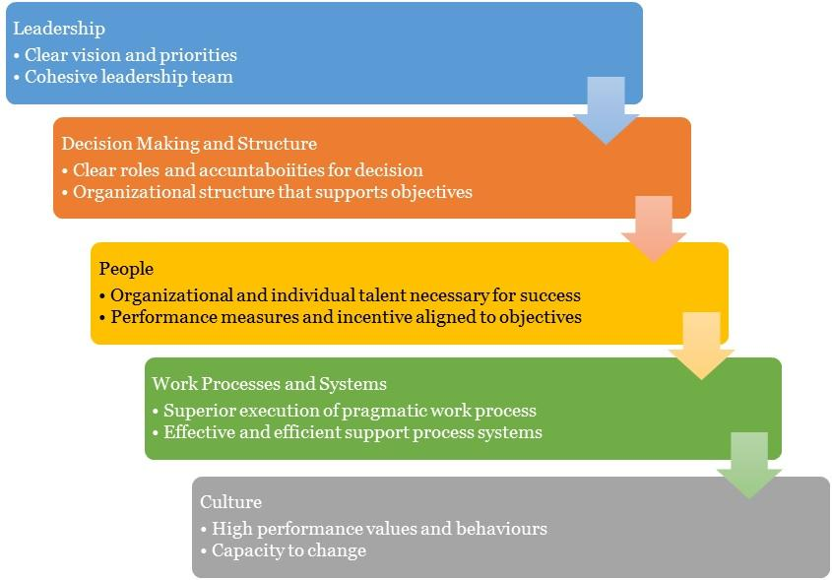

4.1 Organizational Chart

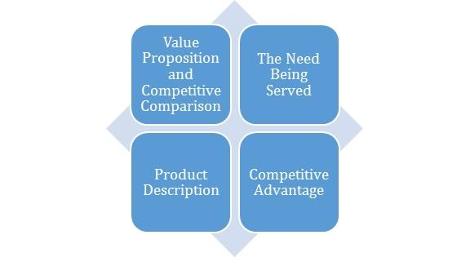

5.0 Value Proposition and Competitive Comparison

Value Proposition
At [Company Name], we understand that the core of our business is centred on people, and this is the paradigm that inspires our entire processes and structures. We promise to make our clients experience more with our brand as we provide superior retail store service at a cost-effective rate.
In a more measurable outline, here’s our value proposition and market reach:
- Provide the best of retail store and delivery service within [Target Location].
- Scale up the operations and expand the retail store and delivery business.
- Ensure maximum profit for our shareholders using effective and efficient strategies in the markets that we operate in.

5.1 Service/Product Offering
[Company Name] Retail Shop is in the retail business, and we will go to great lengths to offer a wide variety of goods and products from leading manufacturers in the US and other nations of the world accessible.
We will have available in our store a wide range of durable goods and non – durable goods at affordable prices. We retail goods such as groceries, clothes, sports equipment, beauty products, jewelry, children’s toys, baby stuffs, home furnishings and home appliances et al.

5.2 Competitive Advantage
[Company Name] Retail Store is opening a standard retail store that will quickly become the preferred place to live in [Location], [State]. Our retail store is situated on a busy road, directly across from one of [Location], [State]'s largest residential estates. We have enough parking space to accommodate well over 100 cars at any given time.

One thing is certain: we will always have a diverse selection of products available in our store. Customers will find it difficult to visit our store and not find the product they are looking for. One of our company objectives is to make [Company Name] Retail Store a one-stop shop. Our excellent customer service culture, online store, numerous payment options, and highly secure facility will provide us with a competitive advantage.
Secondly, we will also ensure that we hire only qualified personnel who are not only experienced but also committed to the company's mission of becoming the best brand in [Target Location], and among the top three in the United States.

We will provide extensive customer service training to our staff so that they can successfully express our brand to customers anytime they represent us. This will guarantee that we not only meet but also exceed our customers' expectations.

Further ahead, we also will derive our competitive advantage from focus on a technology-centric, innovation driven strategy. This will in turn create a brand of quality, exciting customer experience and attention to the slightest detail that is synonymous with a unique customer care service enveloped in excellence. We are moving towards being the standard.

6.0 MARKET RESEARCH AND ANALYSIS

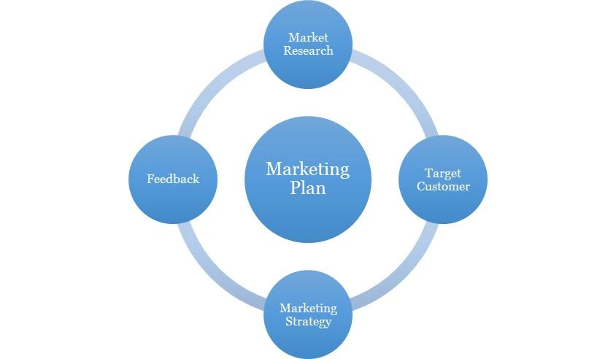

6.1 Market Overview
Retailing is a broad industry that encompasses many different types of businesses, but it all centers around the distribution of consumer goods. Products in these groups include those sold in department stores, such as clothes and home decor. That is to say, retailers deal in the sale of final products, which they acquire from producers and then sell on to consumers (consumers). There is another way to classify retail items: durable vs. non-durable. Non-durable items include food, toiletries, drinks, beauty products, jewelry, clothing, shoes, and accessories, while durable goods include electronics, computers, and accessories. With more than a million stores in the United States of America, the retail business is a key contributor to the country's economy, bringing in well over a trillion dollars every year.

More than 15 million individuals, or around 12 percent of the labor force in the United States, are employed by the industry. According to eMarketer.com, worldwide retailing brought in over $22 trillion in sales in 2014. This indicates that retailing is a massive sector. It is a well-known fact that consumer spending accounts for roughly two-thirds of GDP growth in the United States. This is why the health of the American economy is often gauged by the performance of the retail sector in America. In essence, a weak economy causes consumers to spend less, which hurts the retail business and could lead to the closure of some stores.

The retail sector has undergone significant transformations over the past two decades, evolving from the traditional mom-and-pop stores into a more streamlined, multi-national enterprise. The proliferation of franchises and e-commerce has allowed brick-and-mortar stores to expand their customer bases well beyond their immediate vicinity. It's remarkable to see how many stores, especially larger ones, have added self-service checkout lanes. As a result, lines form that are more manageable for customers; most people don't want to wait any longer than necessary.

In addition, retail is a lucrative sector of the economy, and any would-be business owner is welcome to enter the market and set up shop there, whether on a modest size like a "mom and pop" store on a busy intersection or on a larger one with multiple locations in major metropolitan areas.

Economic, Social and Technological Factors
A stronger economy enables customers to purchase the goods they desire, rather than purchasing simply what they require. It also indicates that more investors are growing interested in the retail sector's profitability. This is achievable as the economy is growing. When it is declining, the opposite is true. Individuals tends to preserve their money for essential items and will spend the bare minimum on meals, and the remainder will go towards their overdue bills. This may occur as unemployment rates increase or when a specific industry is impacted more severely than others.

Even during the recession, the retail business was able to remain stable. It is one of the few industries that barely survived. The industry's global sales approached $30 trillion by 2020 making the present global economic conditions favorable for the expansion of retail industries. Consumers have more discretionary income to spend on luxuries but yet, it does not matter how many things are given if the economy is inadequate. This is because, nobody can rationalize or afford the purchases unless retail firms respond appropriately (by reducing prices.

Every day, retail businesses employ a range of technologies. Similar to a point-of-sale system. In addition to cash registers for managing money after sales. That is typical for any stores embracing new systems, software, and hardware as technology improves. For instance, registers in smaller establishments are transitioning to laptops or iPads. It is quick and simple to use. The internet has also provided substantial benefits to the retail sector.

In addition to streamlining services, global audiences is now a priority as most businesses creates an online presence and essentially providing a computerized library of their products. Large enterprises can now provide a variety of products online and the products are either mailed to the customer's home or picked up at the nearest store.

For example, Amazon and Walmart are competing with one another and each organization offers online retail products for sale and shipment. Smaller competitors cannot compete on the same scale but this does not preclude them from having a business website or displaying their products online. It simply implies they lack the resources to match the same demand as larger retailers

Customer preferences are the most influential societal element on the retail sector. People prefer purchasing items in quantity, for instance, the identical concept behind the Canadian retailer CostCo says that Large quantities of food, clothing, and electronics are available here. Now, retailers besides CostCo store also provides large quantities of a variety of products to avoid running out fast.

Retailers do not purchase these items on a whim, they do market research to determine purchasing trends and changes in customer behavior. Knowing these two factors facilitates the identification of items likely to increase profitability. Online merchants who sell merchandise are able to acquire customer information. They can readily determine which products consumers are purchasing, leaning toward, or ignoring. They then tailor their offerings depending on this information even though that is an endless process.

Frequently, retail businesses display adverts to customers who are most likely to make a purchase. This is simpler for larger merchants to do than for small firms, but smaller businesses might benefit from offering discounts and specials. Every shopper appreciates a bargain.

6.2 Target Market
People from every corner of the globe buy at retail establishments since everyone on the planet needs something that can be purchased there. It's unusual to run into someone who doesn't shop at least occasionally.
Because of this, we have positioned our store to serve the people of [Location], [State], as well as those in any of the other [State] communities where we plan to open stores in the near future. We have done the legwork to understand our target market's needs and expectations. [Company Name] Retail Shop is based in _____ which houses approximately 20 million residents, our focus is on We are in the retail trade to serve the following demographics:

- Households
- Corporate Executives
- Business People
- Expectant Mothers
- Sports Men and Women
- Students
- Tourists

6.3 Competitive Environment
The industry, with respect to this service niche is relatively green. There are top and thriving retail store in ____, with strategic locations across the city. Some of them are listed below;
- ********
- ********

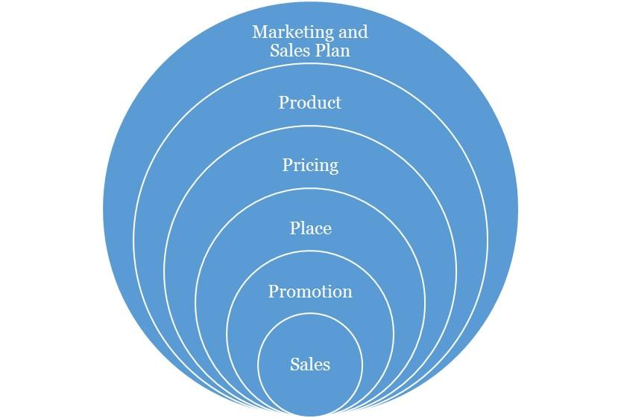

Marketing and Sales Plan

Concerning our marketing, we will execute a comprehensive strategy that is centred on the 4P’s of marketing (this refers to Product, Pricing, Place and Promotions) which are fundamental to any campaign. Each aspect is discussed as follows:

7.1 Product
We have developed relevant products that are tailored for the customer segments that have been identified. These will cut across the core aspects of our service offering.

7.2 Pricing
The pricing strategy to be adopted will be a combination of the cost-plus pricing and competition-based pricing. This entails fixing prices for the services that ensures that production costs are covered and a fair profit margin is realised from sales. However, in selecting this price points, consideration will be given to the prices offered by competitors in the industry. We are high end as shown in the services we provide, but more affordable than the average ones. This will ensure that we do not price ourselves out of the market. And as we progress, our brand growth and imagery will become a factor to our pricing.

7.3 Place
We seek locations that puts us in a comfortable uncontested niche that will help ensure we can capture the clients in the vicinity and retain them. Our physical location and place aim to strike a balance between brand exposures, awareness, achieving maximum accessibility to clients, while keeping costs low.

As the business grows and expands, subsequently, we will explore the possibility of establishing [Company Name] Retail Shop in other major places in [Target Location] and other large cities in the country where potential clients are identified to be situated.

7.4 Promotions
In terms of promotion, we will implement an awareness process engineering aimed at market activation, customer acquisition and retention strategy. Our promotions will be hinged on creating awareness and deals from the quality of our service offering, the experience, cost and time effectiveness etc. We will employ innovative product and service promotion techniques to acquire customers.

Types of Promotion and Explanation
Advertising | As an SME, [Company Name] will minimize its exposure to Above The Line advertising with exceptions to major events, but will engage in Below The Line and Through The Line Advertising.  The Above The Line (ATL) advertising includes the following; mass media, large format printing, electronic broadcasts and it’s for building brand awareness and goodwill.  The Below The Line (BTL) includes the following; industry magazine, newsletters, social media and google AdWords.  [Company Name] will invest resources and promote using BTL with a focus on social media and an active blog in targeting specific clients and to build an awareness. Social media unlike traditional media provides insights and analytics to measure pubic interaction and a quicker ROI.
Public Relations | Consistency, good clients’ relationship and excellent service will grow the brand’s recognition and increase its market share and sustain growth. We will also continually share our core values and brand promises with the public, with the aim of making [Company Name] Retail Shop synonymous with high-end retail store service.  We will also maintain close relationship with our clients for feedback, as well as with our vendors in clusters, alliances and complementary organizations.  The art of a good public relations is not only to obtain favourable publicity within the community, but to raise and keep the awareness within the vicinity. It also involves being able to handle attention, support and feedback.
Sales Promotion | We will create strategies targeted to our client segments and make available promotions and referral bonus to increase sales. We trust we will keep these clients with our excellent service and through our value-added service creating loyalty.
Internet Marketing | We will promote and sell our service over the internet such as our interactive website, active blog, social media handles, affiliate marketing and sponsoring across popular blogs and social media influencers.

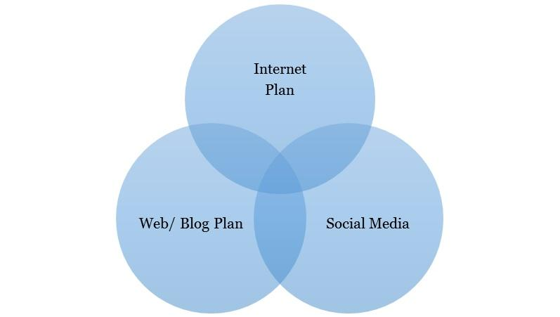

8.0 Internet Plan

The internet is here to stay and any business not positioned towards this trend will most likely be disrupted from within the industry. Internet plan is not limited to a website alone as this is one of the many platforms that should be maximized for business purposes.

8.1 Web/Blog Plan
Our website will serve as a source of information for online visitors and our strategy is to optimize the use of search engine optimization and search engine marketing (SEO/SEM), and the development of editorial content. This simple strategy will easily position the brand as a maven within this segment of the industry. [Company Name] will evaluate and also include on-demand capabilities into its business model.

The overall strategy of the website will be to provide a clear and simple architecture that allows the user obtain all the information they need, simply and easily.

Website Marketing Strategy
The website will be integral in [Company Name]’s marketing effort as the site is a key sales tool for both local and distant customers. The URL address will always be used in promotional material, encouraging people to check out the company and service offering. In addition to the inclusion in traditional marketing campaigns, [Company Name] will submit its website to a variety of search engines, significantly increasing the number of inquiries from people searching our services.

Development Requirement
A computer programmer/designer will be employed with the tasks to manage the design, implementation, and maintenance of the website. The majority of the tasks will be completed by him/her; a few tasks that are outside of his/her skill set will be subcontracted to associates

8.2 Social Media Plan
Objectives:
- To increase the [Company Name] brand awareness
- To build close rapport with potential and existing market
- Position the [Company Name] brand as the maven within the industry
- Increase two-way communication with current and prospective clients.

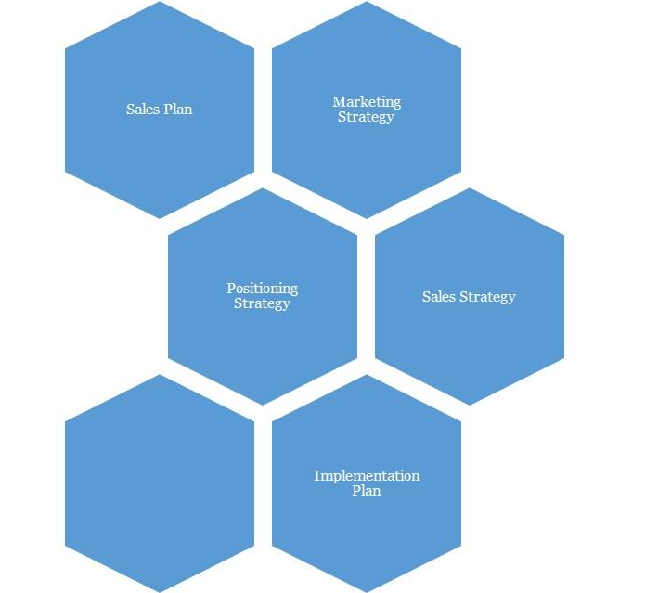

9.0 Strategy and Implementation Summary

At [Company Name], we recognize the importance of marketing and promoting our service as a factor to business growth and success. And to that end, we plan to promote our retail business with an ambitious, targeted marketing campaign. Our goal is to keep our marketing budget to no more than 5% of our gross annual sales.

9.1 Marketing and Sales Plan
[Company Name] will activate the following market plans to boost brand visibility and acceptance as well as grow engagement:
- Defining our central ideology is essential.
- Creating prominence on social media. This is just beyond posts and likes, but engagement techniques too. This may require a social media content plan.
- Define [Company Name]’s set of brand promises clearly

[Company Name] will also activate the following plans:

- Having a marketing strategy and marketing operations that targets not just individuals but corporate and cluster groups.
- Word of Mouth marketing is still the most effective form of advertising, so a mechanism has to be devised for this. An example is a simple referral form shared amongst our most loyal customers, and a discount incentive for each referral.

9.2 Marketing Strategy:

Before choosing a location for [Company Name] Retail Store, we completed a thorough market assessment and feasibility studies in order for us to be able to be able to penetrate the available market and become the chosen choice for residence of [Location], [State]. We have a detailed information and data that we were able to apply to organize our firm to attract the numbers of people we wish to draw per time.

To assist us in creating marketing plans that will enable us to accomplish our corporate objective of capturing a larger share of the [Location], [State] market, we hired professionals with solid knowledge of the retail sector. We will go above and beyond to enable our sales and marketing team to deliver because in order to stay in business and expand, we must continue to sell the products that are offered in our store. We plan to use a couple of specific online techniques to guarantee that customers outside of [Target Location] are aware of [Company Name] Retail Shop. Not only will our website be interactive and user-friendly, but it will also be well-designed to appear in top searches for people looking for the best retail store.

In conclusion, People's Choice Retail Store will use the following sales and marketing strategies to sway clients:

- Advertise our business in community-based newspapers, local TV and radio stations.
- Encourage our long-term clients to recommend us to their friends and family.
- Introduce our business by sending introductory letters to residence, business owners and organizations
- List our business on yellow pages ads
- Leverage on the internet to promote our business
- Word of mouth marketing (referrals)
- Participate in direct marketing.
- Promote [Company Name] through both traditional and online directories
- Sell our services through the internet - our website – as well as social media

9.3 Promotion Pattern
At [Company Name], our promotional strategy will be based on maximizing technology and new media through the internet and our cluster group alliances. But most importantly, an exponential referral scheme.

Advertising:
- We will utilize the social magazines, cinemas, and top executive conferences and seminars with our exclusive services.
- We will advertise on the business bulletins of most companies around that area. We will also create value driven post-cards that is aimed on giving insights on sales as a subliminal way of advertising to its holders and readers.
- We will have a comprehensive website with full interactivity. We will also make use of the social networks to promote and drive traffic to what we do.

Also, we will love to work with PR/ Advertising Stakeholders. These refer to the sales influencers. They include:
Blogs: Blogging has become very popular now in the United States and is one of the most popular means of brand / product promotion. The question we hope to constantly ask and answer the question, “How Can [Company Name] maximize the platform of blogging to create awareness in a less typical way”?

9.4 Distribution Strategy
One of our distribution channels will be focused on the use of alliances
- We will place our brochure within the offices of our corporate referral clients. We will also be giving commissions to clients who refer us to others.
- We will work on building a database of all the top executives of banks, cinemas, IT firms and other offices around a 50metre radius and to try to create an alliance with them.
- In addition, we will forge alliances with our referral clients, financial institutions, corporate firms, media, top hotels, firms and restaurants, offices, cinemas and businesses that will be strategically beneficial for generating new clients.

9.5 Positioning Strategy
In terms of positioning, we would be applying a marketing warfare concept where we choose to apply four different methodologies depending on the market dynamics. These methodologies are listed below as:
- Defensive: Defensive strategy would be applied when we are sure to be the market leaders.
- Offensive: Offensive strategy would be applied when we are sure to be the strong challenger.
- Flanking: Flank strategy would be applied when we are sure to be the weaker challenger.
- Guerrilla: Guerrilla strategy would only be applied when we are sure to be struggling for survival and want to avoid being crushed by the bigger competitors.

We believe that marketing is all about positioning, and we being able to identify our position and applying the right strategy. At this point it is interesting to note that our marketing program is not just about customers, but about gaining, for ourselves, a noticeable proportion of the total available market share or its segment being occupied.

9.6 Pricing Strategy
As we progressively penetrate the market, our fees will come with discounts yet it would retain a competitive positioning as much as possible. But as we gain larger brand equity, we will add more value-added services that will justify an increase in our prices when we ever see the need to do so. However, it is important to note that while competition enables a healthy business atmosphere, we aim to build an iconic brand that makes the competition feel irrelevant by continuously perfecting and offering more value-added service to all of our clients. We will not charge over, nor substantially under, rather will we be charging standard prices in line with quality for our products & services just as our contemporaries in do.

10.0 SALES PLAN

10.1 Sales Strategy
The sales function will be driven by our in-house sales unit. The unit will be responsible for lead generation and management. This will be required to meet sales targets that will be set on a weekly basis. The sales unit will be headed by the manager/CEO. He will be responsible for coordinating all sales activities and delivering on sales.

10.2 Sales Programs
- Our comprehensive brochure will explain the nature of our services, and how this benefits our clients. It will be able to paint a vivid picture of who we are, what we offer and where we are going.
- Our website and social media will be comprehensively informative, updated weekly of our services as well as tips and free benefits. Additionally, we will have pages on social networks to always create traffic for [Company Name].
N.B: Check the Sales breakdown sheets on the financial model for more information

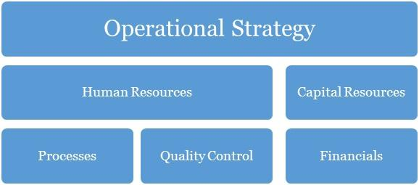

11.0 Operational Strategy

Operation strategy in any business organization is essentially about how the organization seeks to subsist and flourish within the environment over the long-term. The decisions and actions taken within its operations have a direct impact on the basis for which the organization is able to operate. The way in which [Company Name] secures, deploys and utilizes resources will determine the extent to which we can successfully pursue our specific performance objectives. Our operations are built on our core values of professionalism, empathy, resourcefulness, continuous improvement.

Further ahead in this growth process, in whatever we do, we will consider the concept of collaboration too as a major step necessary for effective business management. It is the role of management to know what is of topmost priority to their organization and to their business. And then concentrate more on that core. Our business will, as much as it can, encourage new and upcoming small medium businesses which provide a service within our need base to step up to the challenge of being the best through their affiliations with [Company Name].

12.0 Human Resources

There has to be a well-defined corporate culture with an immersion process for all of its human resources. This starts off as an on-boarding process for new entrants, and then a constant reminder as they stay in the organization (trainings, review, test and appraisals, KSS (knowledge Sharing Sessions) with each of this, having an injection of the DNA of the brand’s core values reminded into them.

This section of [Company Name]’s processes is one that identifies the current and future human resource needs for our organization to achieve its projected goals as listed in our mission and vision statements. It would serve as the link between our management and the overall strategic plan of our organization.

Human resources management and development is a core issue and is hinged on professionalism and productivity. A high premium is placed on our most valued assets, the men and women who would make [Company Name] Retail Shop a household brand in United States and most especially beyond. Our human capital base is made up of people from diverse professional, ethnic, tribal and cultural backgrounds, who exhibit high level of business ethics, are performance driven, result-oriented, ambitious, team players and conform to the company’s standards and core values.

Our employee policies will include:
- Weekly management meetings
- Monthly employee meetings
- On-going training
- Performance reviews every six months
- Performance incentives
- Encouragement of creativity
- Financial Plan

At [Company Name], we understand and partner with employees individually and collectively to support them in meeting their unique aspirations and needs by training, developing, motivating, providing professionally challenging jobs to help them attain self-discovery, fulfilment and contribute to the achievement of our corporate objectives.

The goal at [Company Name] is to have a team of committed associates who empower each other so that the customer's expectations can be exceeded. Our goal is to offer career opportunities, advancement opportunities and a level of income and benefits that is competitive within the region and job classification. It is our long-term goal to be the preferred employer within our niche market.

13.0 Quality Control

Quality control here refers to the standards and mode of operation and provision of value within the organization. This should be defined in the structure so much that all products delivered should be exact with the intended work with no variations at all. To achieve this, there has to be checks, balances and predefined structures to ensure minimal variation from scope, deliverables and quality. This should be in the designation and job description of a Quality Control Officer. This is perhaps the most important work role in the organization.

Quality Control Plan
Our company’s quality control team will monitor and audit every stage of value creation and delivery. The manager will be in charge of analysing quality work done; he is expected to identify any inadequacies that would affect the brand. Indeed, this personnel will be fully authorized to enforce whatever corrective measures may be necessary (including shutting down service) so as to maintain the company’s reputation for excellence.

14.0 Processes

Operational processes are vital to solving problems and tasks while managing the day-to-day issues associated with the engagement, development, management and interaction of people, techniques, businesses and systems. Without a stable foundation of corporate operational processes, organizations devote their management efforts to managing problems in this area, thereby generally failing to achieve the efficiency and effectiveness as well as the confidence, trust and support of staff i.e. the cornerstone to being able to win and grow.

With a thorough understanding of our business operations, we can categorize our entire business processes into the following main aspects including:
  - Management processes
  - Core Business processes
  - Supporting Processes
  - Collaboration
  - Automation

15.0 Financials

The basis for our financial planning has been looking forward with conservative estimates for revenue and expenses. We are committed to consistently growing our cash balances through the prudent management of our expenses. Our focus will be on remaining profitable year after year, while also building adequate cash reserves.

Capital Requirements
In order to expand our business as desired, we require about $66,414 to support the already tangible investments made into the business. The capital requested would be used to incur the following expenses.
Capital Requirements
 | Amount
Capital Expenditure | $ 69,414
Operating Expenses (6 months) | $ 31,957
Other Required Items | $ 1000
 | $ 102,370

Financial Viability
The main criterium for establishing the company is that it achieves financial viability both in the short and long term. Shareholders must be rewarded for the risks that they are assuming by investing in the company through the payment of regular dividends within specified parameters of prudent business requirements.
The company must satisfy customers but at the same time take cognizance of the fact that it may cost more to satisfy some needs than any customers are willing to pay. Or it may be much more costly to try to attract new customers than it is to build a strong relationship with-and repeat purchases from- existing customers. So, profit – the difference between the firm’s revenue and its total costs – is the bottom-line measure of our success and ability to survive. The management team will ensure that there is a balancing point that helps it to determine the needs it will try to satisfy.
Aggressive financial targets have been set for [Company Name] to achieve on an annual basis. These targets are the key focus of the company, without compromising quality of products or service delivery, and includes a return on stakeholders’ funds.
Gross Margin % of Sales
Gross Margin | $ 131,040
Total Sales | $ 211,680
Gross Margin/Total Sales | 61.9%
Total Fixed Expenses
Payroll | $ 59,963.79
Operating Expenses | $ 35,071.43
Operating + Payroll | $ 95,035
Breakeven Sales in Dollars (Annual)
Gross Margin % of Sales | 61.9%
Total Fixed Expenses | $ 95,035
Yearly Breakeven Amount | $ 153,518
Monthly Breakeven Amount | $ 12,793

For a more rigorously detailed financial plan:
PLEASE SEE EXCEL SHEET ATTACHED IN A SEPERATE DOCUMENT

IMPORTANT ASSUMPTIONS
The financial plan depends on important assumptions, most of which are shown in the following table. The key underlying assumptions are:
- We assume a slow-growth economy, without major recession in the following years.
- We assume that there are no unforeseen changes in federal grant funding availability.
- We assume a continued need for our products in the market.

General Assumptions
Inflation Rate | -
Cost Escalator | 10%
Tax Rate | 32%
Dividend Pay-out Ratio | 0%

16.0 EXIT PLAN AND STRATEGY

No one attempts a business with the anticipation of failure. However sometimes ventures do not fulfil their promise. We at [Company Name] are committed to our concept and its viability. In the event that our venture cannot achieve profitability and retire the encumbrances the promoter or investors in the business have several exits scenario options subject to the prevailing conditions and circumstances at the time. These could include any of the following:

SCENARIO I (Promote Staff):
Promotion of its staffs to partnership based on performance, dedication, skills and years of service – this should be considered in the long run.

SCENARIO II (Sell/divest stock):
A promoter or investor looking to exit the business can sell equity to other interested investors. The sellers can choose to sell all or part of their equity.

SCENARIO III (Initial Public Offering):
The company can also break up some of its products into separate entities as it grows large enough. But it is most likely, that sometimes soon; it may go public and will aim to be quoted in the United States Stock Exchange.

SCENARIO IV (Default):
If we are unable to sell the operation for sufficient proceeds, we will be forced to default whereby the loans acquired will be in senior standing. Any further outstanding balances will be borne by the equity share owners of the business on a weighted percentage based on the total amounts due in bankruptcy proceedings.

17.0 Plan Improvement
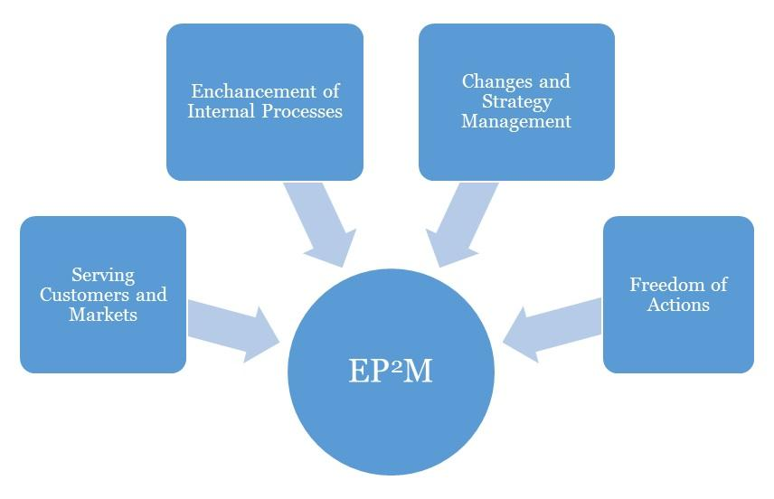
Effective Progress and Performance Measurement

Performance Measurement
This business plan's performance should be assessed against its effectiveness in achieving its high priority goals and performance targets. Occasionally, three (3) months interval should be advised for a Retail Store Business.
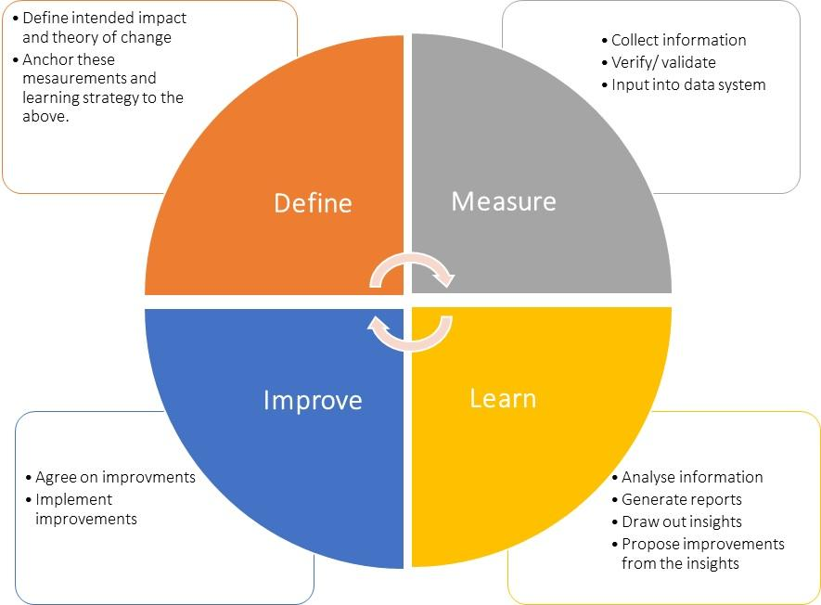

Plan Review and Up Date
To ensure your business plan continues to provide a sharp focus and remain responsive to change, it should be formally reviewed and updated every six months, at the achievement of a strategic goal and at any other time deemed necessary. Implementation of this plan is to be a fixed agenda item at meetings of [Company Name]’s Board of Directors.

