Interior Design Business Plan
… Making your space, speak its story …
This business plan is intended solely for informational purposes to assist in determining if you with a due-diligence investigation of this project. The information contained herein is believed to be reliable, but the management team makes no representations or warranties with respect to this information. The financial projections that are part of this plan represent estimates based on extensive research and on assumptions considered reasonable, but they are of course not guaranteed. The contents of this plan are confidential and are not to be reproduced without express written consent.

TABLE OF CONTENT

1.0 EXECUTIVE SUMMARY……………………………………………………………………….…………….….4
1.1 Vision
1.2 Mission
1.3 Core Values
1.4 Keys to Success
1.5 Objectives

2.0 Company Summary ………………………………………………………………………………………........8
2.1 Business Description
2.4 Milestones

3.0 Ownership and Management…………………………………………………………………………………12
3.1 Management Summary
3.2 Business Model Canvas
3.3 Management Background
3.4 Personnel Plan

4.0 Organizational Structure ……….........................................................................................16
4.1 Organizational Chart

5.0 Value Proposition and Competitive Comparison………………………………………………….18
5.1 Service/Product Offering
5.2 Competitive Advantage

6.0 Market Research and Analysis…………………………………………………………..………………20
6.1 Industry Overview
6.2 Target Market
6.3 Major Competition

7.0 Marketing and Sales Plan…………………………………………………………………………………25
7.1 Product
7.2 Pricing
7.3 Place
7.4 Promotions
7.5 Sales

8.0 Internet Plan ………………………………………………………………………………..………………….28
8.1 Website/Blog Plan
8.2 Social Media Plan

9.0 Strategy and Implementation Summary..........................................................................31
9.1 Marketing & Sales Plan
9.2 Marketing Strategy
9.3 Sales & Marketing Target
9.4 Promotion Pattern
9.5 Distribution Strategy

10.0 Sales Plan..........................................................................................................................36
10.1 Sales Strategy
10.2 Sales Forecast

11 Operational Strategy.............................................................................................................38
12 Human Resources................................................................................................................38
13 Quality Control.....................................................................................................................40
14 Processes...............................................................................................................................41
15 Financials.............................................................................................................................42
16 Exit Plan and Strategy..........................................................................................................47
17 Plan Improvement................................................................................................................48

EXECUTIVE SUMMARY

[Company Name] Inc. is a prospective company that will provide comprehensive interior design services for homes and offices in the United States. We were able to locate a conventional office building in a prime location in Virginia Beach, Virginia. We are a world-class interior design firm eager to participate in the highly competitive interior design market in the United States and worldwide.
[Company Name] Inc. will provide residential interior design, commercial interior design, goods sales, interior decorating services consultancy (such as advise on interior decorating matters, residential design, and institutional design), and other related services.

Our company's ambition is to become one of the top interior design businesses in the United States, and we will ensure that every graphic design task that leaves our studio can compete with the best in the sector. As the company expands, our staff will be drawn from a pool of bright and innovative interior designers in and around [Location], [State], as well as from all over the world, particularly Toronto and Madrid.
We will ensure that all of our staff have the necessary training to accomplish their jobs successfully and compete with the greatest interior designers in the United States and around the world.

At [Company Name] Inc. the best interests of our clients come first, and everything we do will be guided by our principles and professional ethics. We will ensure that we live up to the highest standards by serving our clients' needs precisely and completely.
We will build a work environment that allows our partners, employees, and clients to earn a living while also living in a compassionate and sustainable manner in our world. [Company Name] Inc. was founded by [Owner] and her long-time friend, classmate, and business partner, [Co-owner].

They both received their degrees from The Interior Design School [State]. [Owner] earned an MBA from the [State] School of Economics. [Owner] and [co-owner] worked for one of Europe's top interior design firms before launching [Company Name] Inc.

This couple is well-versed in the interior design industry and has read extensively on the subject. They will be able to create something beautiful from the ground up.

Capital Needs
[Company Name] Inc. will run at an assumed sales profit of approximately $150,627 in its next year of expansion, with a profit after tax of $21,536 and a consistent progression for the future years. We seek an additional loan of $66,414 in capital contribution. The chart below explains our projections:

(All figures shown in the graphs are in $’000)

Our marketing strategy will include the use of both flank and guerrilla type of marketing attack to topple larger brands by offering unique service and experiences at competitive prices that is being ignored by larger brands. We will also include online marketing with great focus on social media and an active blog to position our brand as the industry leader with our regular contents.

1.1 Our Vision
Our vision at [Company Name] Inc is to build a standard interior design firm whose services and brand will be accepted not only in [Location], but also throughout the United States of America and other areas of the world.

1.2 Our Mission
Our mission at [Company Name] Inc is to develop an interior design firm that is known for executing high-quality designs and projects, and to become the first option of real estate agencies and other industry stakeholders.
We aspire to develop an interior design firm that can compete competitively with other industry leaders.

1.3 Our Core Values
The following core values drive our operations, products and team.
- Integrity
- Excellence
- Originality
- Creativity
- Teamwork
- Competence
- Innovation

1.4 Keys to Success
[Company Name] Inc.’s enviable success is achieved through:
- Creating a Fantastic Portfolio: The portfolio is one of the first few items a prospective client will look at when selecting an interior design firm, as we are aware. As a result, we've developed separate portfolios for commercial and residential projects that each feature a selection of the best images of our work.
- Efficacious Publicity: Our publicity strategy is to consciously position our brand as a maven within the industry by affiliating with complementary corporate and luxury brands. Our campaigns and publicity will include online visibility such as social media engagement and an interactive website supported with an active blog as well as prints and referral in reaching our potential clients.
- Referral System: Also, a strong referral system is essential.
- Maintain a Quality Relationships with Clients: As a company, our ultimate goal is to amass a clientele so large that each individual is able to confidently apply for our services again and recommend us to their friends and family. We ensure this by further addressing the interior design needs of these customers, provide them products that have been particularly picked & charging reasonable prices for our services that don't leave our consumers in the red but also leaves a profit for us. As an added measure, we make sure all of our customers' complaints and repairs are handled with care by keeping up a strong online presence, talk to our clients through our website & other personalized ways of communicating and sending them follow-up communications.
- Brand and Reputation: The business and brand model are aimed at providing the best possible level of interior design & advice quality. Our brand feel and experience will go beyond the basic service that we offer but will include other value-added services such as excellent customer experience, and trust that creates loyalty to the brand. Our brand strategy will be geared towards an abstract feel of superior experience with [Company Name] Inc.
- Outsourcing Extra Duties: The importance of paper works in the interior design industry is not lost on us. In contrast to the time spent on paperwork, we would rather go shopping for our clients. So that you can save time and energy that you can put toward more important endeavors. We want to hire an experienced bookkeeper to take care of our financial records, file our taxes, and provide us with regular updates on the health of our company.
- Monitor Online Reviews/ Customer Satisfaction & Feedback: We understand that reviews can make or ruin any business and that the most powerful form of marketing is by word of mouth. As a result, we will ask for feedback from customers to know how they rate us and to find out areas to improve in our services. We will do our best to keep track of our reviews on a frequent basis. Respond to all customer reviews, whether positive or negative, if at all feasible, so that prospective clients that search for our company online will understand that we appreciate our customers and are constantly striving to improve. We will give customers an incentive (like a discount) to review our mobile phone shop and build trust online.

1.5 Objectives:
In a more quantifiable outline, we hope to achieve the following:
- Predefine a series of brand promises we must keep. This will be more like a broadcasted accord of threshold we will never fall short off.
- To create a service-based company whose goal is to exceed customers expectation while creating hype moments (neuropsychologically exciting experiences) and moments worth returning to.
- To have a clientele retention and return rate of near 90% year on year.
- To increase the number of clients served by at least 200% per year through superior marketing performance and word-of-mouth referral schemes.
- Profitably deliver world-class interior design service that would enhance our clients' satisfaction level in general.
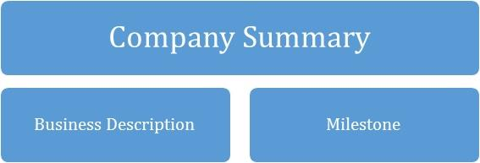

2.0 COMPANY SUMMARY

[Company Name] Inc. is a customer-centric brand that will be focused on providing professional residential interior design, commercial interior design, goods sales, interior decorating services consultancy (such as advise on interior decorating matters, residential design, and institutional design), and other related services.
We’d lay prominence on the overwhelming demand for a good interior design service around the globe and the satisfaction that comes with getting the exact interior service paid for without lifting a muscle, thereby giving our customers the desired results.

In addition, with the invaluable experience garnered over the years and with the support of a seasoned team, tools and technology, [Company Name] Inc. will promote positive responses towards what we do, that will convert consumers into customers then into loyalists and eventual evangelists.

However, what will set [Company Name] Inc. apart from the competition is our focus on interior service innovation through technology and commitment to providing professional, friendly, self-service, prompt, cost effective, time effective, a brand networking hub, and most importantly, personalised services.

2.1 Business Description
As a legal entity, the company is registered under the [Your Country’s Corporate Affairs Commission] as [Company Name] Inc. We operate from our office in [ Location], and we look forward to open a second office at [New location after expansion], equipped with a reception to receive customers, interact with them and book sections for our services.

We will provide goods and services related to the professional courier industry including, delivery of different types of goods to our various customers both locally and nationwide, consultancy services, trainings, franchise etc. as part of our wide range of courier services. Other services eventually will include international deliveries.

2.2 Milestones till date
Type | Status | Timeline
Business Name Availability Check | Completed | September 2022
Business Incorporation | Completed | August 2022
Opening of Corporate Bank Accounts various banks in the [Country Name] | Completed | July 2022
Application and Obtaining Tax Payer’s ID | In Progress | November 2023
Application for business license and permit | Completed | June 2022
Purchase of All form of Insurance for the Business | In Progress | October 2023
Drafting of Contract Documents | Completed | February 2023
Securing a Standard Office Facility Plus Renovation of the Facility | Completed | December 2022
Secure trademark for our products | In Progress | January 2023
Opening Online Payment Platforms | Completed | January 2023
Conducting Feasibility Studies | Completed | January 2022
Generating part of the start – up capital from the founders | Completed | November 2023
Writing of Business Plan | Completed | January 2022
Drafting of Employee’s Handbook | Completed | January 2022
Design of The Company’s Logo | In Progress | February 2023
Graphic Designs and Printing of Packaging Marketing / Promotional Materials | In Progress | February 2023
Recruitment of employees | In Progress | July 2023
Purchase of the Needed furniture, office equipment, software applications, electronic appliances and facility facelift | In Progress | May 2023
Creating Official Website for the Business | In Progress | October 2023
Creating Awareness for the business | In Progress | January 2023
Health Safety and Fire Safety Arrangement | Completed | November 2022
Establishing business relationship with vendors and key players in the real estate industry | Completed | January 2022

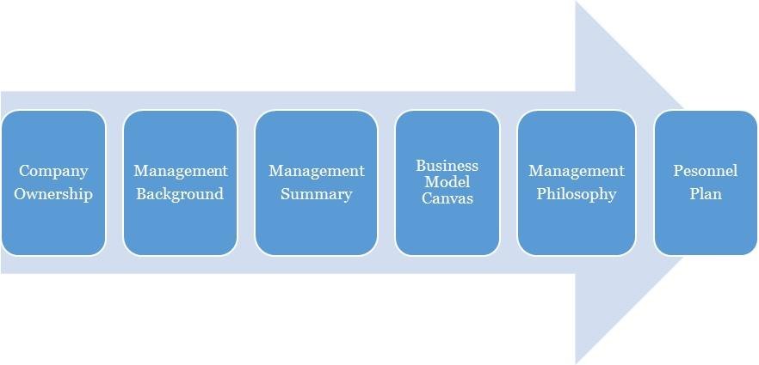

3.0 OWNERSHIP AND MANAGEMENT

[Company Name] Inc. is owned by [Owner 1] and [Owner 2]. The management of [Company Name] Inc. is a simple one with the CEO acting as the MD to provide leadership for the organization as operations are managed by the Manager; [Owner 2].

As of November 2023,
Name | Title | No. Of Shares | % Of Ownership
Owner 1 | CEO |  | 50%
Owner 2 | Manager |  | 50%
TOTAL |  |  | 100%

3.1 Management Background
Owner 1:
Owner 1 is a self-motivated and reliable individual, familiarized to working in fast-paced environments where the goal is to deliver top-notch service; with a remarkable track record of experience in Leadership, holding top positions in interior design-related establishments.

He holds a Master’s Degree in [Course], United Kingdom and a Bachelor of Science Degree in Accounting from ________, United States. He is a certified professional under Leadership in Energy and Environmental Design (LEED). His trainings and experience have also helped him develop his leadership and coaching skills and a strategic view-point to every project or endeavour.
Owner 2:
[ Owner 2] is the General Manager of [Company Name] Inc., a position he will hold after its inception in ____. He is a graduate of [school] holding a Second-class Upper degree in [Course]. He is a certified professional under NCIDQ (National Council Interior Design Qualification) United States.

[Owner 2] hails from ______ in ____; he is an innovative, vivacious individual with the passion to achieve greatness. He is also a goal setter and achiever who ensures all the pre-requisites for achieving the set objectives are met. As a leader he recognizes the value of team work, team play and time management.

3.2 Management Summary
The management philosophy at [Company Name] Inc. will be based on mutual respect for each of our fellow colleagues and for every customer.

Our success will depend a lot on how well we serve our customers and how well we get along with them. That's why we'll always focus on making the best designs and will treat our employees well and tell them to do the same with customers. Our employees are the face of the brand and will represent the brand when decorating and designing houses for our clients. Employees who are customer-oriented and committed to quality will boost customer loyalty and repeat business.
The management team will consist of the owner/CEO and the general manager. We will hire only those who demonstrate the qualities necessary for working in a nurturing environment, and the willingness to learn more skills and move forward in study of energetic principals if not already so trained.
Furthermore, all duties will be divided and delegated according to the strengths and weaknesses of our staff. At [Company Name], we will expect a high degree of designing skills and personality as this is essential to our success. The management team will assess the productivity and performance evaluations of all employees every two months. These bi-monthly evaluations are conducive to the continued growth of our business.

3.3 Business Model Canvas
Business Model Canvas for [Company Name] Inc.
Key Partnerships  Real Estate Companies & Realtors, Construction Companies, Home Builders associations,  Financial Partners, Cluster Groups | Value Propositions  - Excellence  - Brand  - Relationship  - Customer Service  - Professionalism | Customer Segments  Business to Business  - Hotels  - Restaurants  - Corporate Organizations  - Home Improvement Companies  - Commercial builders of office and home complexes  - Furniture stores  - The Government (Public Sector)  - Religious Organizations (Church hall and other places of worship)  - Television Stations (studios and offices)  - Property Development Companies  - Schools  - Salons  - Clubs and Bars  - Other Interior Design Businesses who would outsource orders they are unable to complete  Business to Client  - Private Individuals  - Home Owners
Key Activities  Providing interior design services to both commercial and residential houses in the country, Consulting services, Training. | Key Resources  Equipment, skills, physical location, vehicles, staff |  | Channels  Direct services, website  Third party drop offs
 | Customer Relationship  Online, offline, community  Social media, customer support, discounts and promotional |  | Channels  Direct services, website  Third party drop offs
Cost Structure  Operational costs: Marketing & ads, logistics, Internet subscription, airtime charges, fuel, maintenance  Utility: electric bills, rents, salaries (skilled labor) etc. |  |  | Revenue Streams  - Residential interior design services  - Commercial interior design services  - Merchandise sales  - Other related services like giving interior makeover to historic buildings, vehicles, such as ships and aircraft et al  - Interior decorating services consulting services (Consulting on interior decorating matters, Consulting on residential design matters, Consulting on institutional design matters & Training)

3.4 Personnel Plan
[Company Name] Inc. is a growing firm and as such staff will be hired according to recommendations, experience and education in their field. High standards will be kept through the orientation and inclusion period for new employees and the new employees will be given a mentor to shadow for the first two (2) weeks of arriving. In so doing, the employees can pick up the ethics of working and representing the [Company Name] brand.

Checklists will be drafted to monitor employee’s quality of service after three months. Staffing and training will be available for sales representatives and customer service candidates. Every personnel will be given specific assignments and valued on completion of the assignment. One on one meetings will be held to discuss and handle any arising issue regarding performance and service.

4.0 ORGANIZATIONAL STRUCTURE

To have a truly value driven team that would be productive, there is a need to map out what is most important to the organization and the team in order of prioritization. This is to ensure a chain of interrelated entities that will define our organization structure. For [Company Name], the following is a further illustration.
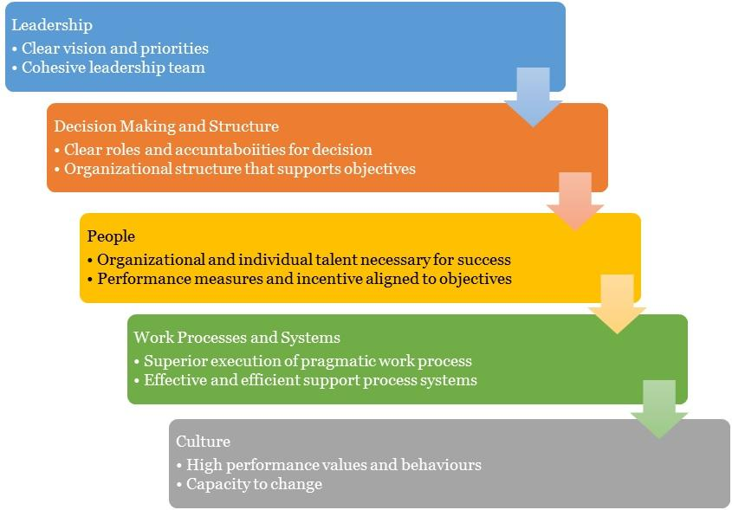

4.1 Organizational Chart

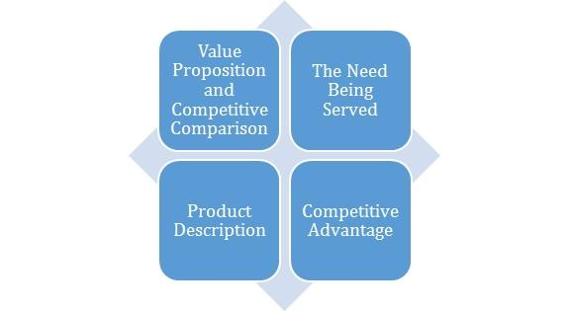

5.0 Value Proposition and Competitive Comparison

Value Proposition
At [Company Name], we understand that the core of our business is centred on people, and this is the paradigm that inspires our entire processes and structures. We promise to make our clients experience more with our brand as we provide superior interior designing service at a cost-effective rate.
In a more measurable outline, here’s our value proposition and market reach:
- Provide the best of interior designing service within [Target Location].
- Scale up the operations and expand the interior design business.
- Ensure maximum profit for our shareholders using effective and efficient strategies in the markets that we operate in.

5.1 Service/Product Offering

[Company Name] Inc. was founded to maximize earnings in the interior design cum real estate industry. We want to compete advantageously with the premier interior design firms in the United States, which is why we have put in place a quality assurance team that will ensure that all of our interior designs and related services meet or even exceed the expectations of our customers.

We will work diligently to guarantee that [Company Name] Inc. is recognized not only in [Location], but also throughout the United States. This is a list of our products and services:

- Residential interior design services
- Commercial interior design services
- Merchandise sales
- Interior design services advisory services (Consulting on interior decorating matters, Consulting on residential design matters, Consulting on institutional design matters)
- Other similar services, such as renovating the interiors of historic buildings, ships, and aircraft, etc.

5.2 Competitive Advantage
Without a question, the rivalry in the interior design market is intensifying by the day; as a result, you must be highly creative and generate appealing designs and concepts to succeed in the field. Interior design is a lucrative and highly competitive sector, as individuals continue to acquire or move into new apartments and modify older ones. Customers will only engage your services if they know they will receive nothing less than the best.

We are well aware that to be highly competitive in the graphic design sector, one must not only be able to produce consistent and highly original designs, but also accomplish predetermined goals. No one would want to retain your services if you consistently miss the deadlines for completing jobs. Our competitive advantage is derived from the strength of our team; our labor force. We have a staff of creative and highly skilled interior designers, a team with strong credentials and experience in a variety of interior design business niches.

In addition to the synergy between our carefully picked interior designers, we have strong relationships with major stakeholders in the real estate business, and our designs and services will adhere to industry standards. Lastly, all of our employees will be well cared for, and their welfare package will be among the finest in the business for our sector (new interior design firms in the United States). It will make them more than willing to build the business with us and assist us in achieving all of our business objectives and ambitions.

6.0 MARKET RESEARCH AND ANALYSIS

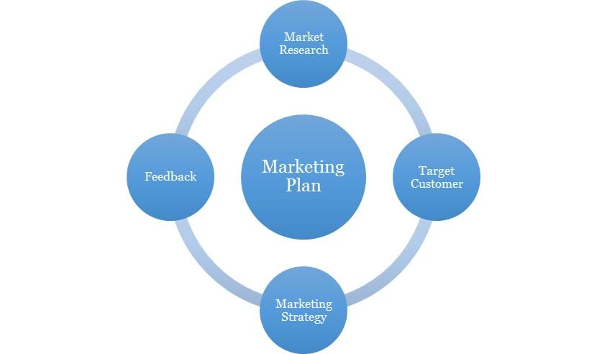

6.1 Market Overview
When we speak of interior design or interior decoration, we are referring to the art or process of creating the inside and, in certain situations, the exterior of a facility, such as a room or a building. A person whose duty it is to coordinate and oversee the execution of such projects is an interior designer.

Interior design is, in reality, a multifaceted profession that encompasses tasks such as conceptual creation, communication with project stakeholders and management, and, of course, design implementation (project as agreed).

Companies that specialize in interior design are responsible for planning the design of both residential and commercial spaces; they are adept at bringing their ideas and concepts to life. The scope of the assignments handled by interior designers might be vast. It could include everything from structural improvements to the choosing of matching furniture, curtains or blinds, wallpaper, and lighting, etc.
Throughout the past five years, the Interior Designers sector has undergone constant expansion and new developments, making it a very large industry. Over the following five years, however, the industry is anticipated to witness a slight improvement. Over the next five years, as existing home sales and housing starts gain pace, there will be a corresponding increase in the demand for residential interior designers.

Similarly, a rise in corporate profit, development, and expansion of corporate organizations will create commercial prospects for interior design firms, as businesses will need to renovate their facilities to accommodate shifting fashions.

According to statistics, market share concentration in the Interior Designers business is low. For example, in 2016, the top four interior decoration design firms are anticipated to account for less than 10% of the industry's overall revenue. In addition, throughout the past five years, the concentration of market share has not altered substantially.
It is essential to clarify that the Interior Designers sector is highly fragmented, with hundreds of companies, of which only a small fraction generate yearly revenues in excess of $1 million. Due to the nature of their work and the little start-up capital required to launch a business, a considerable percentage of interior designer professionals are self-employed.

Indeed, the interior design industry is a very vast and global one. There are over 102,848 registered interior design firms in the United States, which employ approximately 127,467 people and generate a staggering $13 billion yearly, according to the statistics.

In 2014 alone, the federal government of the United States of America spent $11,270,048 on interior designers. During the time under consideration, they awarded 437 interior design contracts to 77 firms, with an average contract value of $146,364.
The industry is very competitive and has a consistent yearly growth rate of 3%. The interior design market is receptive to any prospective entrepreneur who possesses the necessary talents to launch his or her own interior design business and, of course, make a solid living in the sector.

In fact, it was predicted that over the next five years, new technologies will continue to emerge that will make it easier for new companies to enter the business, hence increasing industry rivalry.

Economic, Social and Technological Factors
The interior design industry, like many others, has been reshaped by the current economic climate. According to recent publications, the global Interior Design market is expected to grow at a significant rate between 2018 and 2025, owing to technological advancements, an increase in innovations, an increase in demand, increased awareness and curiosity among the masses, a change in lifestyle, an increase in the standard of living, and an increase in the population's disposable income.
During the forecast period, the residential segment of the Interior Design market is expected to be the market leader.
Because of the influence of urbanization culture around the world, people experience different kinds of cultures such as values, food, festivals, and lifestyles and work with people of different nationalities, cultures, and love, the residential segment dominates the global Interior Design. Because of growing workplace concerns, corporations are expected to be the fastest growing market, necessitating a greater emphasis on creating physical spaces and cultures that attract employees.

Technology has affected the interior design industry positively. Designers use digital design processes like Building Information Modeling (BIM) to create and manage a space's physical and functional elements. This helps the designer, client, lead real-estate builder, and architect coordinate and communicate.
Thus, technology improves accuracy, reduces errors, and lets designers realize their ideas without a lot of time, money, or effort.
Mood boards, or inspiration boards, are a common tool for designers. Moodboards can be made with a smartphone app. Instagram and Pinterest have become popular places for designers to share their inspiration boards with the world.
These aid customers in imagining the end result. To cater to their clients' wide range of preferences, designers utilize a variety of technological resources. Technology advancements usually result in updated design software.

With the help of modern tools like social media, SEO, etc., promoting an interior design business is now much simpler. As a result, designers can now use Foyr Neo, Cad Software, and E-pens to quickly and easily create portfolios and showcase design samples to their local market. By collaborating with one another in online communities, designers can quickly pick up tips on how to advance their careers and streamline their operations.

Predicting interior design trends is difficult. Social influence affects everything. Take the recent coronavirus outbreak. Work-from-home interiors have changed in weeks. It is

Interior design, like many fields, caters to consumers. Designers advise, not set trends. We improve and develop them. We listen to customers and meet their specific needs.

Social change involves functionally and aesthetically solving everyday problems or meeting local needs. A designer uses time, money, evaluation, and engagement to create a realistic design concept to meet needs and improve society through social change. Social change involves designers taking social responsibility through social justice, equality, and sustainability to address social issues in their designs. Interior designers create life-enhancing physiological and sociological interiors. Because design solves the world's biggest problems, designers have a social responsibility. As interior design becomes more popular, designers are urged to create spaces that benefit people, the environment, and the economy.
Social design in interior design is a process that improves human and environmental well-being and livelihood.

6.2 Target Market
Before launching our interior design firm, we were certain that a variety of corporate and individual clients cannot successfully move into a new facility without the assistance of interior designers. Without the services of interior designers, the interiors of facilities would not be as attractive and welcoming as they are today.
We will ensure that we form strategic alliances with real estate developers, property management firms, local builders, real estate agents, and home improvement companies.
This will provide our business with multiple options for generating revenue. In light of this, we have developed strategies that will enable us to reach out to corporations and individuals who cannot afford to forego our services. After conducting our market research and survey, we will ensure that all of our interior design services are well-received on the market.

Below is a list of the individuals and organizations to whom we have marketed our products and services.

- Construction Companies
- Property Development Companies
- Home Owners
- Corporate Organizations
- Realtors —for their clients’ homes
- Home Improvement Companies
- Commercial builders of office and home complexes
- Home builders associations
- Furniture stores
- Paint and wall paper stores
- Flower shops
- Real Estate Owners, Developers, and Contractors
- The Government (Public Sector)
- Hotels
- Religious Organizations (Church hall and other places of worship)
- Television Stations (studios and offices)
- Everyone in our target market who would require our services

6.3 Competitive Environment
The industry, with respect to this service niche is relatively green. There are top and thriving interior design companies in ____, with strategic locations across the city. Some of them are listed below;
- ********
- ********

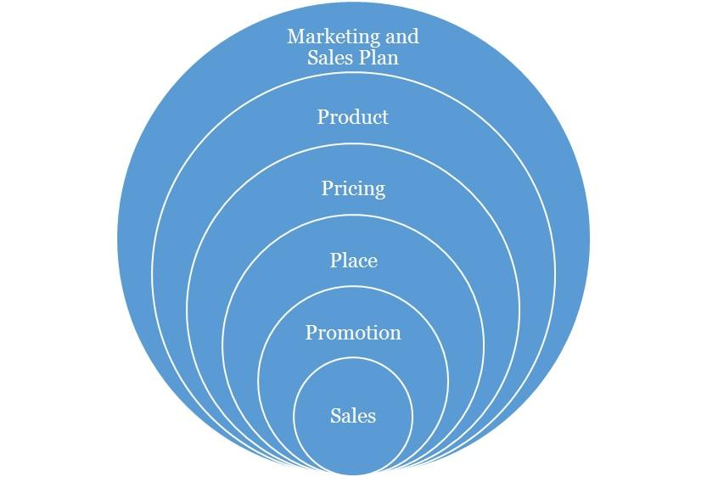

Marketing and Sales Plan

Concerning our marketing, we will execute a comprehensive strategy that is centred on the 4P’s of marketing (this refers to Product, Pricing, Place and Promotions) which are fundamental to any campaign. Each aspect is discussed as follows:

7.1 Product
We have developed relevant designs that are tailored for the customer segments that have been identified. These will cut across the core aspects of our service offering, ranging from local to nationwide houses,Training, consulting etc.

7.2 Pricing
The pricing strategy to be adopted will be a combination of the cost-plus pricing and competition-based pricing. This entails fixing prices for the services that ensures that production costs are covered and a fair profit margin is realised from sales. However, in selecting this price points, consideration will be given to the prices offered by competitors in the industry. We are high end as shown in the services we provide, but more affordable than the average ones. This will ensure that we do not price ourselves out of the market. And as we progress, our brand growth and imagery will become a factor to our pricing.

7.3 Place
We seek locations that puts us in a comfortable uncontested niche that will help ensure we can capture the clients in the vicinity and retain them. Our physical location and place aim to strike a balance between brand exposures, awareness, achieving maximum accessibility to clients, while keeping costs low.

As the business grows and expands, subsequently, we will explore the possibility of establishing [Company Name] Inc. in other major places in [Target Location] and other large cities in the country where potential clients are identified to be situated.

7.4 Promotions
In terms of promotion, we will implement an awareness process engineering aimed at market activation, customer acquisition and retention strategy. Our promotions will be hinged on creating awareness and deals from the quality of our service offering, the experience, cost and time effectiveness etc. We will employ innovative product and service promotion techniques to acquire customers.

Types of Promotion and Explanation
Advertising | As an SME, [Company Name] will minimize its exposure to Above The Line advertising with exceptions to major events, but will engage in Below The Line and Through The Line Advertising.  The Above The Line (ATL) advertising includes the following; mass media, large format printing, electronic broadcasts and it’s for building brand awareness and goodwill.  The Below The Line (BTL) includes the following; industry magazine, newsletters, social media and google AdWords.  [Company Name] will invest resources and promote using BTL with a focus on social media and an active blog in targeting specific clients and to build an awareness. Social media unlike traditional media provides insights and analytics to measure pubic interaction and a quicker ROI.
Public Relations | Consistency, good clients’ relationship and excellent service will grow the brand’s recognition and increase its market share and sustain growth. We will also continually share our core values and brand promises with the public, with the aim of making [Company Name] Inc. synonymous with high-end interior design service.  We will also maintain close relationship with our clients for feedback, as well as with our vendors in clusters, alliances and complementary organizations.  The art of a good public relations is not only to obtain favourable publicity within the community, but to raise and keep the awareness within the vicinity. It also involves being able to handle attention, support and feedback.
Sales Promotion | We will create strategies targeted to our client segments and make available promotions and referral bonus to increase sales. We trust we will keep these clients with our excellent service and through our value-added service creating loyalty.
Internet Marketing | We will promote and sell our service over the internet such as our interactive website, active blog, social media handles, affiliate marketing and sponsoring across popular blogs and social media influencers.

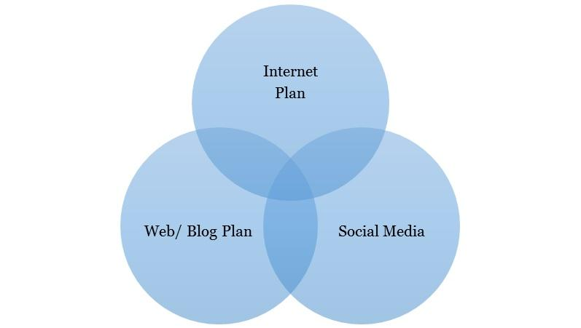

8.0 Internet Plan

The internet is here to stay and any business not positioned towards this trend will most likely be disrupted from within the industry. Internet plan is not limited to a website alone as this is one of the many platforms that should be maximized for business purposes.

8.1 Web/Blog Plan
Our website will serve as a source of information for online visitors and our strategy is to optimize the use of search engine optimization and search engine marketing (SEO/SEM), and the development of editorial content. This simple strategy will easily position the brand as a maven within this segment of the industry. [Company Name] will evaluate and also include on-demand capabilities into its business model.

The overall strategy of the website will be to provide a clear and simple architecture that allows the user obtain all the information they need, simply and easily.

Website Marketing Strategy
The website will be integral in [Company Name]’s marketing effort as the site is a key sales tool for both local and distant customers. The URL address will always be used in promotional material, encouraging people to check out the company and service offering. In addition to the inclusion in traditional marketing campaigns, [Company Name] will submit its website to a variety of search engines, significantly increasing the number of inquiries from people searching our services.

Development Requirement
A computer programmer/designer will be employed with the tasks to manage the design, implementation, and maintenance of the website. The majority of the tasks will be completed by him/her; a few tasks that are outside of his/her skill set will be subcontracted to associates

8.2 Social Media Plan
Objectives:
- To increase the [Company Name] brand awareness
- To build close rapport with potential and existing market
- Position the [Company Name] brand as the maven within the industry
- Increase two-way communication with current and prospective clients.

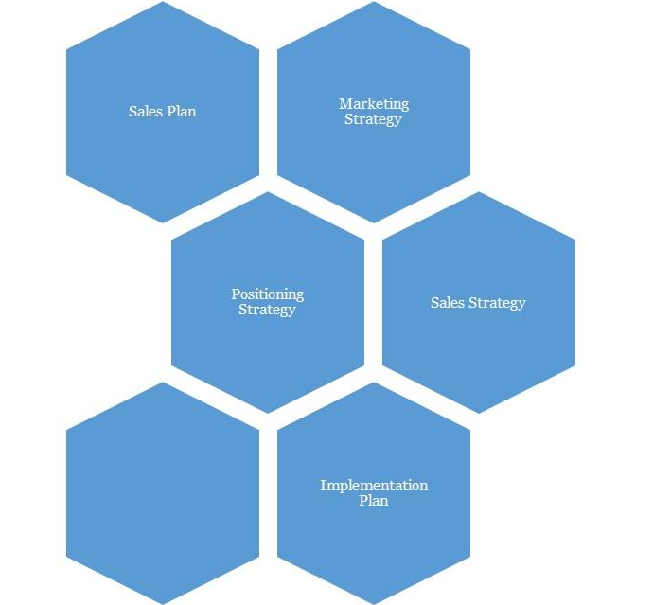

9.0 Strategy and Implementation Summary

At [Company Name], we recognize the importance of marketing and promoting our service as a factor to business growth and success. And to that end, we plan to promote our business with an ambitious, targeted marketing campaign. Our goal is to keep our marketing budget to no more than 5% of our gross annual sales.

9.1 Marketing and Sales Plan
[Company Name] will activate the following market plans to boost brand visibility and acceptance as well as grow engagement:
- Defining our central ideology is essential.
- Creating prominence on social media. This is just beyond posts and likes, but engagement techniques too. This may require a social media content plan.
- Define [Company Name]’s set of brand promises clearly

[Company Name] will also activate the following plans:

- Having a marketing strategy and marketing operations that targets not just individuals but corporate and cluster groups: servicing cluster groups and corporate organization will aid in economies of scale. Cluster groups may include residence associations, mini estates and service apartments, gyms, churches, small hotels etc.
- Word of Mouth marketing is still the most effective form of advertising, so a mechanism has to be devised for this. An example is a simple referral form shared amongst our most loyal customers, and a discount incentive for each referral.

9.2 Marketing Strategy:
We are aware of the increased competition in the interior design industry; there are numerous interior designers vying for contracts, which is why we have been able to hire some of the best marketing professionals to handle our sales and marketing.

The sales and marketing team of [Company Name] Inc. will be recruited based on their extensive experience in the real estate market, and they will receive regular training so that they are well-equipped to meet their goals and the company's overall business objective.

Our objective is for [Company Name] Inc. to become one of the leading interior design firms in the United States of America, which is why we have devised strategies that will enable us to capitalize on the available market and grow to become a major force not only in [Location] [State], but also in other cities across the country. We plan to use a couple of specific online techniques to guarantee that customers outside of [Target Location] are aware of [Company Name] Inc. Not only will our website be interactive and user-friendly, but it will also be well-designed to appear in top searches for people looking for the best interior service.

Finally, we at [Company Name] Inc plan to adopt the following marketing strategy to increase the number of clients for our courier service:

- Sponsor pertinent community-based activities and programs.
- Sell our services through the internet - our website – as well as social media
- Engage in periodic roadshows in targeted neighborhoods
- Ensure that all of our employees wear company-branded shirts and that our logo is prominently displayed on all of our vehicles and trucks, etc.
- Advertise in local publications as well as on local radio and television stations.
- Encourage our long-term clients to recommend us to their friends and family.
- Participate in direct marketing.
- Promote [Company Name] through both traditional and online directories
- Utilize the internet and social media platforms such as Instagram, Facebook, Twitter, YouTube, and Google Plus, among others, to market our services.
- Place our billboards in strategic locations throughout [Location], [State].
- Distribute our flyers and leaflets in strategic locations.
- Contact businesses and residents in our target areas by phone and inform them of [Company Name] Inc. and the services we provide.
- Include our interior design firm in local business directories and the yellow pages.

9.3 Promotion Pattern
At [Company Name], our promotional strategy will be based on maximizing technology and new media through the internet and our cluster group alliances. But most importantly, an exponential referral scheme.

Advertising:
- We will utilize the social magazines, cinemas, and top executive conferences and seminars with our exclusive services.
- We will advertise on the business bulletins of most companies around that area. We will also create value driven post-cards that is aimed on giving insights on interior designing as a subliminal way of advertising to its holders and readers.
- We will have a comprehensive website with full interactivity. We will also make use of the social networks to promote and drive traffic to what we do.

Also, we will love to work with PR/ Advertising Stakeholders. These refer to the sales influencers. They include:
Blogs: Blogging has become very popular now in the United States and is one of the most popular means of brand / product promotion. The question we hope to constantly ask and answer the question, “How Can [Company Name] maximize the platform of blogging to create awareness in a less typical way”?

9.4 Distribution Strategy
One of our distribution channels will be focused on the use of alliances
- We will place our brochure within the offices of our corporate referral clients. We will also be giving commissions to clients who refer us to others.
- We will work on building a database of all the top executives of banks, cinemas, IT firms and other offices around a 50metre radius and to try to create an alliance with them.
- In addition, we will forge alliances with our referral clients, financial institutions, corporate firms, media, top hotels, firms and restaurants, offices, cinemas and businesses that will be strategically beneficial for generating new clients.

9.5 Positioning Strategy
In terms of positioning, we would be applying a marketing warfare concept where we choose to apply four different methodologies depending on the market dynamics. These methodologies are listed below as:
- Defensive: Defensive strategy would be applied when we are sure to be the market leaders.
- Offensive: Offensive strategy would be applied when we are sure to be the strong challenger.
- Flanking: Flank strategy would be applied when we are sure to be the weaker challenger.
- Guerrilla: Guerrilla strategy would only be applied when we are sure to be struggling for survival and want to avoid being crushed by the bigger competitors.

We believe that marketing is all about positioning, and we being able to identify our position and applying the right strategy. At this point it is interesting to note that our marketing program is not just about customers, but about gaining, for ourselves, a noticeable proportion of the total available market share or its segment being occupied.

9.6 Pricing Strategy
As we progressively penetrate the market, our fees will come with discounts yet it would retain a competitive positioning as much as possible. But as we gain larger brand equity, we will add more value-added services that will justify an increase in our prices when we ever see the need to do so. However, it is important to note that while competition enables a healthy business atmosphere, we aim to build an iconic brand that makes the competition feel irrelevant by continuously perfecting and offering more value-added service to all of our clients. We will not charge over, nor substantially under, rather will we be charging standard prices in line with quality for our services just as our contemporaries in do.

10.0 SALES PLAN

10.1 Sales Strategy
The sales function will be driven by our in-house sales unit. The unit will be responsible for lead generation and management. This will be required to meet sales targets that will be set on a weekly basis. The sales unit will be headed by the manager and the CEO will be kept abreast. Both of them will be responsible for coordinating all sales activities.

10.2 Sales Programs
- Our comprehensive brochure will explain the nature of our services, and how this benefits our clients. It will be able to paint a vivid picture of who we are, what we offer and where we are going.
- Our website and social media will be comprehensively informative, updated weekly of our services, latest interior designs, techniques as well as tips and free benefits. Additionally, we will have pages on social networks to always create traffic for [Company Name].
N.B: Check the Sales breakdown sheets on the financial model for more information

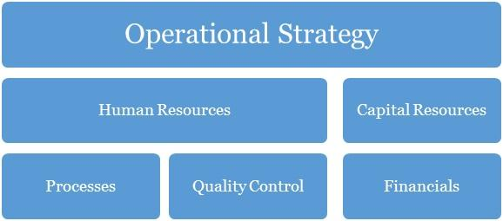

11.0 Operational Strategy

Operation strategy in any business organization is essentially about how the organization seeks to subsist and flourish within the environment over the long-term. The decisions and actions taken within its operations have a direct impact on the basis for which the organization is able to operate. The way in which [Company Name] secures, deploys and utilizes resources will determine the extent to which we can successfully pursue our specific performance objectives. Our operations are built on our core values of professionalism, empathy, resourcefulness, continuous improvement.

Further ahead in this growth process, in whatever we do, we will consider the concept of collaboration too as a major step necessary for effective business management. It is the role of management to know what is of topmost priority to their organization and to their business. And then concentrate more on that core. Our business will, as much as it can, encourage new and upcoming small medium businesses which provide a service within our need base to step up to the challenge of being the best through their affiliations with [Company Name].

12.0 Human Resources

There has to be a well-defined corporate culture with an immersion process for all of its human resources. This starts off as an on-boarding process for new entrants, and then a constant reminder as they stay in the organization (trainings, review, test and appraisals, KSS (knowledge Sharing Sessions)) with each of this, having an injection of the DNA of the brand’s core values reminded into them.

This section of [Company Name]’s processes is one that identifies the current and future human resource needs for our organization to achieve its projected goals as listed in our mission and vision statements. It would serve as the link between our management and the overall strategic plan of our organization.

Human resources management and development is a core issue and is hinged on professionalism and productivity. A high premium is placed on our most valued assets, the men and women who would make the interior design business Inc. a household brand in United States and most especially beyond. Our human capital base is made up of people from diverse professional, ethnic, tribal and cultural backgrounds, who exhibit high level of business ethics, are performance driven, result-oriented, ambitious, team players and conform to the company’s standards and core values.

Our employee policies will include:
- Weekly management meetings
- Monthly employee meetings
- On-going training
- Performance reviews every six months
- Performance incentives
- Encouragement of creativity
- Financial Plan

At [Company Name], we understand and partner with employees individually and collectively to support them in meeting their unique aspirations and needs by training, developing, motivating, providing professionally challenging jobs to help them attain self-discovery, fulfilment and contribute to the achievement of our corporate objectives.

The goal at [Company Name] is to have a team of committed associates who empower each other so that the customer's expectations can be exceeded. Our goal is to offer career opportunities, advancement opportunities and a level of income and benefits that is competitive within the region and job classification. It is our long-term goal to be the preferred employer within our niche market.

13.0 Quality Control

Quality control here refers to the standards and mode of operation and delivery of value within the organization. This should be defined in the structure so much that all products delivered should be exact with the intended work with no variations at all. To achieve this, there has to be checks, balances and predefined structures to ensure minimal variation from scope, deliverables and quality. This should be in the designation and job description of a Quality Control Officer. This is perhaps the most important work role in the organization.

Quality Control Plan
Our company’s quality control team will monitor and audit every stage of value creation and delivery. The manager will be in charge of analysing quality work done; he is expected to identify any inadequacies that would affect the brand. Indeed, these personnel will be fully authorized to enforce whatever corrective measures may be necessary (including shutting down service) so as to maintain the company’s reputation for excellence.

14.0 Processes

Operational processes are vital to solving problems and tasks while managing the day-to-day issues associated with the engagement, development, management and interaction of people, techniques, businesses and systems. Without a stable foundation of corporate operational processes, organizations devote their management efforts to managing problems in this area, thereby generally failing to achieve the efficiency and effectiveness as well as the confidence, trust and support of staff i.e. the cornerstone to being able to win and grow.

With a thorough understanding of our business operations, we can categorize our entire business processes into the following main aspects including:
  - Management processes
  - Core Business processes
  - Supporting Processes
  - Collaboration
  - Automation

15.0 Financials

The basis for our financial planning has been looking forward with conservative estimates for revenue and expenses. We are committed to consistently growing our cash balances through the prudent management of our expenses. Our focus will be on remaining profitable year after year, while also building adequate cash reserves.

Capital Requirements
In order to expand our business as desired, we require about $66,414 to support the already tangible investments made into the business. The capital requested would be used to incur the following expenses.
Capital Requirements
 | Amount
Capital Expenditure | $ 69,414
Operating Expenses (6 months) | $ 31,957
Other Required Items | $ 1000
 | $ 102,370

Financial Viability
The main criterium for establishing the company is that it achieves financial viability both in the short and long term. Shareholders must be rewarded for the risks that they are assuming by investing in the company through the payment of regular dividends within specified parameters of prudent business requirements.
The company must satisfy customers but at the same time take cognizance of the fact that it may cost more to satisfy some needs than any customers are willing to pay. Or it may be much more costly to try to attract new customers than it is to build a strong relationship with-and repeat purchases from- existing customers. So, profit – the difference between the firm’s revenue and its total costs – is the bottom-line measure of our success and ability to survive. The management team will ensure that there is a balancing point that helps it to determine the needs it will try to satisfy.
Aggressive financial targets have been set for [Company Name] to achieve on an annual basis. These targets are the key focus of the company, without compromising quality of service delivery, and includes a return on stakeholders’ funds.

Gross Margin % of Sales
Gross Margin | $ 130,980
Total Sales | $ 220,300
Gross Margin/Total Sales | 59.5%
Total Fixed Expenses
Payroll | $ 59,963.79
Operating Expenses | $ 35,071.43
Operating + Payroll | $ 95,035
Breakeven Sales in Dollars (Annual)
Gross Margin % of Sales | 59.5%
Total Fixed Expenses | $ 95,035
Yearly Breakeven Amount | $ 159,843
Monthly Breakeven Amount | $ 13,320

For a more rigorously detailed financial plan:
PLEASE SEE EXCEL SHEET ATTACHED IN A SEPERATE DOCUMENT

IMPORTANT ASSUMPTIONS
The financial plan depends on important assumptions, most of which are shown in the following table. The key underlying assumptions are:
- We assume a slow-growth economy, without major recession in the following years.
- We assume that there are no unforeseen changes in federal grant funding availability.
- We assume a continued need for our products in the market.

General Assumptions
Inflation Rate | -
Cost Escalator | 10%
Tax Rate | 32%
Dividend Pay-out Ratio | 0%

16.0 EXIT PLAN AND STRATEGY

No one attempts a business with the anticipation of failure. However sometimes ventures do not fulfil their promise. We at [Company Name] are committed to our concept and its viability. In the event that our venture cannot achieve profitability and retire the encumbrances the promoter or investors in the business have several exits scenario options subject to the prevailing conditions and circumstances at the time. These could include any of the following:

SCENARIO I (Promote Staff):
Promotion of its staffs to partnership based on performance, dedication, skills and years of service – this should be considered in the long run.

SCENARIO II (Sell/divest stock):
A promoter or investor looking to exit the business can sell equity to other interested investors. The sellers can choose to sell all or part of their equity.

SCENARIO III (Initial Public Offering):
The company can also break up some of its products into separate entities as it grows large enough. But it is most likely, that sometimes soon; it may go public and will aim to be quoted in the United States Stock Exchange.

SCENARIO IV (Default):
If we are unable to sell the operation for sufficient proceeds, we will be forced to default whereby the loans acquired will be in senior standing. Any further outstanding balances will be borne by the equity share owners of the business on a weighted percentage based on the total amounts due in bankruptcy proceedings.

17.0 Plan Improvement
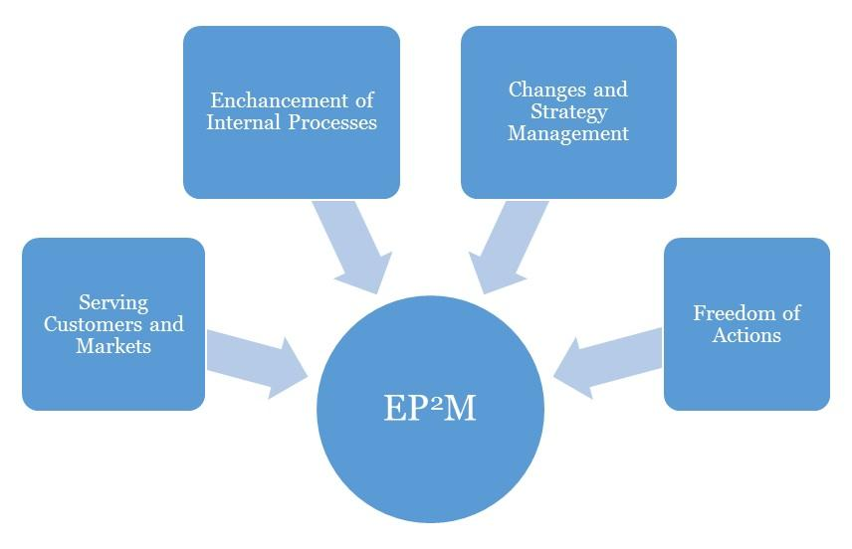
Effective Progress and Performance Measurement

Performance Measurement
This business plan's performance should be assessed against its effectiveness in achieving its high priority goals and performance targets. Occasionally, three (3) months interval should be advised for a Interior Design business.
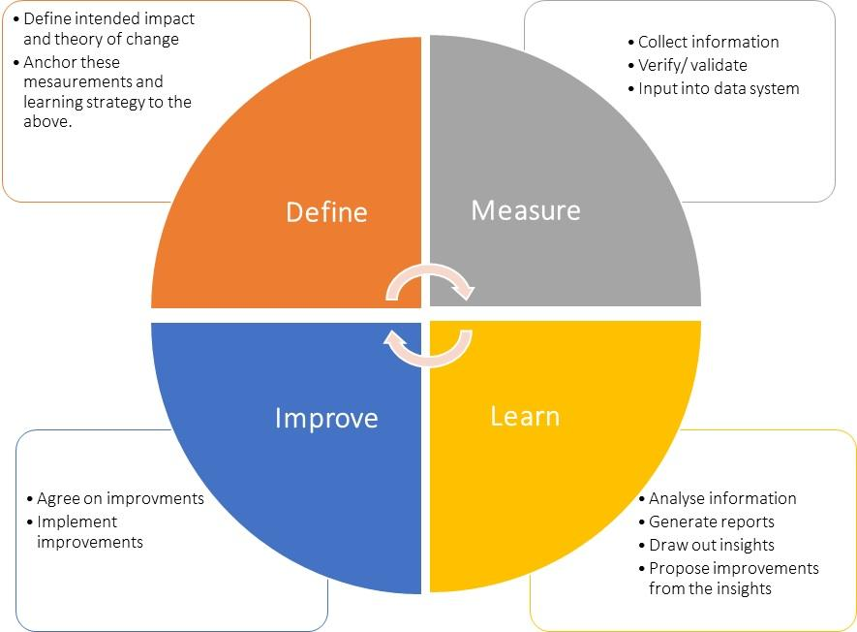

Plan Review and Up Date
To ensure your business plan continues to provide a sharp focus and remain responsive to change, it should be formally reviewed and updated every six months, at the achievement of a strategic goal and at any other time deemed necessary. Implementation of this plan is to be a fixed agenda item at meetings of [Company Name]’s Board of Directors.

