Childminding Business Plan
… A Great Place to Grow …
This business plan is intended solely for informational purposes to assist in determining if you with a due-diligence investigation of this project. The information contained herein is believed to be reliable, but the management team makes no representations or warranties with respect to this information. The financial projections that are part of this plan represent estimates based on extensive research and on assumptions considered reasonable, but they are of course not guaranteed. The contents of this plan are confidential and are not to be reproduced without express written consent.

TABLE OF CONTENT

1.0 EXECUTIVE SUMMARY……………………………………………………………………….…………….….4
1.1 Vision
1.2 Mission
1.3 Core Values
1.4 Keys to Success
1.5 Objectives

2.0 Company Summary ………………………………………………………………………………………........8
2.1 Business Description
2.4 Milestones

3.0 Ownership and Management…………………………………………………………………………………12
3.1 Management Summary
3.2 Business Model Canvas
3.3 Management Background
3.4 Personnel Plan

4.0 Organizational Structure ……….........................................................................................16
4.1 Organizational Chart

5.0 Value Proposition and Competitive Comparison………………………………………………….18
5.1 Service/Product Offering
5.2 Competitive Advantage

6.0 Market Research and Analysis…………………………………………………………..………………20
6.1 Industry Overview
6.2 Target Market
6.3 Major Competition

7.0 Marketing and Sales Plan…………………………………………………………………………………25
7.1 Product
7.2 Pricing
7.3 Place
7.4 Promotions
7.5 Sales

8.0 Internet Plan ………………………………………………………………………………..………………….28
8.1 Website/Blog Plan
8.2 Social Media Plan

9.0 Strategy and Implementation Summary..........................................................................31
9.1 Marketing & Sales Plan
9.2 Marketing Strategy
9.3 Sales & Marketing Target
9.4 Promotion Pattern

10.0 Sales Plan..........................................................................................................................36
10.1 Sales Strategy
10.2 Sales Forecast

11 Operational Strategy.............................................................................................................38
12 Human Resources................................................................................................................38
13 Quality Control.....................................................................................................................40
14 Processes...............................................................................................................................41
15 Financials.............................................................................................................................42
16 Exit Plan and Strategy..........................................................................................................47
17 Plan Improvement................................................................................................................48

EXECUTIVE SUMMARY

[Company Name] ® is the best childminding center in [State], which is in the United States. It wants take good care of babies and its students to be the best at everything they do, since they will be the leaders of tomorrow. We plan to do all of this and more by putting together a curriculum that is made just for kids. Our curriculum is supplemented with extra-special child care services. This is unlike anything our competitors have to offer because we provide innovative technology plans, after-school training, and activities that help children grow. Arts, dance, crafts, gymnastics, theater, and sports are just a few examples.

[Company Name] ® is a privately-owned business run by Mrs. [Owner]. Mrs. [Owner] has ten years of experience in educational training. She does, in fact, have a master's degree in child psychology. As a result, she is always at the top of her game when it comes to child management and psychology. [Company Name] was founded as a result of her advanced degree in child psychology and her passion for children. She will be assisted in her daily operations by another educator and psychologist, as well as other employees. With the ongoing inflationary pressures on the American economy, parents will always need to work more than one job at a time to supplement their income.

As a result, there will always be a demand for high-quality child care services and also with [State]'s lowest population of 11.59 million people, there will always be a need for capable childminding centers to cater to them. That is why we have decided to position our business to meet the plethora of needs of parents who want the best for their children.

[Company Name] ® leaves no stone unturned in ensuring that we provide high-quality child care services, thoroughbred educated instructors, and personal skills that will allow us to compete effectively in our market. We will also offer competitive pricing as one of our success factors in order to attract everyone to our prestigious Childminding center.

Furthermore, we understand the importance of having a positive relationship with parents and the community we serve, which is why we train and even retrain our employees so that they always bring the best skills and attitude to the table. With the aforementioned points in place, we do not expect to be looking for customers for long as we go all-out to build a loyal customer base by providing the kids under our child care centre with a very hospitable-yet-educational experience in a comfortable and beneficial environment.

Capital Needs
[Company Name] ® will run at an assumed sales profit of approximately $66,414 in its next year of expansion, with a profit after tax of $150,972 and a consistent progression for the future years. We seek an additional loan of $21,881 in capital contribution. The chart below explains our projections:

(All figures shown in the graphs are in $’000)

Our marketing strategy will include the use of both flank and guerrilla type of marketing attack to topple larger brands by offering unique service and experiences at competitive prices that is being ignored by larger brands. We will also include online marketing with great focus on social media and an active blog to position our brand as the industry leader with our regular contents.

1.1 Our Vision
Our vision is to establish a high-quality day childminding facility where parents can confidently leave their children in our care and be completely satisfied in the long run.

1.2 Our Mission
To build an international standard childminding center where children can be groomed and prepared to be tomorrow's leaders.

1.3 Our Core Values
The following core values drive our operations, products and team.
- Integrity
- Commitment
- Respect
- Excellence
- Empathy
- Quality
- Safety
- Innovation

1.4 Keys to Success
[Company Name] ® ’s enviable success is achieved through offering convenience, personalization and efficiency respectively.
- Passionate Team: We intend to staff our company with dedicated individuals that are eager to succeed in the same ways that we are. A group of people who share a commitment to child welfare and an appreciation for its norms and ideals.
- Efficacious Publicity: Our publicity strategy is to consciously position our brand as a maven within the industry by affiliating with complementary corporate and luxury brands. Our campaigns and publicity will include online visibility such as social media engagement and an interactive website supported with an active blog as well as prints and referral in reaching our potential clients.
- Referral System: Also, a strong referral system is essential.
- Use of Video Marketing: our marketing strategy encompasses Video marketing as it is becoming increasingly popular as a means of information consumption. A short video can get more eyeballs on our content than an article can in most cases. Furthermore, young people are more likely to finish a video than a blog piece. We understand that blogging is an essential part of a wide range of multi-pronged advertising approaches but with Short videos about our institution and services can be a great addition to a blog since they provide readers another way to take in the information presented. The basic fact is that people are visual beings, thus they absorb visual content much more effectively. Video marketing is highly efficient because it facilitates the display of our institution's character, which in turn facilitates the viewer's ability to connect with us and our institution, allowing us to interact with them on a more human level.
Potential clients will feel more at ease with our school and be able to envision their kids learning under our care before they even set foot on our school, by giving them a glimpse behind the scenes, or if we address some frequently asked questions and give them a more personal tour of our facilities.
- Monitoring Our Progress: we know that going with our gut and making decisions has historically yielded positive outcomes, but we will not rely on predictor of future performance when compared to hard data. We will find out how we will measure success. We find out the key marketing metrics that can be used to predict how many students will enroll and get a system in place that lets us monitor development. We will keep tabs on these key performance indicators to determine where we are succeeding and where we are falling short
- Brand and Reputation: The business and brand model is aimed at delivering decisive advantage. Our brand feel and experience will go beyond the basic service that we offer but will include other value-added services such as excellent customer experience, and trust that creates loyalty to the brand. Our brand strategy will be geared towards an abstract feel of superior experience with [Company Name] ®.

1.5 Objectives:
In a more quantifiable outline, we hope to achieve the following:
- Predefine a series of brand promises we must keep. This will be more like a broadcasted accord of threshold we will never fall short off.
- To create a service-based company whose goal is to exceed customers expectation.
- To have a clientele retention and return rate of near 90% year on year.
- To increase the number of clients served by at least 200% per year through superior marketing performance and word-of-mouth referral schemes.
- Profitably deliver world-class childminding services that would enhance our clients' satisfaction level in general.
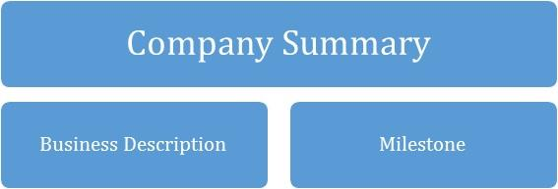

2.0 COMPANY SUMMARY

[Company Name] ® is a customer-centric brand that will be focused on providing professional childminding services for all kids registered into our school. We’d lay prominence on the overwhelming demand for a good childminding service around the [State], as well as the peace of mind parents have when their children are in a caring and stimulating environment while they must be away from them.

In addition, with the invaluable experience garnered over the years and with the support of a seasoned team, toys and technology, [Company Name] ® will promote positive responses towards what we do, that will convert consumers into customers then into loyalists and eventual evangelists.

However, what will set [Company Name] ® apart from the competition is our focus on putting together a curriculum that is made just for kids. A curriculum supplemented with extra-special child care services. It will be different from what our competitors have to offer because we have new technology plans, training for kids after school, and activities that help them grow. Some examples are arts, dance, crafts, gymnastics, theater, and sports.

2.1 Business Description
As a legal entity, the company is registered under the [Your Country’s Corporate Affairs Commission] as [Company Name] ®. Our school is in [ Location], and we look forward to open a second school at [New location after expansion], equipped with new technologies, toys and school kid materials for training for kids.

2.2 Milestones till date
Type | Status | Timeline
Business Name Availability Check | Completed | September 2022
Business Registration | Completed | August 2022
Opening of Corporate Bank Accounts | Completed | July 2022
Opening Online Payment Platforms | Completed | September 2022
Application and Obtaining Tax Payer’s ID | In Progress | November 2023
Application for business license and permit | Completed | June 2022
Purchase of Insurance for the Business | Completed | October 2023
Renting of Building and Remodeling it | In Progress | February 2023
Securing Point of Sales (POS) Machines | Completed | December 2022
Opening Mobile Money Accounts | Completed | January 2023
Opening Online Payment Platforms | Completed | January 2023
Conducting Feasibility Studies | Completed | January 2022
Drafting of Contract Documents and other relevant Legal Documents | In Progress | May 2023
Generating Capital From Family Members | In Progress | November 2023
Obtaining of Health Permit | Completed | January 2022
Drafting of Employee’s Handbook | Completed | January 2022
Design of The Company’s Logo | In Progress | February 2023
Graphic Designs and Printing of Packaging Marketing / Promotional Materials | In Progress | February 2023
Applications for Loan from the bank | In Progress | April 2023
Recruitment of employees | In Progress | July 2023
Purchase of the Needed furniture, beddings, toys, electronic appliances, office appliances and other equipment | In Progress | May 2023
Creating Official Website for the Childminding Center | In Progress | October 2023
Creating Awareness for the Business both Online and Around the Neighbourhood of Location | In Progress | January 2023
Health Safety and Fire Safety Arrangement(License) | Completed | November 2022
Opening party / launching party planning | In Progress | May 2023
Establishing business relationship with key players in the industry | Completed | January 2022

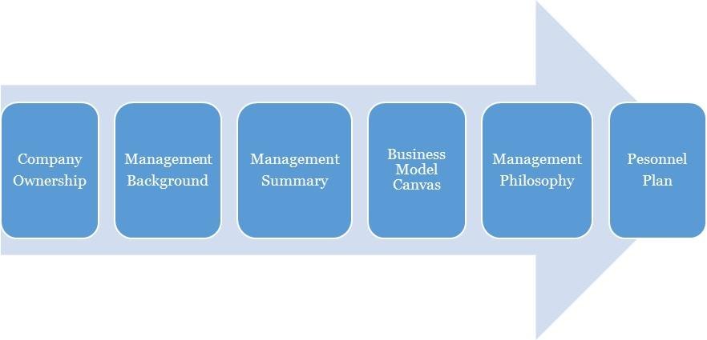

3.0 OWNERSHIP AND MANAGEMENT

[Company Name] ® is owned by [Owner]. The management of [Company Name] is a simple one with the CEO as the manager. Operations are managed by her

As of November 2023,
Name | Title | No. Of Shares | % Of Ownership
Owner | CEO |  | 100%
TOTAL |  |  | 100%

3.1 Management Background
Owner:
[Owner] is a self-motivated, compassionate and reliable individual, familiarized to working in nurtured environments where the goal is to deliver top-notch childminding services; with a remarkable track record of experience in Leadership, holding top positions in Childminding-related establishments.

He holds a Master’s Degree in [Course], United States and a Bachelor of Science Degree in Psychology from ________, United States. His trainings and experience have also helped him develop his leadership and coaching skills and a strategic view-point to every project or endeavour. [Owner] hails from ______ in ____; he is an innovative, vivacious individual with the passion for kids and in achievement for greatness. He is also a goal setter and achiever who ensures all the pre-requisites for achieving the set objectives are met. As a leader he recognizes the value of team work, team play and time management.

3.2 Management Summary
The management philosophy at [Company Name] ® will be based on mutual respect for each of our fellow colleagues and for every customer.

Our success will greatly depend on how effective our relationship and care for our customers kids while under our watch, this is why we will focus on treating our employees’ right and encourage our customers kids the best care. Our employees are the face of the brand and will represent the brand when interacting with our client. Customer friendly employees will increase general client loyalty and repeat business.
The management team will consist of the owner/CEO and the general manager. We will hire only those who demonstrate the qualities necessary for working in a nurturing environment, and the willingness to move forward in study of energetic principals if not already so trained. We will be hiring the ultimate "people persons."
Furthermore, all duties will be divided and delegated according to the strengths and weaknesses of our staff. At [Company Name], we will expect a high degree of customer service skills and personality as this is essential to our success. The management team will assess the productivity and performance evaluations of all employees every two months. These bi-monthly evaluations are conducive to the continued growth of our business.

3.3 Business Model Canvas
Business Model Canvas for [Company Name] ®
Key Partnerships  Community Groups, Religious Groups, Financial Partners, Cluster Groups | Value Propositions  - Excellence  - Brand  - Integrity  - Commitment  - Respect  - Empathy  - Quality  - Safety  - Innovation  - Relationship  - Customer Service  - Professionalism | Customer Segments  Business to Business  - Corporate Executives  - Business People  - Sports Men and Women  - Government Officials  - Families  - Low class, middle class and high-class people  Business to Client  - Corporate Executives  - Private Individuals  - Celebrities  - Parents
Key Activities  Provision of top & reliable childminding services to all the parents in its vicinity, [Location] & [State] in general. | Key Resources  Toys, kids Tech devices, skills, physical location, vehicles, staff | Channels  Direct services, website
 | Customer Relationship  Online, offline, community  Social media, customer support, discounts and promotional | Channels  Direct services, website
Cost Structure  Operational costs: Marketing & ads, logistics, Internet subscription, airtime charges, fuel, maintenance  Utility: electric bills, rents, salaries (skilled labor) etc. |  | Revenue Streams  - Taking good care and training of infants, toddlers and preschoolers

3.4 Personnel Plan
[Company Name] ® is a growing firm and as such staff will be hired according to recommendations, experience and education in their field. High standards will be kept through the orientation and inclusion period for new employees and the new employees will be given a mentor to shadow for the first two (2) weeks of arriving. In so doing, the employees can pick up the ethics of working and representing the [Company Name] brand.
Checklists will be drafted to monitor employee’s quality of service after three months. Staffing and training will be available for sales representatives and customer service candidates. Every personnel will be given specific assignments and valued on completion of the assignment. One on one meetings will be held to discuss and handle any arising issue regarding performance and service.

4.0 ORGANIZATIONAL STRUCTURE

To have a truly value driven team that would be productive, there is a need to map out what is most important to the organization and the team in order of prioritization. This is to ensure a chain of interrelated entities that will define our organization structure. For [Company Name], the following is a further illustration.
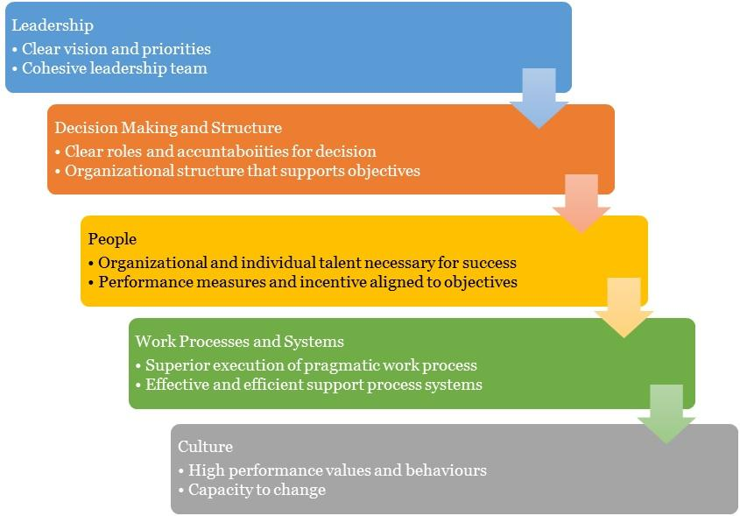

4.1 Organizational Chart

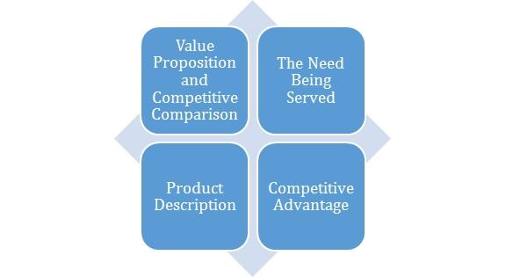

5.0 Value Proposition and Competitive Comparison

Value Proposition
At [Company Name], we understand that the core of our business is centred on people, and this is the paradigm that inspires our entire processes and structures. We promise to make our clients experience more with our brand as we provide superior childminding services at a cost-effective rate.
In a more measurable outline, here’s our value proposition and market reach:
- Provide the best of childminding service within [Target Location].
- Scale up the operations and expand the childminding business.
- Ensure maximum profit for our shareholders using effective and efficient strategies in the markets that we operate in.

5.1 Service/Product Offering
[Company Name] ® is first and foremost concerned with making the childminding center a welcoming environment. We understand that some parents may be concerned about the environment in which their children will be placed, which is why we have taken the time to research and learn the various methods for constructing a world-class establishment. This is what we did in [Location] which houses approximately 20 million residents in the state of [State]. Among our services are the following:

- Taking care of the infants, toddlers and pre-schoolers
- Cleaning the infants and toddlers up whilst they are dirty
- Have all kids well fed when hungry
- Keep them active with some extracurricular activities.

5.2 Competitive Advantage
We discovered that there are no childminding centers in our area based on the state in which we have decided to establish our business. If we are able to perform our research and acquire a large customer base, we have a chance of achieving success within the first few years of operation.
We intend to operate a normal Childminding, therefore we recruited one of the top business consultants to assist us in establishing our business. The business consultant we've recruited has more than ten years of experience in business management and has successfully built a number of childminding centers in major U.S. cities.

So far, all indications point to the fact that, based on what he has said, we will undoubtedly succeed and even surpass other enterprises in the state. We feel that because we have employed one of the most knowledgeable individuals in the area, we will perform very well once we launch.
We will provide extensive customer service training to our staff so that they can successfully express our brand to customers anytime they represent us. This will guarantee that we not only meet but also exceed our customers' expectations.

6.0 MARKET RESEARCH AND ANALYSIS

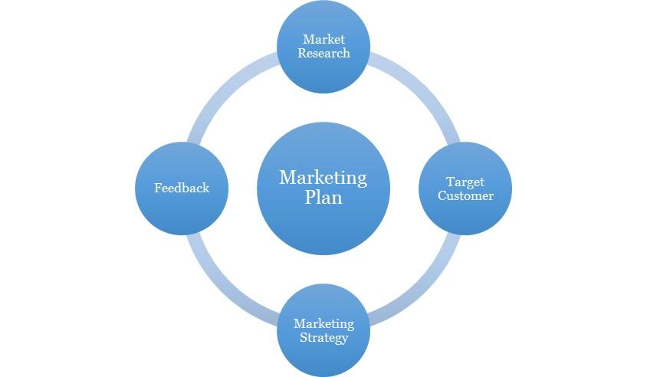

6.1 Market Overview
Childminding is a simple business that almost anyone with a passion for children can easily start. There is no doubt that as parents' desire to earn more money grows, the need for newer and more experienced Childminding centers to emerge becomes critical. As a result, investors are beginning to capitalize on the high demand for Childminding services in order to establish even better ones.

As a result, there isn't a single neighborhood in America that doesn't have a Childminding center. The business is indeed profitable, and those in the business of establishing them are smiling to the banks every day. However, this does not diminish the fact that significant effort must be expended in order to satisfy the parents who use these childminding centers.

Whether you want to start a small or large one, the truth is that there will always be a need for children in these places. This is why some people who lack financial resources may choose to start from their homes, whereas others may prefer to start from the smallest spaces available.

One bright spot in the Childminding business is that there is always room for growth as one learns on the job and then improves the services that one provides.

Setting up a Childminding business entails dealing with small babies, and as such, care must be taken to hire not just employees, but those who are extremely knowledgeable in the field and capable of assisting the Childminding business to a great extent. There will always be a need to learn new things in order to provide the best possible experience for the children.

The returns on investment are so high here that all that remains is to keep doing the things that will ensure repeat customers while also providing the children who are being cared for with a growth experience that they will not soon forget.

Economic, Social and Technological Factors
It’s common sense that parents with young children need access to child care in order to obtain and retain a job, which makes child care providers a vital part of local and state economies. That’s why a report released by the Committee for Economic Development, Child Care in State Economies: 2019 Update is so important. The report reviews the market-based child care industry (which includes centers and home-based child care providers) and estimates that child care has an overall economic impact of $99.3 billion – supporting over 2 million jobs throughout the country.
What the report shows is that there is a strong link between child care and state and local economic growth and development. And, that the child care industry causes spillover effects (additional economic activity like the purchase of goods and services and job creation or support within the community) beyond those employed within child care or the business income of those operating centers or home-based programs.
Here in North Carolina, child care programs have an overall economic impact of $3.15 billion ($1.47 billion in direct revenue and $1.67 billion in spillover in other industries throughout our counties and cities). Child care programs have an overall jobs impact throughout the state of 64,852, which includes 47,282 individuals who are employed within child care centers or who operate a home-based business plus another 17,570 in spillover jobs – created through the activity of those operating child care programs.
The economic impact of child care matters because it helps drive local economies. When parents can access child care, they are more likely to enter the workforce and stay employed.
Access to affordable child care also supports parents who seek additional education or job training, which can result in higher earnings over an individual’s lifetime. For example, according to U.S. Census Bureau data, the difference between the income of a parent in North Carolina with a high school degree and a parent who dropped out of high school is $6,231 annually[i], but over a lifetime, that’s $249,240 the parent would earn just by going back to school to earn a high school diploma. If that parent were to enroll in community college, and obtain an Associate’s degree, he or she could earn $10,652 more annually[ii] or $426,080 more over a lifetime compared to a parent who has not graduated from high school.
Earnings for those with a college degree are that much higher — $17,748 annually[iii] for a parent who has a Bachelor’s degree compared to a parent with an AA ($709,920 more over a lifetime). When parents have access to child care, both labor force participation grows (and with that, the ability for parents to support their families) and also the potential for parents to return to school to increase their earnings over the long-term becomes possible.

Media screens are everywhere—television, smart phones, touch pads, e-books, computers—and new ones are hitting the market frequently. Parents and educators are raising and teaching children in an era when the abundance of digital media presents unique challenges as well as educational opportunities. Limited research shows that there can be many negative effects on young children through early exposure to specific types of screen time. Knowing how to manage this technology and use it appropriately is critical for early educators.
Television is still the most common form of technology to which young children are exposed. Studies vary in the average reported amounts of viewing time for two to four year olds, but one study indicated as much as thirty-two hours per week. Forty percent of three month old infants are regular viewers and as many as thirty percent of infants less than a year old have a TV in their room.
The American Association of Pediatrics recommends that children under the age of two have no screen time (including TV, computer, DVD, or video games) and that children over the age of two have no more than two hours per day.
Recommendations from the Institute of Medicine (IOM) encourage limiting screen time for children ages two to five to fewer than thirty half-day early learning programs and no more than sixty minutes for those in full day early learning programs.
The Let’s Move! Child Care Initiative (LMCC) recommends caregivers allow no screen time for children in their care under the age of two and no more than 30 minutes per week for children over the age of two while in their care. Both and LMCC stress that caregivers work together with parents to ensure that children over two years are limited to no more than two hours of total, quality screen time per day.

6.2 Target Market
When it comes to childminding, our target market is, of course, guardians and parents. That is why we must concentrate our efforts primarily on these individuals. We intend to provide our services to the following individuals:
- Corporate Executives
- Business People
- Sports Men and Women
- Government Officials
- Families
- Low class, middle class and high-class people

6.3 Competitive Environment
The industry, with respect to this service niche is relatively green. There are top and thriving childminding companies in ____, with strategic locations across the city. Some of them are listed below;
- ********
- ********

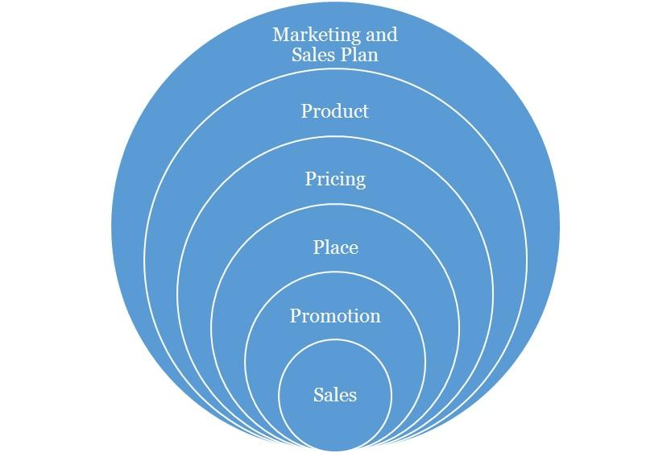

Marketing and Sales Plan

Concerning our marketing, we will execute a comprehensive strategy that is centred on the 4P’s of marketing (this refers to Product, Pricing, Place and Promotions) which are fundamental to any campaign. Each aspect is discussed as follows:

7.1 Product
We have developed relevant products that are tailored for the customer segments that have been identified. These will cut across the core aspects of our service offering.

7.2 Pricing
The pricing strategy to be adopted will be a combination of the cost-plus pricing and competition-based pricing. This entails fixing prices for the services that ensures that production costs are covered and a fair profit margin is realised from sales. However, in selecting this price points, consideration will be given to the prices offered by competitors in the industry. We are high end as shown in the services we provide, but more affordable than the average ones. This will ensure that we do not price ourselves out of the market. And as we progress, our brand growth and imagery will become a factor to our pricing.

7.3 Place
We seek locations that puts us in a comfortable uncontested niche that will help ensure we can capture the clients in the vicinity and retain them. Our physical location and place aim to strike a balance between brand exposures, awareness, achieving maximum accessibility to clients, while keeping costs low.

As the business grows and expands, subsequently, we will explore the possibility of establishing [Company Name] ® in other major places in [Target Location] and other large cities in the country where potential clients are identified to be situated.

7.4 Promotions
In terms of promotion, we will implement an awareness process engineering aimed at market activation, customer acquisition and retention strategy. Our promotions will be hinged on creating awareness and deals from the quality of our service offering, the experience, cost and time effectiveness etc. We will employ innovative product and service promotion techniques to acquire customers.

Types of Promotion and Explanation
Advertising | As an SME, [Company Name] will minimize its exposure to Above The Line advertising with exceptions to major events, but will engage in Below The Line and Through The Line Advertising.  The Above The Line (ATL) advertising includes the following; mass media, large format printing, electronic broadcasts and it’s for building brand awareness and goodwill.  The Below The Line (BTL) includes the following; industry magazine, newsletters, social media and google AdWords.  [Company Name] will invest resources and promote using BTL with a focus on social media and an active blog in targeting specific clients and to build an awareness. Social media unlike traditional media provides insights and analytics to measure pubic interaction and a quicker ROI.
Public Relations | Consistency, good clients’ relationship and excellent service will grow the brand’s recognition and increase its market share and sustain growth. We will also continually share our core values and brand promises with the public, with the aim of making [Company Name] ® synonymous with high-end childminding service.  We will also maintain close relationship with our clients for feedback, as well as with our vendors in clusters, alliances and complementary organizations.  The art of a good public relations is not only to obtain favourable publicity within the community, but to raise and keep the awareness within the vicinity. It also involves being able to handle attention, support and feedback.
Sales Promotion | We will create strategies targeted to our client segments and make available promotions and referral bonus to increase sales. We trust we will keep these clients with our excellent service and through our value-added service creating loyalty.
Internet Marketing | We will promote and sell our service over the internet such as our interactive website, active blog, social media handles, affiliate marketing and sponsoring across popular blogs and social media influencers.

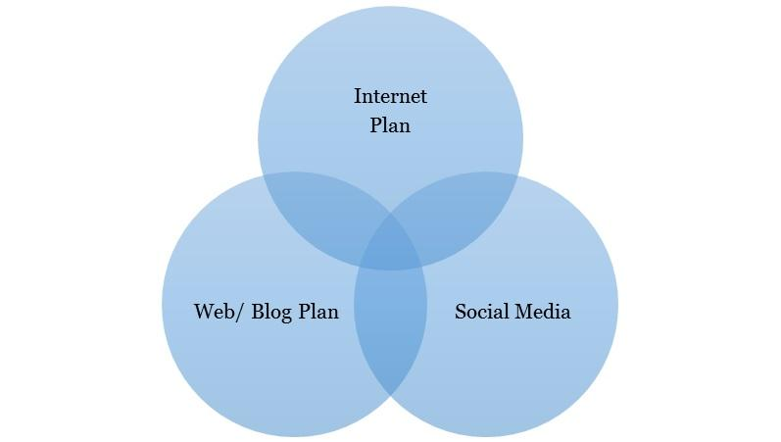

8.0 Internet Plan

The internet is here to stay and any business not positioned towards this trend will most likely be disrupted from within the industry. Internet plan is not limited to a website alone as this is one of the many platforms that should be maximized for business purposes.

8.1 Web/Blog Plan
Our website will serve as a source of information for online visitors and our strategy is to optimize the use of search engine optimization and search engine marketing (SEO/SEM), and the development of editorial content. This simple strategy will easily position the brand as a maven within this segment of the industry. [Company Name] will evaluate and also include on-demand capabilities into its business model.

The overall strategy of the website will be to provide a clear and simple architecture that allows the user obtain all the information they need, simply and easily.

Website Marketing Strategy
The website will be integral in [Company Name]’s marketing effort as the site is a key sales tool for both local and distant customers. The URL address will always be used in promotional material, encouraging people to check out the company and service offering. In addition to the inclusion in traditional marketing campaigns, [Company Name] will submit its website to a variety of search engines, significantly increasing the number of inquiries from people searching our services.

Development Requirement
A computer programmer/designer will be employed with the tasks to manage the design, implementation, and maintenance of the website. The majority of the tasks will be completed by him/her; a few tasks that are outside of his/her skill set will be subcontracted to associates

8.2 Social Media Plan
Objectives:
- To increase the [Company Name] brand awareness
- To build close rapport with potential and existing market
- Position the [Company Name] brand as the maven within the industry
- Increase two-way communication with current and prospective clients.

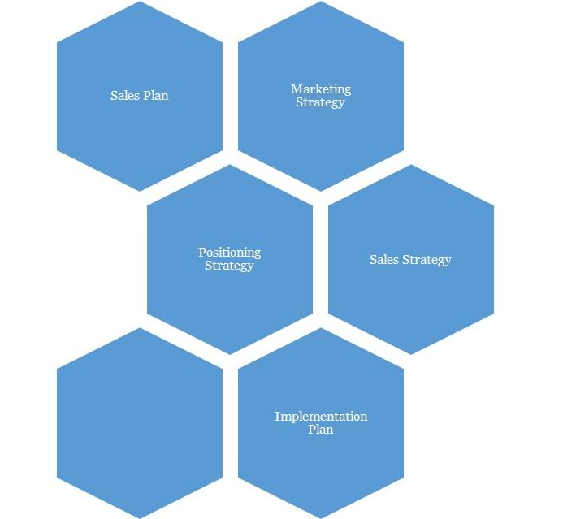

9.0 Strategy and Implementation Summary

At [Company Name], we recognize the importance of marketing and promoting our service as a factor to business growth and success. And to that end, we plan to promote our childminding business with an ambitious, targeted marketing campaign. Our goal is to keep our marketing budget to no more than 5% of our gross annual sales.

9.1 Marketing and Sales Plan
[Company Name] will activate the following market plans to boost brand visibility and acceptance as well as grow engagement:
- Defining our central ideology is essential.
- Creating prominence on social media. This is just beyond posts and likes, but engagement techniques too. This may require a social media content plan.
- Define [Company Name]’s set of brand promises clearly

[Company Name] will also activate the following plans:

- Having a marketing strategy and marketing operations that targets not just individuals but corporate and cluster groups: servicing cluster groups and corporate organization will aid in economies of scale. Cluster groups may include residence associations, etc.
- Word of Mouth marketing is still the most effective form of advertising, so a mechanism has to be devised for this. An example is a simple referral form shared amongst your most loyal customers, and maybe a discount incentive for each referral.

9.2 Marketing Strategy:
[Company Name] will host a grand opening celebration when it finally opens. One of the very unique things we intend to do on that day is to reveal some of our professionals and junior employees. These are the people who will assist us in getting things started on the right foot. Why is this such a big deal for us? It is significant for us because parents will have the opportunity to interact with these individuals and ask any questions they may have.

Our day care center's location is strategically positioned to attract a large number of customers with little or no effort on our part, which is why we do not include marketing and sales executives in our company's structure. As a result, we will implement the following strategies to ensure that we not only attract customers but also generate a large number of people;

- Advertise our childminding service on well-known internet forums, blogs, and websites.
- Advertise in local publications as well as on local radio and television stations.
- Position our greeters to welcome parents and the kids as they arrive
- Create a loyalty plan that will enable us reward our regular customers
- Position our flexi banners at strategic positions all around the vicinity
- Advertise our [Company Name] Business on yellow pages magazines
- Partner with child’/ education agencies to refer parents who are looking for a good day care center
- Encourage our long-term clients to recommend us to their friends and family.
- Participate in direct marketing.
- Promote [Company Name] through both traditional and online directories
- Sell our services through the internet - our website – as well as social media

9.3 Promotion Pattern
At [Company Name], our promotional strategy will be based on maximizing technology and new media through the internet and our cluster group alliances. But most importantly, an exponential referral scheme.

Advertising:
- We will utilize the social magazines, cinemas, and top executive conferences and seminars with our exclusive services.
- We will advertise on the business bulletins of most companies around that area. We will also create value driven post.
- We will have a comprehensive website with full interactivity. We will also make use of the social networks to promote and drive traffic to what we do.

Also, we will love to work with PR/ Advertising Stakeholders. These refer to the sales influencers. They include:
Blogs: Blogging has become very popular now in United States and is one of the most popular means of brand / product promotion. The question we hope to constantly ask and answer the question, “How Can [Company Name] maximize the platform of blogging to create awareness in a less typical way”?

9.5 Positioning Strategy
In terms of positioning, we would be applying a marketing warfare concept where we choose to apply four different methodologies depending on the market dynamics. These methodologies are listed below as:
- Defensive: Defensive strategy would be applied when we are sure to be the market leaders.
- Offensive: Offensive strategy would be applied when we are sure to be the strong challenger.
- Flanking: Flank strategy would be applied when we are sure to be the weaker challenger.
- Guerrilla: Guerrilla strategy would only be applied when we are sure to be struggling for survival and want to avoid being crushed by the bigger competitors.

We believe that marketing is all about positioning, and we being able to identify our position and applying the right strategy. At this point it is interesting to note that our marketing program is not just about customers, but about gaining, for ourselves, a noticeable proportion of the total available market share or its segment being occupied.

9.6 Pricing Strategy
As we progressively penetrate the market, our fees will come with discounts yet it would retain a competitive positioning as much as possible. But as we gain larger brand equity, we will add more value-added services that will justify an increase in our prices when we ever see the need to do so. However, it is important to note that while competition enables a healthy business atmosphere, we aim to build an iconic brand that makes the competition feel irrelevant by continuously perfecting and offering more value-added service to all of our clients. We will not charge over, nor substantially under, rather will we be charging standard prices in line with quality for our services just as our contemporaries in do.

10.0 SALES PLAN

10.1 Sales Strategy
The sales function will be driven by our in-house sales unit. The unit will be responsible for lead generation and management. This will be required to meet sales targets that will be set on a weekly basis. The sales unit will be headed by the manager/CEO. He will be responsible for coordinating all sales activities.

10.2 Sales Programs
- Our comprehensive brochure will explain the nature of our services, and how this benefits our clients. It will be able to paint a vivid picture of who we are, what we offer and where we are going.
- Our website and social media will be comprehensively informative, updated weekly of our services. Additionally, we will have pages on social networks to always create traffic for [Company Name].
N.B: Check the Sales breakdown sheets on the financial model for more information

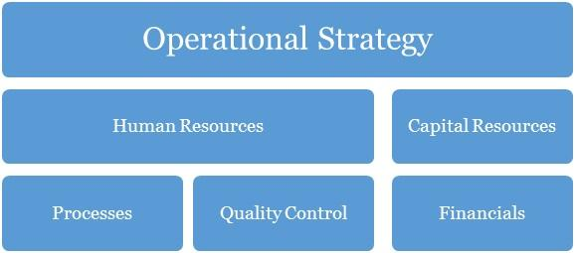

11.0 Operational Strategy

Operation strategy in any business organization is essentially about how the organization seeks to subsist and flourish within the environment over the long-term. The decisions and actions taken within its operations have a direct impact on the basis for which the organization is able to operate. The way in which [Company Name] receives, treat and train their students will determine the extent to which we can successfully pursue our specific performance objectives. Our operations are built on our core values of professionalism, empathy, resourcefulness, continuous improvement.

Further ahead in this growth process, in whatever we do, we will consider the concept of collaboration too as a major step necessary for effective business management. It is the role of management to know what is of topmost priority to their organization and to their business. And then concentrate more on that core. Our business will, as much as it can, encourage new and upcoming small medium businesses which provide a service within our need base to step up to the challenge of being the best through their affiliations with [Company Name].

12.0 Human Resources

There has to be a well-defined corporate culture with an immersion process for all of its human resources. This starts off as an on-boarding process for new entrants, and then a constant reminder as they stay in the organization (trainings, review, test and appraisals, KSS (knowledge Sharing Sessions)) with each of this, having an injection of the DNA of the brand’s core values reminded into them.

This section of [Company Name]’s processes is one that identifies the current and future human resource needs for our organization to achieve its projected goals as listed in our mission and vision statements. It would serve as the link between our management and the overall strategic plan of our organization.

Human resources management and development is a core issue and is hinged on professionalism and productivity. A high premium is placed on our most valued assets, the men and women who would make the Childminding service Business ® a household brand in United States and most especially beyond. Our human capital base is made up of people from diverse professional, ethnic, tribal and cultural backgrounds, who exhibit high level of business ethics, are performance driven, result-oriented, ambitious, team players and conform to the company’s standards and core values.

Our employee policies will include:
- Weekly management meetings
- Monthly employee meetings
- On-going training
- Performance reviews every six months
- Performance incentives
- Encouragement of creativity
- Financial Plan

At [Company Name], we understand and partner with employees individually and collectively to support them in meeting their unique aspirations and needs by training, developing, motivating, providing professionally challenging jobs to help them attain self-discovery, fulfilment and contribute to the achievement of our corporate objectives.

The goal at [Company Name] is to have a team of committed associates who empower each other so that the customer's expectations can be exceeded. Our goal is to offer career opportunities, advancement opportunities and a level of income and benefits that is competitive within the region and job classification. It is our long-term goal to be the preferred employer within our niche market.

13.0 Quality Control

Quality control here refers to the standards and mode of operation and delivery of value within the organization. This should be defined in the structure so much that all products delivered should be exact with the intended work with no variations at all. To achieve this, there has to be checks, balances and predefined structures to ensure minimal variation from scope, deliverables and quality. This should be in the designation and job description of a Quality Control Officer. This is perhaps the most important work role in the organization.

Quality Control Plan
Our company’s quality control team will monitor and audit every stage of value creation and delivery. The manager will be in charge of analysing quality work done; he is expected to identify any inadequacies that would affect the brand. Indeed, this personnel will be fully authorized to enforce whatever corrective measures may be necessary (including shutting down service) so as to maintain the company’s reputation for excellence.

14.0 Processes

Operational processes are vital to solving problems and tasks while managing the day-to-day issues associated with the engagement, development, management and interaction of people, techniques, businesses and systems. Without a stable foundation of corporate operational processes, organizations devote their management efforts to managing problems in this area, thereby generally failing to achieve the efficiency and effectiveness as well as the confidence, trust and support of staff i.e. the cornerstone to being able to win and grow.

With a thorough understanding of our business operations, we can categorize our entire business processes into the following main aspects including:
  - Management processes
  - Core Business processes
  - Supporting Processes
  - Collaboration
  - Automation

15.0 Financials

The basis for our financial planning has been looking forward with conservative estimates for revenue and expenses. We are committed to consistently growing our cash balances through the prudent management of our expenses. Our focus will be on remaining profitable year after year, while also building adequate cash reserves.

Capital Requirements
In order to expand our business as desired, we require about $66,414 to support the already tangible investments made into the business. The capital requested would be used to incur the following expenses.
Capital Requirements
 | Amount
Capital Expenditure | $ 69,414
Operating Expenses (6 months) | $ 31,957
Other Required Items | $ 1000
 | $ 102,370

Financial Viability
The main criterium for establishing the company is that it achieves financial viability both in the short and long term. Shareholders must be rewarded for the risks that they are assuming by investing in the company through the payment of regular dividends within specified parameters of prudent business requirements.
The company must satisfy customers but at the same time take cognizance of the fact that it may cost more to satisfy some needs than any customers are willing to pay. Or it may be much more costly to try to attract new customers than it is to build a strong relationship with-and repeat purchases from- existing customers. So, profit – the difference between the firm’s revenue and its total costs – is the bottom-line measure of our success and ability to survive. The management team will ensure that there is a balancing point that helps it to determine the needs it will try to satisfy.
Aggressive financial targets have been set for [Company Name] to achieve on an annual basis. These targets are the key focus of the company, without compromising quality of service delivery, and includes a return on stakeholders’ funds.
Gross Margin % of Sales
Gross Margin | $ 131,280.00
Total Sales | $ 259,560.00
Gross Margin/Total Sales | $ 0.51
Total Fixed Expenses
Payroll | $ 59,963.79
Operating Expenses | $ 35,071.43
Operating + Payroll | $ 95,035.22
Breakeven Sales in Pounds (Annual)
Gross Margin % of Sales | $ 0.51
Total Fixed Expenses | $ 95,035.22
Yearly Breakeven Amount | $ 187,898.70
Monthly Breakeven Amount | $ 15,658.22

For a more rigorously detailed financial plan:
PLEASE SEE EXCEL SHEET ATTACHED IN A SEPERATE DOCUMENT

IMPORTANT ASSUMPTIONS
The financial plan depends on important assumptions, most of which are shown in the following table. The key underlying assumptions are:
- We assume a slow-growth economy, without major recession in the following years.
- We assume that there are no unforeseen changes in federal grant funding availability.
- We assume a continued need for our products in the market.

General Assumptions
Inflation Rate | -
Cost Escalator | 10%
Tax Rate | 32%
Dividend Pay-out Ratio | 0%

16.0 EXIT PLAN AND STRATEGY

No one attempts a business with the anticipation of failure. However sometimes ventures do not fulfil their promise. We at [Company Name] are committed to our concept and its viability. In the event that our venture cannot achieve profitability and retire the encumbrances the promoter or investors in the business have several exits scenario options subject to the prevailing conditions and circumstances at the time. These could include any of the following:

SCENARIO I (Promote Staff):
Promotion of its staffs to partnership based on performance, dedication, skills and years of service – this should be considered in the long run.

SCENARIO II (Sell/divest stock):
A promoter or investor looking to exit the business can sell equity to other interested investors. The sellers can choose to sell all or part of their equity.

SCENARIO III (Initial Public Offering):
The company can also break up some of its products into separate entities as it grows large enough. But it is most likely, that sometimes soon; it may go public and will aim to be quoted in the United States Stock Exchange.

SCENARIO IV (Default):
If we are unable to sell the operation for sufficient proceeds, we will be forced to default whereby the loans acquired will be in senior standing. Any further outstanding balances will be borne by the equity share owners of the business on a weighted percentage based on the total amounts due in bankruptcy proceedings.

17.0 Plan Improvement
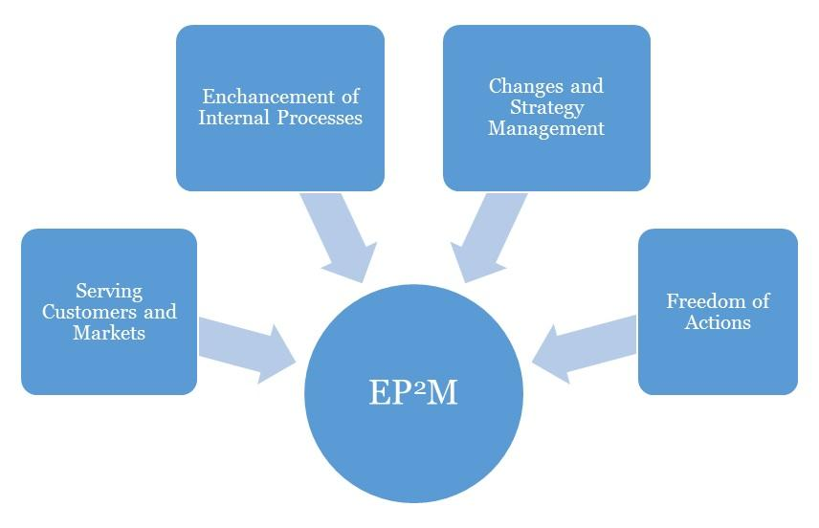
Effective Progress and Performance Measurement

Performance Measurement
This business plan's performance should be assessed against its effectiveness in achieving its high priority goals and performance targets. Occasionally, three (3) months interval should be advised for a Childminding service business.
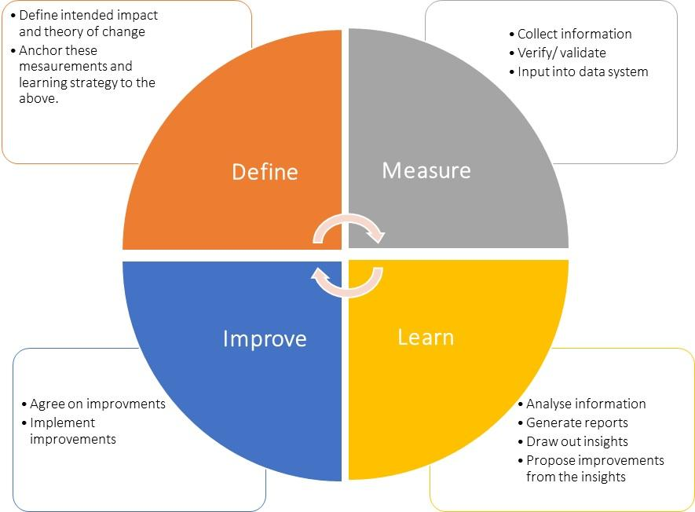

Plan Review and Up Date
To ensure your business plan continues to provide a sharp focus and remain responsive to change, it should be formally reviewed and updated every six months, at the achievement of a strategic goal and at any other time deemed necessary. Implementation of this plan is to be a fixed agenda item at meetings of [Company Name]’s Board of Directors.

