What Are the Benefits of Hiring an SEO Web Agency?
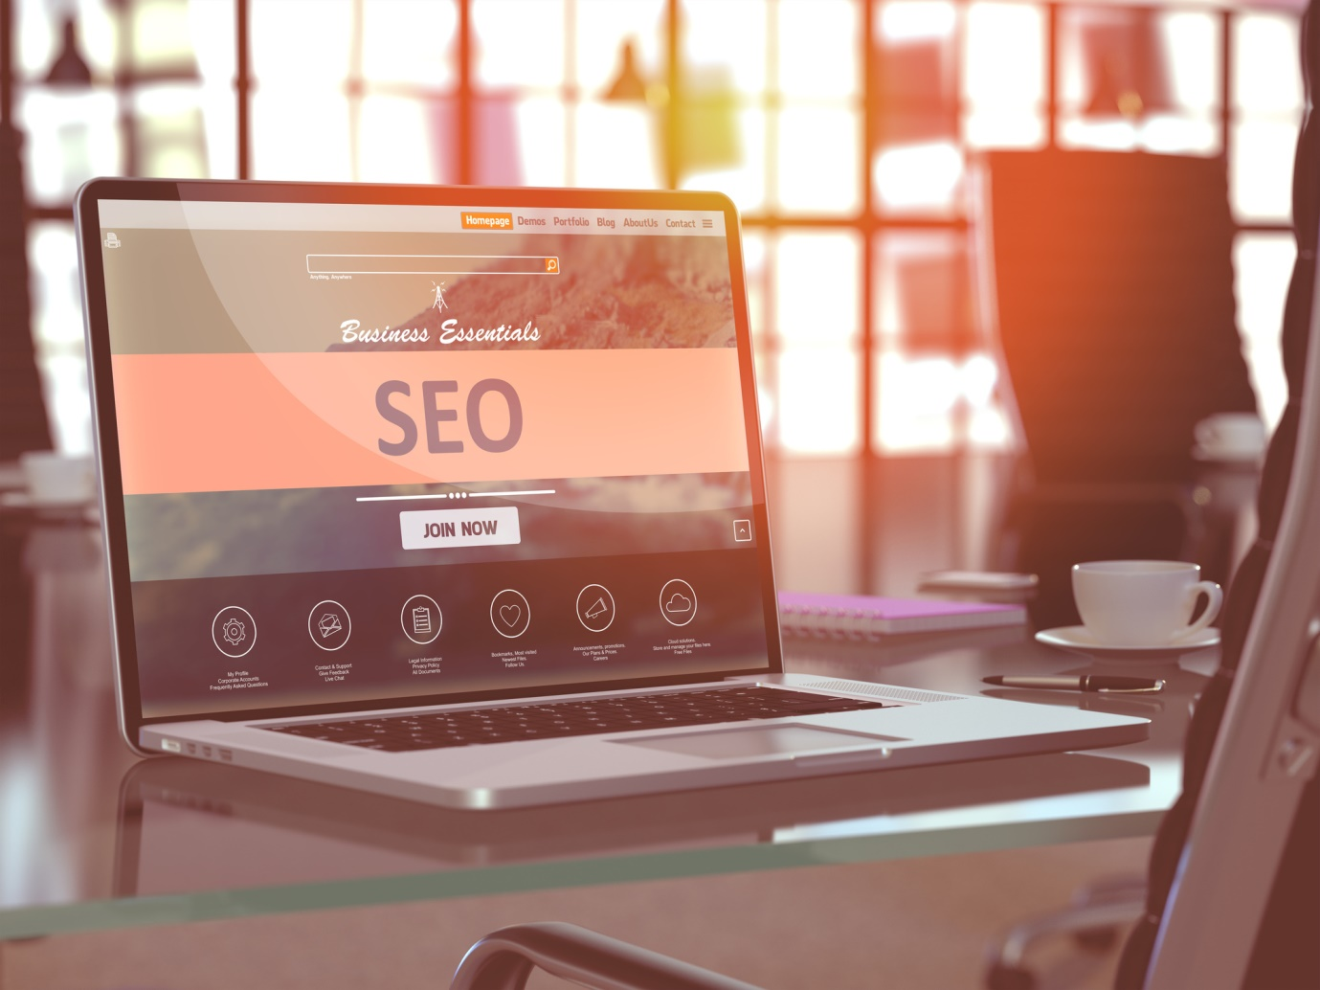
If you've heard anything about marketing in the last few years, you've undoubtedly heard of the hottest topic of the age: SEO. Believe it or not, the word is still spreading, considering 70% of businesses still lack an SEO strategy.
What's more, many businesses still don't even have a website, meaning they don't have a chance of ranking. Luckily for you, that means you have less competition!
However, you still have to optimize your strategy for the best results. Let's talk about what an SEO web agency can do for you.
What Is an SEO Web Agency?
If you're unfamiliar with the term, search engine optimization (SEO) is the primary driver of organic traffic online. Organic traffic is the traffic you don't have to prompt. Essentially, they find you, not the other way around.
Well, this traffic is more likely to trust your brand, as most people skip over the search ads at the top in favor of organic traffic. This initial note of trust helps build brand recognition, brand loyalty, and ultimately, making more conversions. So, how does it work?
By optimizing your website's content, user experience, and industry authority, your website will inevitably rank higher on search engines, which drives more traffic. How much more? Well, the top 3 spots on Google searches receive over 75% of all traffic on the search, from every page combined.
Consequently, more businesses are catching on to the importance of search engine optimization, so it's best to get in while you can. However, it's hard to do on your own, which is why SEO agencies are there to help.
Conversely, the right SEO web agency will help you find the right keywords, conduct competitor research, try affiliate marketing, and initiate an appropriate content marketing strategy for your business. However, that's not all. Let's talk about some of the other benefits.
Benefits of Hiring an SEO Agency
Okay, so we've established the importance of building organic traffic, but what's stopping a business owner from just building their own SEO strategy or hiring a marketer to do it? Well, here are some of the key benefits of using an SEO web agency.
1. Building the Foundation
With any SEO strategy, building upon a broken foundation will not get you very far. However, hiring an SEO agency with web design services will help you build a strong foundation from which you can expand over time.
Essentially, an SEO strategy with a poor website is not going to work. You can have the best content marketing strategy in the world, but search engines do not want to promote low-quality sites to their users, as it would reflect poorly on their services.
Consequently, a strong website that is optimized for Google will have a much easier time building backlinks, developing a successful content strategy, and expanding its organic traffic.
Starting off on a note of quality will help your SEO prospects in many ways, but it will also help with user retention, user experience, and building brand loyalty. If you want to give other sites a reason to link to yours and give your users a reason to keep coming back, then you want a professional, optimized website.
2. Saving Time and Money
First, hiring your own SEO team or SEO specialist is expensive, and most small businesses wouldn't be able to afford it. However, by hiring an SEO firm, you're essentially sharing the expenses with other companies looking for SEO services, which is a much more affordable approach.
Also, if you want to grow your own SEO strategy yourself but you lack the knowledge and experience, there is a large learning curve to overcome. Learning to build an SEO-friendly website and develop a content marketing strategy takes a lot of time, and that's not even mentioning the time it would take to implement these strategies.
Well, you can save yourself a lot of time, money, and guessing games by hiring an experienced SEO company.
3. Industry Expertise
Hiring a dedicated SEO firm eliminates all the guesswork, as you will have a team of experienced SEO professionals who will work with your team to give you the end product you want.
Essentially, there is a lot of SEO misinformation and misconceptions out there, so having a team that can look past the misleading information and follows the general best practices will pay off in the long run.
4. Security
No matter what, investing in SEO is a risk for your business. Unlike PPC campaigns, it takes a while for a strategy to come to fruition, which can cause some major stress in the interim. Well, hiring the right team with a proven track record offers security for your investment.
Whether you try to DIY or hire someone, you will be spending money on your strategy, so you want to have as much security as possible. SEO professionals can help with that.
5. Finding the Right Market
When you hire local SEO services, you can rest assured that your content is reaching the right people. If your business relies on local traffic, then you need to direct your content toward that.
Of course, local SEO services are the best way to do that, especially if they're in your area. The agency will know the right directories to list your site on, the right keywords to use, and which affiliates to reach out to for backlinks or other assistance.
How to Choose the Right SEO Agency
Now that you know why hiring an SEO agency is so important to compete in today's business world, you still have to choose the right agency. Well, here are some tips on what to look for when choosing one!
Services Offered
Of course, you don't want to hire an SEO agency that doesn't offer the services you need. When is the last time you updated your website? If your answer is more than two years ago, then you definitely need a redesign.
Keeping up with online trends is stressful in an ever-changing business climate, but it's a necessary evil. Most users spend their time on sites with incredible resources like Facebook or YouTube. Like it or not, that's the standard of today.
Unfortunately, there is no DIY equivalent for living up to the competition, so ensure that whatever services your business needs, an SEO agency can accommodate them.
Industry Knowledge
Does the SEO agency offer any specified knowledge about your industry? Have they worked with similar companies before? If so, this is a huge bonus.
When an SEO agency already knows the ins and outs of your business, they will have a lot of the keywords, competitor research, and appropriate affiliates ready to go, potentially saving time and money while giving you a better product!
Reviews and Case Studies
Testimonials, online reviews, and case studies are great places to check to see previous customer satisfaction with an SEO company. We strongly recommend asking for case studies or references so you can get an idea of how well the company performed in the past and whether or not they have experience in your industry.
Now, if you're looking at online reviews, only look for useful information. Some people just leave one-star or five-star reviews without any context, which is useless to those seeking real help with their strategies. Instead, read what previous customers had to say if you want to judge the company on quality.
Realistic Expectations
Remember, SEO is a marathon, not a sprint. Unfortunately, the industry is ripe with scammers offering a lot of "valuable" services.
For example, if they are offering you "one thousand backlinks in two weeks or less", then you should know not to trust them. To find a quality agency, ask questions about their expectations for your campaign.
Ideally, you will hear them say something along the lines of "we can have your website complete within a couple of weeks and you should be seeing improvements in traffic within the coming months."
If they are realistic, reasonably priced, communicative, and offer constructive feedback, then you've found the help you need!
Get SEO Help Today!
Okay, so now that you know what an SEO web agency can do for your business, and how to choose the right one, there's no time like the present to get started. SEO takes time, but the sooner you start, the sooner you will see lasting results.
Start boosting those conversions today and stay up to date with our blog for the latest marketing news!

